

**33rd International Chemistry Olympiad**

**Mumbai, Tuesday, 10 July 2001**

# Theoretical Examination

## Instructions for students

* Write your name and student code in the upper corner of the first pages of all problems and your student code on all other pages of this question paper.
* You have 5 hours to complete all the problems and record your results in the answer boxes. You must stop your work immediately after the STOP command is given. A delay in doing this by 3 minutes or more will lead to cancellation of the current problem and will result in zero points for the problem.
* All results must be written in the appropriate boxes on the pages. Anything written elsewhere will not be marked. If you need any more sheets for rough work or a replacement answer sheet, ask the supervisor.
* You must give the main steps in a calculation in the answer box provided.
* When you have finished the examination, you must put all the papers into the envelope provided, then you must seal the envelope. Only papers in the sealed envelope will be marked.
* A receipt will be issued for your sealed envelope. Do not leave the examination room until you are directed to do so.
* Use only the pen and calculator provided.
* Values of some fundamental constants and some useful information are given on page 2.
* A copy of the Periodic Table of the Elements is provided at the end of the paper.
* This examination paper consists of 39 pages of problems including answer boxes.
* An official English–language version is available on request.

Some Useful Information

Avogadro’s constant NA = 6.022 x 1023 mol–1

Electronic charge e = 1.602 x 10–19 C

Molar gas constant R = 8.315 JK–1mol–1

Planck’s constant h = 6.626 x 10–34 Js

Speed of light (in vacuum) c = 2.998 x 108 ms–1

1 atomic mass unit (1u) = 931.5 MeV/c2

1 Dalton = 1.661 x 10 –27 kg

1 eV = 1.602 x 10–19 J

1 bar = 105 Pa = 105 Nm–2

1 Å = 10-10 m

For a sequence of first order reactions





**33rd IChO  Problem 1 7 Points**

**Hydrogen Atom and Hydrogen Molecule**

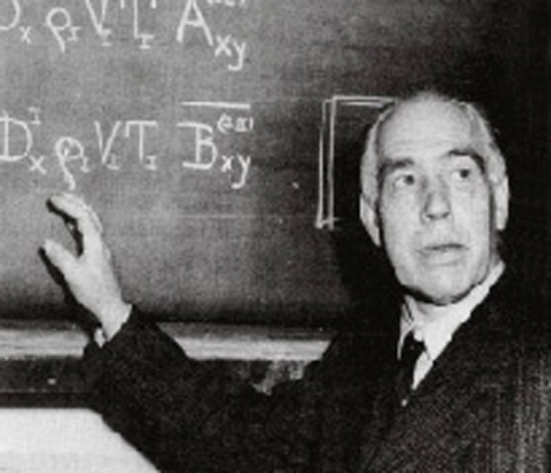

**Niels Bohr (1885-1962)**

The observed wavelengths in the line spectrum of hydrogen atom were first expressed in terms of a series by Johann Jakob Balmer, a Swiss teacher. Balmer’s empirical formula is 

Here,  09678 cm−1

is the Rydberg constant. me is the mass of an electron. Niels Bohr derived this expression theoretically in 1913. The formula is easily generalized to any one-electron atom/ion.

* 1. Calculate the longest wavelength in Å (1Å = 10 −10 m) in the ‘Balmer series’ of singly ionized helium (He+). Ignore nuclear motion in your calculation.

Longest wavelength corresponds to n = 3

For He+  (0.5)

L = 16411 Å 1)

**1.5 marks**

* 1. A formula analogous to Balmer’s formula applies to the series of spectral lines which arise from transitions from higher energy levels to the lowest energy level of hydrogen atom. Write this formula and use it to determine the ground state energy of a hydrogen atom in eV.



(0.5)

(0.5)

(0.5)

**1.5 marks**

A ‘muonic hydrogen atom’ is like a hydrogen atom in which the electron is replaced by a heavier particle, the muon. The mass of a muon is about 207 times the mass of an electron, while its charge is the same as that of an electron. A muon has a very short lifetime, but we ignore its unstable nature here.

* 1. Determine the lowest energy and the radius of the first Bohr orbit of the muonic hydrogen atom. Ignore the motion of the nucleus in your calculation. The radius of the first Bohr orbit of a hydrogen atom



(called the Bohr radius, ) is 0.53 Å.

Lowest energy = −207 x 13.6 = −2.82 keV (1)

Radius of the first Bohr orbit = 0.53 / 207 = 2.6 x 10−3 Å (1)

**2 marks**

The classical picture of an ‘orbit’ in Bohr’s theory has now been replaced by the quantum mechanical notion of an ‘orbital’. The orbital ψ1s (r) for the ground state of a hydrogen atom is given by



where r is the distance of the electron from the nucleus and ao is the Bohr radius.

**1.4** Consider a spherical shell of radius ao and thickness 0.001ao. Estimate the probability of finding the electron in this shell. Volume of a spherical shell of inner radius r and small thickness Δr equals 4πr2 Δr.

Probability = ⏐ (ao)⏐2 4πao2 x 0.001ao (1)

= 0.004 e−2

(1) = 5.41 x 10−4

**2 marks**

The H2 molecule can dissociate through two different channels:

(i) H2 → H + H (two separate hydrogen atoms)

(ii) H2 → H+ + H− (a proton and a hydride ion)

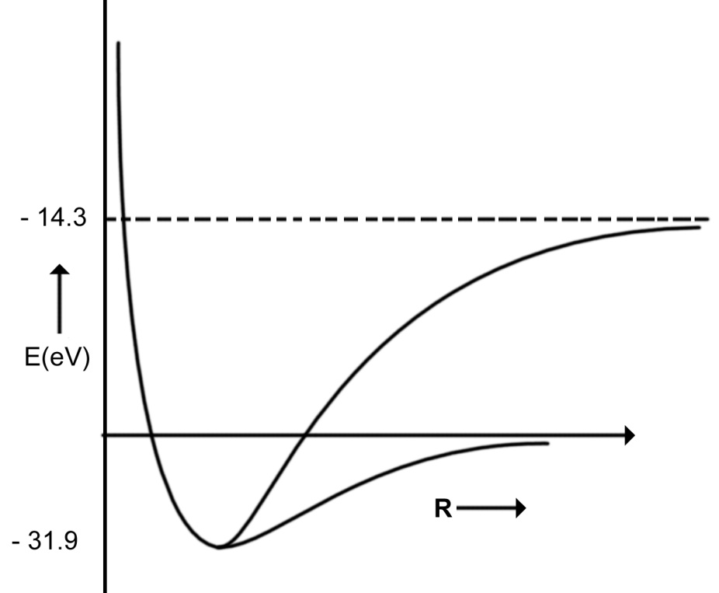The graph of energy (E) vs internuclear distance (R) for H2 is shown schematically in the figure. The atomic and molecular energies are given in the same scale.

(ii)

* 1. Put appropriate channel labels (i) or (ii) in the boxes below.

(i)

**1 mark**

**1.6** Determine the values of the dissociation energies (De in eV) of the H2 molecule corresponding to

4.7 eV

eV

channel (i)

17.6 eV

channel (ii) **1 mark**

* 1. From the given data, calculate the energy change for the process

H− → H + e−

electron affinity = −13.6 – (−14.3) = 0.7 eV

**1 mark**

**1.8** H− is a two-electron atomic system. Assuming that the Bohr energy formula is valid for each electron with nuclear charge Z replaced by Zeff, calculate Zeff for H−.

−13.6 + 27.2 Z2eff = 0.7 (1)

Zeff = 0.7 (1)

**2 marks**

**33rd IChO  Problem 2 7 Points**

**Phosphoric Acid**

Phosphoric acid is of great importance in fertiliser production. Besides, phosphoric acid and its various salts have a number of applications in metal treatment, food, detergent and toothpaste industries.

* 1. The pK values of the three successive dissociations of phosphoric acid at 25°C are:

pK1a = 2.12

pK2a = 7.21

pK3a = 12.32

Write down the conjugate base of dihydrogen phosphate ion and determine its pKb value.

The conjugate base of dihydrogen phosphate(H2PO4−) is monohydrogen phosphate (HPO42−) : (0.5)

H2PO4− + H2O  HPO42− + H3O+ K2a

HPO42− + H2O  H2PO4− + OH− K2b

2 H2O  H3O+ + OH− Kw

pK2a + pK2b = pKw = 14 (0.5)

pK2b = 6.79 (1.0)

**2 marks**

Small quantities of phosphoric acid are extensively used to impart the sour or tart taste to many soft drinks such as colas and root beers. A cola having a density of 1.00 g mL–1 contains 0.05 % by weight of phosphoric acid.

**2.2** Determine the pH of the cola (ignoring the second and the third dissociation steps for phosphoric acid). Assume that the acidity of the cola arises only from phosphoric acid.



(1)

H3PO4 + H2O  H2PO4− + H3O+

0.0051–x x + x

pK1a = 2.12 gives K1a = 7.59 x 10–3 (0.5)

(1)

(1)

(0.5



**4 marks**

**2.3** Phosphoric acid is used as a fertiliser for agriculture. 1.00 x 10–3 M phosphoric acid is added to an aqueous soil suspension and the pH is found to be 7.00.

Determine the fractional concentrations of all the different phosphate species present in the solution. Assume that no component of the soil interacts with any phosphate species.

#### Let



denote the fractional concentrations of different phosphate species. C is the total initial concentration of H3X. (X= PO4)

#### 

#### 

#### These equations lead to

(2)

From the values of pK1a, pK2a, pK3a and pH, one gets

K1a = 7.59 x 10–3 ; K2a = 6.17 x 10–8 ; K3a = 4.79 x 10–13

[ H3O+] = 10–7 (1)

The fractional concentrations of different phosphate species are

H3PO4 (fo) = 8.10 x 10–6

H2PO4− (f1) = 0.618

HPO42− (f2) = 0.382

PO43− (f3) = 1.83 x 10–6 (2)



**5 marks**

**2.4** Zinc is an essential micronutrient for plant growth. Plants can absorb zinc in water soluble form only. In a given soil water with pH = 7.0, zinc phosphate was found to be the only source of zinc and phosphate. Calculate the concentration of [Zn2+] and [PO43-] ions in the solution. Ksp for zinc phosphate is 9.1 × 10−33.

Let S mol L–1 be the solubility of Zn3(PO4)2 in soil water.

[Zn++] = 3 S (1)

Total concentration of different phosphate species = 2 S mol L–1

[PO43–] = f3 x 2S (1)

#### f3 can be determined from the relation derived in **2.3**

For pH = 7, f3 = 1.83 x 10 –6 (1)

Ksp = [Zn2+]3 [PO43–]2

9.1 x 10–33 = (3S)3(f3 x 2S)2 (1)

Solubility of Zn3(PO4)2 = 3.0 x 10 –5 mol L–1 (0.5)

[Zn2+] = 9 x 10 –5 mol L–1 (0.5)

#### [PO43–] = 1.1 x 10 –10 mol L–1

**5 marks**

**33rd IChO  Problem 3 8 Points**

# D:\User\sample\figure\edited images\gibbs2.TIFSecond Law of Thermodynamics

The Second Law of Thermodynamics is a fundamental law

of science. In this problem we consider the thermodynamics

of an ideal gas, phase transition and chemical equilibrium.

J.W.Gibbs (1839 –1903)

3.00 mol of CO2 gas expands isothermally (in thermal contact with the surroundings; temperature = 15.0oC) against a fixed external pressure of 1.00 bar. The initial and final volumes of the gas are 10.0 L and 30.0 L, respectively.

* 1. Choose the correct option for change in the entropy of the system (ΔSsys) and of the surroundings (ΔSsur) :

(a) ΔSsys > 0 ΔSsur = 0

(b) ΔSsys < 0 ΔSsur > 0

(c) ΔSsys > 0 ΔSsur < 0

(d) ΔSsys = 0 ΔSsur = 0

[Mark X in the correct box.] **1 mark**

**3.2** Calculate ΔSsys, assuming CO2 to be an ideal gas.

Since ΔSsys is independent of path, it is the same as for isothermal reversible expansion of an ideal gas.

(1)

= 27.4 JK−1 (1)



**2 marks**

**3.3** Calculate ΔSsur

#### q = pext ΔV (0.5)

(1)



**1.5 marks**

**3.4** Calculate the change in entropy of the universe.

ΔSuni = ΔSsys + ΔSsur

= 20.5 JK−1

**0.5 mark**

Does your answer agree with the Second law of Thermodynamics?

[Mark X in the correct box.]

Yes No

**0.5 mark**

The pressure – temperature phase diagram of CO2 is given below schematically. The diagram is not to scale.

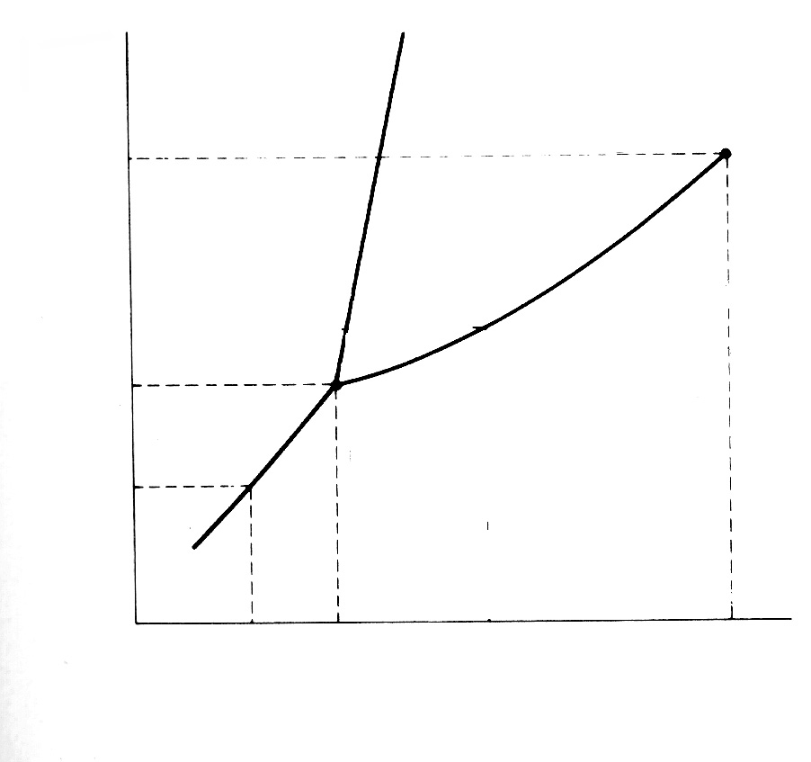

P / bar

73.8

5.18

1.01

–78.5

–56.6

31.0

t / oC

vapour

Phase diagram of CO2

liquid

solid

**3.5** CO2 gas, initially at a pressure of 4.0 bar and temperature of 10.0 oC, is cooled at constant pressure. In this process,

1. it goes first to the liquid phase and

then to the solid phase.

1. it goes to the solid phase without

going through the liquid phase.

[Mark X in the correct box.] **0.5 mark**

**3.6** Starting with the same pressure and temperature as above (in **3.5**), CO2 is compressed isothermally. In this process,

(a) it goes first to the liquid phase and

then to the solid phase.

(b) it goes to the solid phase without

going through the liquid phase.

[Mark X in the correct box.] **0.5 mark**

* 1. From the data given in the phase diagram, calculate the molar enthalpy change of sublimation of CO2. Write down the formula used.



(1)

 = 26.1 kJ mol−1 (1)

**2 marks**

**3.8** CO gas, used extensively in organic synthesis, can be obtained by reacting CO2 gas with graphite. Use the data given below to show that the equilibrium constant at 298.15 K is less than unity.

At 298.15 K

CO2(g) : = −393.51 kJ mol−1 ; = 213.79 JK−1 mol−1



CO(g) : = −110.53 kJ mol−1 ; = 197.66 JK−1 mol−1



C (graphite) : = 5.74 JK−1 mol−1



ΔHo = 172.45 kJ mol−1 (0.5)

ΔSo = 176 JK−1 mol−1  (0.5)

ΔGo = ΔHo − TΔSo = 120 kJ mol−1  (1)

ΔGo > 0 implies K < 1 (0.5)

**2.5 marks**

**3.9** Estimate the temperature at which the reaction would have an equilibrium constant equal to 1. Ignore slight variations in the thermodynamic data with temperature.

ΔGo = 0 when ΔHo = TΔSo (0.5)

T = 980 K (0.5)

**1 mark**

* 1. The reaction above (in **3.8**) is carried out between CO2 and excess hot graphite in a reactor maintained at about 800oC and a total pressure of 5.0 bar. The equilibrium constant Kp under these conditions is 10.0. Calculate the partial pressure of CO at equilibrium.

CO2 (g) + C(s)  2CO (g) 1−α 2α (0.5)

Partial 1 − α 2α (1)

pressure 1 + α 1 + α

x 5

x 5

Kp = p2 (CO) / p (CO2)(0.5)

p (CO) = 3.7 bar (1)

**3 marks**

**33rd IChO  Problem 4 9 Points**

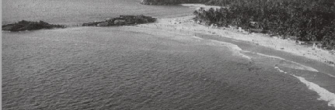

**Beach Sand Mineral in Kerala**

Beach sand mineral, monazite, is a rich source of thorium, available in large

quantities in the state of Kerala in India. A typical monazite sample contains about

9% ThO2 and 0.35% U3O8. 208Pb and 206Pb are the stable end-products in the

radioactive decay series of 232Th and 238U, respectively. All the lead (Pb) found in

monazite is of radiogenic origin.

The isotopic atom ratio 208Pb/232Th, measured mass spectrometrically, in a

monazite sample was found to be 0.104. The half–lives of 232Th and 238U are

1.41 × 1010 years and 4.47 × 109 years, respectively. Assume that 208Pb, 206Pb, 232Th and 238U remained entirely in the monazite sample since the formation of monazite

mineral.

**4.1** Calculate the age (time elapsed since its formation) of the monazite sample.

(1)

(No – N) = Total number of 232Th atoms decayed.

= Total number of 208Pb atoms formed.

(1)

(1)

∴ The age of monazite mineral is 2 × 109 years.



**3 marks**

**4.2** Estimate the isotopic atom ratio 206Pb/238U in the monazite sample.

Let x be the required ratio.

where t = 2.01 × 109 years, (1)

and t1/2 = 4.47 ×109 years.

x = 0.366 (1)

.



**2 marks**

**4.3** Thorium–232 is a fertile material for nuclear energy. In thermal neutron irradiation, it absorbs a neutron and the resulting isotope forms 233U by successive β– decays. Write the nuclear reactions for the formation of 233U from 232Th.

β−

(n,γ)

232Th 233Th  233Pa  233U

β−

**1 mark**

In nuclear fission of 233U a complex mixture of radioactive fission products is formed. The fission product 101Mo initially undergoes radioactive decay as shown below:



**4.4** A freshly prepared radiochemically pure sample of 101Mo contains 5000 atoms of 101Mo initially. How many atoms of

1. 101Mo
2. 101Tc
3. 101Ru

will be present in the sample after 14.6 min?

(i) The number of atoms of 101Mo (N1) in the sample after one half–life is :

N1 = 2500 (0.5)

1. The number of atoms of 101Tc (N2) is given by

# At t = 14.6 min

N2 = 1710 (1)

(iii) Number of atoms of 101Ru (N3) at t = 14.6 min is :

N3 = N0 − N1− N2

= 790 atoms (0.5)



**2 marks**

**[3 % variation in answers to N2 and N3 will be permitted.]**

**33rd IChO  Problem 5 11 Points**

**Halogen Chemistry**

Halogens in their reactions among themselves and with a variety of other elements give rise to a large number of compounds with diverse structure, bonding and chemical behaviour. Metal halides, halogen derivatives and interhalogens represent major types of halogen compounds.

1. **Photography**

A “black and white” photographic film contains a coating of silver bromide on a support such as cellulose acetate.

**5.1** Write the photochemical reaction that occurs when light falls on AgBr(s) coated on a film.



**0.5 mark**

**5.2** During the developing process, unexposed AgBr is washed away by complexation of Ag(I) by sodium thiosulphate solution. Write down this chemical equation.



**1 mark**

* 1. These washings are often disposed of as waste. However, metallic silver can be recovered from them by adding cyanide, followed by zinc. Write down the reactions involved.



(0.5)

(1)

**1.5 marks**

**(B) Shapes, spectra and reactivity**

The most reactive halogen, fluorine, reacts with other halogens, Cl2, Br2, and I2 under controlled conditions giving a tetra−atomic, hexa−atomic and an octa−atomic molecule, respectively.

**5.4** Write the formulae and 3 dimensional structures of these interhalogen molecules on the basis of VSEPR theory. Show the disposition of the lone pairs on the central atom, where appropriate.

## Formula Structure



ClF3 (0.5)

(1)

(0.5)

BrF5 (0.5)



**3.5 marks**

(0.5)

IF7 (0.5)



A mixture of iodine vapour and chlorine gas when fed into a mass spectrometer gave two sets (A and B) of mass spectral peaks corresponding to molecular ions of two chemical species at m/z :

A : (162,164)

B : (464, 466, 468, 470, 472, 474, 476)

**5.5** Identify the molecular species corresponding to m/z = 162, 164, 466 and 476. Draw the structure of the heaviest species (m/z = 476) indicating clearly the lone pairs on I atom(s). Show the isotopic composition of each species.

Mass Species

162 I35Cl (0.5)

164 I37Cl (0.5)

466 I235Cl537Cl (0.5)

476 I237Cl6  (0.5)

(1)



**3 marks**

In aqueous medium chlorine gas oxidises sodium thiosulphate to an ion containing the highest oxidation state of sulphur.

* 1. Write down the chemical equation for this reaction.



**1 mark**

* 1. Write down the Lewis dot structure of the thiosulphate ion. Circle the sulphur atom that has the lower oxidation state.



**1 mark**

**5.8** Chlorine dioxide reactswith sodium hydroxide as shown below. Identify the products X and Y (both containing chlorine) and balance the equation.



X Y

**2 marks**

**5.9** Reaction of chlorinean alkali is used for manufacturing bleach. Write the chemical reaction for its formation.



**1 mark**

**5.10** The oxidation state(s) of chlorine in bleach is (are):

–1 and +1

**1 mark**

**(C) Alkali metal halides and X–ray crystallography**

X–ray crystallography reveals many aspects of the structure of metal halides. The radius ratio (r+/r−) is a useful parameter to rationalize their structure and stability. A table of radius ratio (r+/r−) for some alkali halides is given below. The variation of the electrostatic component of lattice energy of alkali halides with radius ratio (r− kept constant) is shown schematically for NaCl–type and CsCl–type crystal structures.

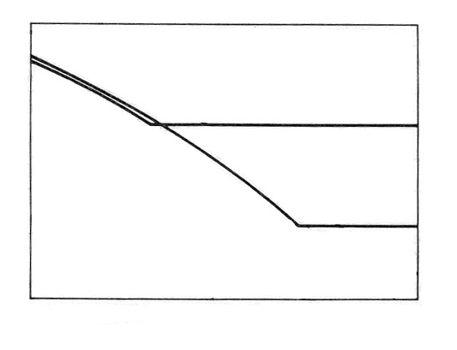

|  |  |  |  |  |  |  |
| --- | --- | --- | --- | --- | --- | --- |
|  | | Li+ | Na+ | K+ | Rb+ | Cs+ |
| Cl− | | 0.33 | 0.52 | 0.74 | 0.82 | 0.93 |
| Br− | | 0.31 | 0.49 | 0.68 | 0.76 | 0.87 |
| I− | | 0.28 | 0.44 | 0.62 | 0.69 | 0.78 |
|  | | | | | | |

Energy

CsCl type

NaCl type

1.0

r+/r−

* 1. For a given anion, the graph for NaCl–type structure levels off at low r+/r− values because of

(a) cation–cation contact along the face diagonal.

(b) anion–anion contact along the face diagonal.

(c) cation–anion contact along the cell edge.

[Mark X in the correct box.] **1 mark**

**5.12** Which among the halides LiBr, NaBr and RbBr is likely to undergo phase transition from NaCl–type to CsCl–type structure with change of temperature and /or pressure?

## RbBr

**0.5 mark**

**5.13** Show by calculation the radius ratio (r+/r−) at which the energy of CsCl–type structure levels off.

In CsCl–type structure,

Cell edge, a = 2r– (0.5)

Body diagonal,  (0.5)

(0.5)



**1.5 marks**

**5.14** Using Cu Kα X–rays ( = 154 pm), diffraction by a KCl crystal (fcc structure) is observed at an angle (θ) of 14.2 °. Given that (i) diffraction takes place from the planes with h2 + k2 + l2 = 4, (ii) in a cubic crystal dhkl = a/ (h2 + k2 + l2)1/2, where 'd' is the distance between adjacent hkl planes and 'a' is the lattice parameter, and (iii) reflections in an fcc structure can occur only from planes with 'all odd' or 'all even' hkl (Miller)indices, calculate the lattice parameter 'a' for KCl.



(0.5)

(0.5)

(0.5)

(0.5)

**2 marks**

* 1. Indicate in thetable given below the required information for the 2nd and 3rd nearest neighbours of a K+ ion in the KCl lattice.

|  |  |  |  |  |  |
| --- | --- | --- | --- | --- | --- |
| 2nd nearest neighbours | | | 3rd nearest neighbours | | |
| number | sign of the charge | distance  (pm) | number | sign of the charge | distance  (pm) |
| 12 | + | 444 | 8 | − | 544 |

**3 marks**

**5.16** Determine the lowest value of diffraction angle θ possible for the KCl structure.

Lowest θ value is for the plane with hkl = (111) (0.5)

(0.5)

(0.5)

(0.5)



2 marks

**33rd IChO  Problem 6 12 Points**

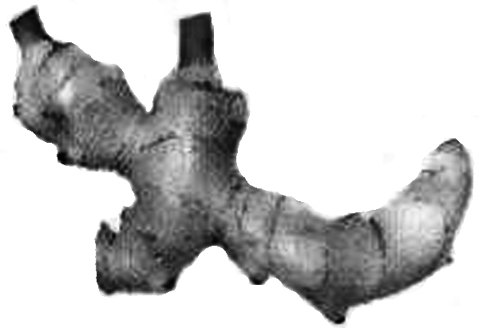**Organic chemistry of Indian spices**

The rhizomes of ginger (*Zingiber officinale*) are well known for their medicinal and flavoring properties. In Ayurveda (the traditional system of medicine in India), different formulations of ginger are used for the treatment of gastrointestinal problems, common cold and other ailments. Several compounds are responsible for the pungency of ginger. Many are simple substituted aromatic compounds with different side chains. Three of them, Zingerone, (+)[6] Gingerol (to be referred hereafter as Gingerol only), and Shogaol are particularly important.

**Zingerone** C11H14O3

**Gingerol** C17H26O4

**Shogaol** C17H24O3

* 1. Zingerone gives positive FeCl3 and 2,4–DNP (2,4–dinitrophenylhydrazine) tests. It does not react with Tollen’s reagent. Therefore, Zingerone contains the following functional groups:[Mark X in the correct boxes.]

# alcoholic hydroxyl (e) ester

# aldehydic carbonyl (f) alkoxyl

# ketonic carbonyl (g) unsaturation

(d) phenolic hydroxyl

**2 marks**

# The data obtained from the 1H NMR spectrum of Zingerone are shown in Table 1. Some other relevant information is given in Table 2.

# Table 1 : 1H NMR spectral data* on Zingerone

Chemical shifts Multiplicity Relative intensity (δ)

2.04 singlet 3

2.69,271 two (closely spaced) triplets of equal intensity 4

3.81 singlet 3

5.90 broad singlet (D2O exchangeable) 1

6.4 – 6.8 two doublets with similar chemical shifts 3

and one singlet

*(* For clarity, some of the data have been altered slightly*.*)*

**Table 2 : Approximate 1H chemical shifts (δ) and spin–spin coupling constants (*J*) of some protons.**

**1H Chemical shifts (δ)**



Spin–spin coupling constants (*J*)

Alkenes *cis* 5 – 14 Hz (commonly around 6 – 8 Hz)

*trans* 11− 19 Hz (commonly around 14 – 16 Hz)

Zingerone on bromination with bromine water gives only one nuclear mono brominated product. The IR spectrum of Zingerone indicates the presence of a weak *intra*molecular hydrogen bond. The same is present even after Clemmensen reduction (Zn–Hg/HCl) of Zingerone.

**6.2** From the information above deduce the following :

**i.** side chain in Zingerone

CH2CH2COCH3

**ii.** substituents on the aromatic ring

OH, OCH3

**iii.** relative positions of the substituentson the ring

1, 2, 4

**3 marks**

**6.3** Draw a possible structure of Zingerone based on the above inferences.



**3 marks**

**[Inference from mono bromination : 1 mark ; Inference from IR : 1 mark ; Inference from Clemmensen reduction : 1 mark]**

**6.4** Complete the following reaction sequence for the synthesis of Zingerone.



+aq. NaOH

**A** **B(C3H6O)**



H2/Catalyst **Zingerone**

**C**

**(C11H14O3)**

**[copy structure 6.4 A to page 30]**

**[Inference on C from Zingerone: 1 mark ; Inference on A and B from C: 2 marks] 3 marks**

**6.5** Zingerone can be easily converted into Gingerol by the following reaction sequence :



Notes : (1) is used to convert OH into −OSiMe3; the group −SiMe3 can be removed by acid hydrolysis.



(2) LDA is lithium diisopropylamide, a strong, very hindered, non–nucleophilic base.

1. Draw the structure of **D**.



**2 marks**

**[Inference from LDA, –78°C: 2 marks ; Inference from only LDA as a base: 1 mark]**

**ii.** Draw the structure of Gingerol.



**2 marks**

**[Addition of hexanal to the side chain: 1 mark]**

1. Complete the Fischer projection of the *R−* enantiomer of Gingerol.



**1 mark**

**[Fischer projection of (ii): 1 mark]**

1. In the above reaction sequence (**6.5**), about 2–3% of another constitutional isomer (**E**) of Gingerol is obtained. Draw the likely structure of **E**.



**1 mark**

**[Notion of positional isomer: 1 mark]**

1. Will the compound **E** be formed as

(a) a pair of enantiomers?

(b) a mixture of diastereomers?

(c) a mixture of an enantiomeric pair and a meso isomer?

[Mark X in the correct box.] **1 mark**

1. Gingerol (C17H26O4) when heated with a mild acid (such as KHSO4 ) gives Shogaol (C17H24O3). Draw the structure of Shogaol.



**1 mark**

**[Indication of plausible dehydration: 1 mark]**

**6.6** Turmeric (*Curcuma longa)* is a commonly used spice in Indian food. It is also used in Ayurvedic medicinal formulations. Curcumin (C21H20O6), an active ingredient of turmeric, is structurally related to Gingerol. It exhibits keto–enol tautomerism. Curcumin is responsible for the yellow colour of turmeric and probably also for the pungent taste.

The 1H NMR spectrum of the keto form of Curcumin shows aromatic signals similar to that of Gingerol. It also shows a singlet around δ 3.5 (2H) and two doublets (2H each) in the region δ 6–7 with *J* = 16 Hz. It can be synthesized by condensing **TWO** moles of **A** (refer to **6.4**) with one mole of pentan–2,4–dione.

**i.** Draw the stereochemical structure of Curcumin.



**3 marks**

**[Inference from NMR: COCH2CO:0.5 mark; C=C: 0.5 mark; *trans* stereochemistry: 1 mark; condensation with dione: 1 mark]**

**ii.** Draw the structure of the enol form of Curcumin



**1 mark**

1. Curcumin is yellow in colour because it has

# (a) a phenyl ring

# (b) a carbonyl group

(c) an extended conjugation

# (d) a hydroxyl group

**1 mark**

**33rd IChO  Problem 7 9 Points**

## Peptides and Proteins

### **D:\User\sample\figure\edited images\enzymecolour.jpg**

### Protein folding

Proteins (polypeptides) are known to assume a variety of backbone conformations. In one conformation, the backbone is in almost fully extended arrangement (as in a parallel or anti–parallel β–sheet), and in another conformation it is in a fully folded arrangement (as in an α–helix).

**7.1** The end–to–end distance in a hexapeptide when it is in a fully extended conformation is approximately :

1. 10 Å
2. 15 Å
3. 20 Å

(d) 25 Å

**1 mark**

[Mark X in the correct box.]

|  |  |  |
| --- | --- | --- |
| Amino Acid | Structure | Molecular mass (Da) |
| Glu – Glutamic acid |  | 147 |
| Hms – Homoserine |  | 119 |
| Leu – Leucine |  | 131 |
| Met – Methionine |  | 149 |
| Lys – Lysine |  | 146 |
| Phe – Phenylalanine |  | 165 |
| Arg – Arginine |  | 174 |
| Ser – Serine |  | 105 |

* 1. Assuming that the following hexapeptide is in α–helix conformation, draw a connecting arrow between an oxygen atom and an amide NH with which it is hydrogen bonded.



**[1 mark for any correct answer; 0 for any wrong connections]**  **1 mark**

* 1. The following two hexapeptides (**A** and **B**) display contrasting conformations in water at pH 7.0, especially when their serine hydroxyls are phosphorylated. **A** is moderately helical and it becomes a stronger helix on serine phosphorylation. **B** is weakly helical and it is completely disordered on serine phosphorylation. Draw connecting arrows to indicate the interactions between the residues that are responsible for this differing behaviour.



**[0.5 mark for each correct arrow]** **2 marks**

Consider the following process of folding/unfolding of a tripeptide segment in a large

protein. The free energy change (ΔG) will depend on the interaction of the unfolded

tripeptide with the solvent (water) and with the rest of the protein in the folded state

(see below). Assume that the tripeptide is made up of one non–polar (hydrophobic;

shaded) and two polar (hydrophilic; unshaded) residues. Assume the following

approximate changes in the interaction free energies :

(a) a non–polar residue and the solvent (water)

ΔG = **+**8 kJ mol**–**1

1. a non–polar residue and the rest of the protein

ΔG = **–** 4 kJ mol**–**1

1. a polar residue and the solvent (water)

ΔG = **–** 16 kJ mol**–**1

1. a polar residue and the rest of the protein

ΔG = **–** 14 kJ mol**–**1

polar residue

 non-polar residue

Tripeptide segment in unfolded form Tripeptide segment in folded form

**7.4** Calculate ΔG for the folding of the tripeptide segment.

ΔG = – 8 – (– 16 x 2) + (– 4 x 1) + (– 14 x 2) = – 8 kJ mol–1

**1 mark**

**7.5** Calculate ΔG for the folding of the tripeptide segment if all the three residues are polar.

ΔG = – (14 x 3) – (– 16 x 3) = + 6 kJ mol–1

**0.5 mark**

β − lactamase and drug resistance

Penicillins are effective drugs in combating bacterial infections. An alarming development over the years has, however, been the emergence of drug resistant bacteria. Penicillin resistance arises due to the secretion of an enzyme called β–lactamase (also known as penicillinase), which inactivates penicillin by opening its β–lactam ring. The mechanism for this β–lactam ring opening involves the nucleophilic attack by serine–OH at the active site of the enzyme as shown below.



An attempt was made to characterize the β–lactamase from *Staphylococcus aureus*. When the pure enzyme was treated with a radiolabelled [32P] phosphorylating agent, only the active site serine got labelled. On analysis, this serine {molecular mass = 105 mass units (Da)} constituted 0.35% by weight of the β–lactamase.

**7.6** Estimate the minimal molecular mass of this β–lactamase.

105 x 100 = 30000 Da

0.35

**1 mark**

* 1. The approximate number of amino acid residues present in a protein of this size is :

1. 100
2. 150
3. 275
4. 375

[Mark X in the correct box.] **1 mark**

**7.8** To map its active site, the β–lactamase was hydrolysed using trypsin, a specific enzyme.

This resulted in a hexapeptide P1 containing the active site serine. Amino acid analysis revealed the following in equimolar proportion : Glu, Leu, Lys, Met, Phe and Ser.

Treatment of P1 with Edman’s reagent (phenyl isothiocyanate) yielded phenyl thiohydantoin (PTH) derivative of phenyalanine and a peptide P2.

Treatment of P1 with cyanogen bromide (CNBr) gave an acidic tetrapeptide P3 and a dipeptide P4.

Treatment of P2 with 1–fluoro–2,4–dinitrobenzene, followed by complete hydrolysis, yielded N–2,4–dinitrophenyl–Glu.

P1, P2, and P3 contain the active site serine.

From the above information, deduce the amino acid sequence of P1, P2, P3 and P4.

P1 : Phe – Glu – Ser – Met – Leu – Lys

P2 : Glu – Ser – Met – Leu – Lys

P3 : Phe – Glu – Ser – Hms/Met

P4 : Leu – Lys **Hms = 1; Met = 0.5**

**4 marks**

7.9 Calculate the molecular mass of P3 in mass units (Da) from the information given in the Table on page 32.

Phe – Glu – Ser – Hms

(165 + 147 + 105 + 119) **–** 3H2O

= 536 **–** 54 = 482 Da

(1 mark : – 3H2O) 1 mark

* 1. The β–lactamase active site provides a unique microenvironment that makes the catalytic serine**–**OH an unusually reactive nucleophile. The first order rate constant for β–lactamase catalysed reaction is 350 s**–**1.For penicillin hydrolysis by free serine**–**OH (at 1M) in solution, the pseudo first order rate constant is 0.5 s**–**1.

From the information above, calculate the effective concentration of this nucleophile at the enzyme active site?

700 M

**1 mark**

**7.11** A molecule competing with penicillin for binding to the β–lactamase active site can inhibit the enzyme. Dissociation constants (KD) for the inhibitor–lactamase complex for three different inhibitors are given below :

Inhibitor Dissociation constant (KD)

A 2.0 x 10–3

B 1.0 x 10–6

C 5.0 x 10–9

Indicate which of these inhibitors is most effective in protecting penicillin against β–lactamase. [Mark X in the correct box]

##### A

B

C

**1 mark**

A β–lactamase inhibitor was designed rationally. On binding to the enzyme active

site, a nucleophilic attack by the OH group of serine resulted in the opening of the

β–lactam moiety of the inhibitor and elimination of Br–. A reactive electrophile is generated as a result and it captures an active site residue X, inactivating the enzyme.

**7.12** Based on the above information, identify the electrophile (A) generated and the final product (B) formed in the enzyme inactivation by the inhibitor shown.



**3 marks**

**33rd International Chemistry Olympiad**

**Mumbai, Sunday, 8 July 2001**

Practical Examination

### Instructions for Students

* Write your name and student code on each answer sheet, and your student code on all other pages.
* Please read each laboratory task and study the lay out of the answer sheets before you begin the task.
* All results and answers are to be written in the appropriate boxes on the answer sheets provided to you. Anything written elsewhere will not be marked. If you need any more sheets for rough work or a replacement answer sheet, ask the laboratory expert.
* Additional chemicals and/or glassware can be requested if used up or broken. The penalty will be 1 mark for each replacement.
* Time duration for the practical examination is 4 hours and 30 minutes. The examination consists of three independent laboratory tasks. Complete the tasks in the order given (1, 2, 3). You must STOP your work immediately after the stop command is given. **A delay in doing so by 3 minutes or more may lead to cancellation of the current task and result in zero score for the task.**
* When you have finished the examination, you must put all the papers in the envelope provided, then **seal the envelope** and sign on it before handing it over to the laboratory expert.
* Do not leave the examination hall before you are asked to do so. Collect a receipt for your sealed envelope before leaving.
* Use only the pen and calculator provided.
* This examination paper consists of **10** pages of laboratory tasks and **6** pages of answer sheets.
* A copy of Periodic Table of the Elements is provided.
* An official English-language version is available only on request.

### Safety Rules

* You must wear a laboratory coat/apron throughout the examination.
* At all times you must wear safety goggles in the laboratory. If you wear contact lenses, full protection goggles, which provide total seal around your eyes, must be worn.

### Rules regarding disposal of waste chemicals, spillage and glassware.

* Organic filtrates and organic washing solutions (lab task 1) should be placed in the waste container labelled "Residues from organic preparation".
* Residues from titration (lab task 2) should be placed in the waste container labelled “Residues from complexometric titration”.
* Residues from redox titration (lab task 3) should be placed in the waste container labelled "Residues from redox titration".
* Broken glass should be placed in the waste disposal container labelled "Glass disposal".
* Non-chemical waste and paper should be placed in the unlabelled waste bucket.

Students who break any of the safety and waste disposal rules will be given only ONE WARNING by the laboratory expert. **A second warning will be considered a major fault, and the student will be expelled from the laboratory with resultant zero score in the practical examination.**

If any questions arise concerning safety procedures during the practical examination, you should not hesitate to ask the nearest laboratory expert for directions.

### Please note

* Use only the distilled water provided. You may ask for additional distilled water if necessary.
* The lab bench should be wiped clean with a wet tissue at the end of the examination, after you hand over your envelope.

## Chemicals: Risk (R) and Safety (S) phrases

### Laboratory Task 1

|  |  |  |  |
| --- | --- | --- | --- |
| **2-Aminobenzoic acid**  **(Anthranilic acid)**  Formula: NH2C6H4COOH  Molecular weight: 137.14 | **i** | R36/37/38: Irritating to eyes, respiratory system and skin.  S26/36: In case of contact with eyes, rinse immediately with plenty of water and seek medical advice. Wear suitable protective clothing. | |
| **Sulphuric acid**  Formula: H2SO4  Molecular weight: 98.08 | **i** | R36/37/38: Irritating to eyes, respiratory system and skin.  S26/36: In case of contact with eyes, rinse immediately with plenty of water and seek medical advice. Wear suitable protective clothing. | |
| **Potassium iodide**  Formula: KI  Molecular weight. 166.00 |  | Not classified. | |
| **Sodium nitrite**  Formula: NaNO2  Molecular weight: 69.00 |  | R8/25: Contact with combustible material may cause fire. Toxic if  swallowed.  S44: Seek medical advice if you feel unwell. |
| **Sodium carbonate anhydrous**  Formula: Na2CO3  Molecular weight:105.99 | **i** | R36: Irritating to eyes.  S26: In case of contact with eyes, rinse immediately with plenty of water and seek medical advice.  S22: Do not breathe dust. | |
| **Sodium bicarbonate**  Formula: NaHCO3  Molecular weight: 84.01 |  | Not classified. | |

### Laboratory Task 2

|  |  |  |
| --- | --- | --- |
| **Ethylenediamine tetraacetic acid**  **disodium salt,** (Na2EDTA)⋅2 H2O Formula: C10H14O8Na2N2.2H2O  Molecular weight: 372.24 | **n** | R22: Harmful if swallowed.  R36/37/38: Irritating to eyes, respiratory system and skin.  S26: In case of contact with eyes, rinse immediately with plenty of water and seek medical advice.  S36: Wear suitable protective clothing. |
| **Manganese(II)sulphate**  **monohydrate**  Formula: MnSO4.H2O  Molecular weight: 169.01 |  | Not classified. |
| Magnesium(II)chloride  Formula: MgCl2.6H2 O  Molecular weight: 203.30 |  | Not classified. |
| Ammonia  Formula: NH3  Molecular weight: 17.03 | **i** | R36/37/38: Irritating to eyes, respiratory system and skin.  S36: Wear suitable protective clothing. |
| **Ammonium nitrate**  Formula: NH4NO3  Molecular weight: 80.04 |  | R36/37/38: Irritating to eyes, respiratory system and skin.  S26: In case of contact with eyes, rinse immediately with plenty of water and seek medical advice.  S36: Wear suitable protective clothing. |
| Hydroxylamine hydrochloride  Formula:NH2OH⋅HCl  Molecular weight: 69.49 | **n** | R20/22-36/38: Harmful by  inhalation and if swallowed.  Irritating to eyes, respiratory  system and skin.  S26/36: In case of contact with  eyes, rinse immediately with plenty of water and seek medical advice. Wear suitable protective clothing. |
| **Sodium fluoride**  Formula: NaF  Molecular weight: 41.99 |  | R23/24/25: Toxic by inhalation, in contact with skin and if swallowed.  S26/44: In case of contact with eyes, rinse immediately with plenty of water and seek medical advice. |

|  |  |  |
| --- | --- | --- |
| Laboratory Task 3 |  |  |
| **Sodium thiosulphate**  Formula: Na2S2O3 .5H2O  Molecular weight: 248.17 |  | Not classified. |
| **Potassium iodide**  Formula: KI  Molecular weight: 166.00 |  | Not classified. |
| **Ethanol**  Formula: C2H6O  Molecular weight: 46.08  b.p. 78.5°C  Density: 0.785 g/cm3 |  | R11: Highly flammable.  S7: Keep container tightly closed.  S16: Keep away from sources of ignition. |
| **Hydrochloric acid**  Formula: HCl  Molecular weight: 36.46 |  | R-36/37/38: Irritating to eyes, respiratory system and skin.  S26: In case of contact with eyes, rinse immediately with plenty of water and seek medical advice. | |
| **Potassium dichromate**  Formula: K2Cr2O7  Molecular weight: 294.18 | **i** | R36/37/38: Irritating to eyes, respiratory system and skin.  S22: Do not breathe dust.  S28: After contact with skin wash with plenty of water. |

##### At the work bench:

### Laboratory Task 1, Organic Synthesis

|  |  |
| --- | --- |
| Beaker (100 mL) | 1 |
| Conical flasks (100mL) | 4 |
| Droppers | 2 |
| Filter paper (circles) | 4 |
| Funnels | 3 |
| Glass rod | 1 |
| Ice bath | 1 |
| Measuring cylinders (10 mL) | 3 |
| Spatula (plastic) | 1 |
| Test tube | 1 |
| Test tube rack | 1 |
| Water bath | 1 |
| Watch glass | 1 |
| Stoppered tubes containing | H2SO4 (2.6 M), 7.2 mL (labelled H2SO4) |
|  | dil. H2SO4, 10 mL |
|  | NaNO2 solution (14% w/v), 7 mL |
|  | KI solution (26% w/v) in 1M H2SO4, 12 mL (labelled KI) |
|  | Saturated NaHCO3 solution, 20 mL |
| Vials containing | 2-aminobenzoic acid, 1.0 g |
|  | Charcoal, 0.3 g |
|  | Na2CO3, 3 g |

### Laboratory Task 2, Complexometric Titration

|  |  |
| --- | --- |
| Burette, 25 mL | 2 |
| Conical flasks, 250 mL | 2 |
| Funnels | 2 |
| Measuring cylinder, 10mL | 1 |
| Measuring cylinder, 50mL | 1 |
| Spatula (metal) | 1 |
| Wash bottle | 1 |
| Reagent bottles containing | MnSO4 (0.0xx M), 60 mL |
|  | Buffer solution, 30 mL |
|  | Na2EDTA (0.0xx M), 100 mL |
| Vials containing | Hydroxylamine hydrochloride, 0.3 g/vial (2 vials) |
|  | NaF, 1.5 g/vial (2 vials) |
|  | Eriochrome black T indicator (powder). |

### Laboratory Task 3, Kinetics

|  |  |
| --- | --- |
| Burette, 50 mL | 2 |
| Conical flasks, 100 mL | 4 |
| Funnels | 2 |
| Measuring cylinder, 10 mL | 2 |
| Stop watch | 1 |
| Reagent bottles containing | K2Cr2O7 solution (0.0xxx M) in HCl (3.6M), 100 mL |
|  | Na2S2O3 (0.0xx M), 100 mL |
|  | KI solution (3 % w/v), 30 mL |
|  | Starch indicator, 15 mL |
| Vial containing | Ethanol, 1 mL |

### Laboratory Task 1 12 points

#### Preparation of 2-iodobenzoic acid [Approx. time: 1 hr]

This laboratory task involves preparation of 2-iodobenzoic acid from 2-aminobenzoic acid. The procedure consists of diazotization of 2-aminobenzoic acid followed by reaction with KI (in aqueous H2SO4).

##### Procedure

Quantitatively transfer the given sample of solid 2-aminobenzoic acid into a 100 mL beaker placed in the ice-bath. Add 7.2 mL of H2SO4 (2.6 M) (labelled H2SO4) and mix the contents thoroughly for 1 minute with the help of a glass rod. Cool the solution for 5 minutes.

Using a measuring cylinder, measure out 4.4 mL of supplied cooled NaNO2 solution from the vial placed in the ice-bath.

With the help of a dropper, slowly add the cooled NaNO2 solution to the acid solution with constant gentle stirring using a glass rod to obtain an almost clear solution (3-5 minutes).

Remove the beaker from the ice bath and then slowly add 9.4 mL of KI solution from the stoppered tube, with stirring.

Get hot water from the laboratory expert. Keep the beaker in hot water for 5 minutes.

Filter the crude product and wash it thoroughly with distilled water (10 mL). Collect the washings along with the main filtrate.

Neutralize the combined filtrate by gradually adding the given solid Na2CO3 until effervescence ceases. Dispose of the filtrate in the appropriate plastic bucket.

##### Purification of the crude product

Place the funnel containing the precipitate on a 100 mL conical flask. Pour about 15 to 20 mL of the supplied NaHCO3 solution (using test tube) over the filter paper so as to dissolve the precipitate completely.

Add the supplied charcoal powder to the filtrate and mix it thoroughly. Filter the solution to remove charcoal.

Add dilute H2SO4 gradually to the filtrate till effervescence ceases. Filter the purified product. Use 10 -15 mL distilled water to wash the precipitate. Keep the filter paper with the product on a watch glass.

Cover the product with the same funnel and hand over the product to the laboratory expert for drying (for a minimum of one hour).

Towards the end of the practical session have the product weighed by the laboratory expert and record the same.

### Laboratory Task 2 18 points

#### Estimation of Mn(II) and Mg(II) present in the given sample. (Approx. time: 1½ hrs)

In this experiment, estimation of the amounts of Mn(II) and Mg(II) present in the given sample is carried out by complexometric titration using standard Na2EDTA solution. Total metal ion content is obtained from the first titration. At this stage, by using adequate solid NaF, selective and quantitative release of EDTA present in Mg-EDTA complex is achieved. The EDTA thus released is bound again by the addition of a known **excess** of standard Mn(II) solution. The unused Mn(II) is estimated by a back titration using the same standard Na2EDTA solution. From these two different titre values, individual amounts of metal ions present can be obtained. Both the titrations are performed using a buffer (pH=10) and Erichrome black T indicator.

**The sample in duplicate is given in two 250 mL conical flasks (labelled as Trial I and Trial II). Perform the titrations for both and record your readings on the answer sheet.**

##### Procedure

Two burettes (25 mL) are supplied to you. Fill one with the given standard Na2EDTA solution and the other with the given standard Mn(II) solution.

##### Titration 1

To the sample solution (supplied in the 250 mL conical flask), add all of the solid hydroxylamine hydrochloride given in one vial followed by 50 mL of distilled water. With the help of a measuring cylinder, add 10 mL buffer solution (pH = 10) and one metal spatula full of the solid indicator. Shake the contents of the flask thoroughly and titrate the solution against the standard Na2EDTA solution until the colour changes from wine red to blue. Record your burette reading (**A** mL). Ensure that you shake the contents of the flask thoroughly throughout the titration.

##### Titration 2

To the same flask, add all of the solid NaF given in one vial and shake the contents well for a minute. To this add 20.0 mL of the given standard Mn(II) solution from the other burette. The addition of the Mn(II) solution should be done in small increments (2-3 mL) with thorough shaking. After addition of the total Mn(II) solution, shake the contents for two to three minutes. The colour of the solution will change from blue to wine red. Titrate the **excess** of Mn(II) in the solution against the standard Na2EDTA solution till the colour changes from wine red to blue. Record your burette reading (**B** mL).

***Repeat the same procedure for******Trial II.***

### Laboratory Task 3 10 points

#### Determination of the rate constant for the redox reaction between ethanol and chromium(VI) (Approx. time: 1½ hrs)

The oxidation of alcohols by chromium(VI) forms the basis for analysis of breath samples for measuring alcohol content. A dilute solution of K2Cr2O7 in the presence of a strong acid (3.6 M HCl here) is a source of HCrO4− which is the oxidant involved in the reaction.

In this experiment, the rate of the reaction between HCrO4− and CH3CH2OH is determined titrimetrically. Under the given experimental conditions, the rate law reduces to

rate = *k*[ HCrO4− ]x

where x is the order of the reaction.

At any given time, [ HCrO4− ] is obtained by iodometric titration.

##### Procedure

You are given 100 mL of standard K2Cr2O7 solution in HCl in a bottle. Transfer all the absolute ethanol given in a vial into this bottle and stopper it. Mix the contents thoroughly, start the stopwatch immediately and regard this as time *t* = 0. Fill the burette with this solution.

After every 10 minutes, start to draw 10.0 mL of this solution to a clean conical flask containing 4 mL of the given KI solution. The solution will turn brown. Titrate this solution with the given standard Na2S2O3 solution until the colour changes to pale greenish yellow. Add 2 mL of starch indicator and continue the titration until the colour changes from blue to pale green. Record the burette reading in the answer sheet. Repeat this procedure at 10 minutes intervals to obtain four readings.

**33rd IChO • Laboratory Task 1 Answer sheet 12 points**

### Preparation of 2-iodobenzoic acid

|  |  |  |
| --- | --- | --- |
| Mass of empty watch glass /g |  | Expert’s initials |
| Mass of watch glass with  product /g |  | Expert’s initials |

**1.1** The mass of your product: 1,27 g

**13 marks**

**1.2** The calculated theoretical yield in g: 1,81 g

(based on 2 aminobenzoic acid)

**1 mark**

**1.3** The yield obtained as a percentage of the 70,00 %

theoretical yield:

**1 mark**

**1.4** Colour of the product obtained:

[The laboratory expert will mark X in the appropriate box with initials.]

|  |  |  |
| --- | --- | --- |
| Brownish yellow |  | 2 |
| Yellow |  | 3 |
| Pale yellow / cream yellow |  | 4 |
| Brown |  | 1 |
| Any other |  | 0 |

**4 marks**

**1.5** Write down the balanced chemical equations for

1. diazotization of 2-aminobenzoic acid using NaNO2 and H2SO4.



**(0.5) (1) (0.5) (0.5)**

**2.5 marks**

(b) the reaction of KI with the diazotized product.



**1 mark**

Penalty!

Additional chemicals and/or glassware can be requested if used up or broken. The penalty will be 1 mark for each replacement.

|  |  |  |  |
| --- | --- | --- | --- |
| No. | Chemical/Glassware | Student’s initials | Expert’s initials |
|  |  |  |  |
|  |  |  |  |
|  |  |  |  |

**Total marks deducted:**

**33rd IChO • Laboratory Task 2 Answer sheet 18 points**

### Estimation of Mn(II) and Mg(II) present in the given sample

Concentration of standard Na2EDTA: 0.050M

Concentration of Mn(II) solution: 0.050 M

**2.1** Batch number of the sample provided to you:

|  |  |  |  |  |
| --- | --- | --- | --- | --- |
|  | **Trial I** | | **Trial II** | |
|  | **Titration 1** | **Titration 2** | **Titration 1** | **Titration 2** |
| **Initial burette reading (mL)** | 0.00 mL | 0.00 mL | 0.00 mL | 0.00 mL |
| **Final burette reading (mL)** | 19.60 mL | 10.80 mL | 19.60 mL | 10.80 mL |
| **Volume of Na2EDTA (mL)** | **19.60 mL**  **(A)** | **10.80 mL**  **(B)** | **19.60 mL**  **(A)** | **10.80 mL**  **(B)** |

**22 marks**

Recalculated using student’s data

**Maximum marks: 22 (15 marks for Mg, 7 marks for Mn)**

**Linear scale: 0–3% deviation, full marks; > 10% deviation, 0 mark**

(The higher of the student’s scores in Trials I and II will be regarded as the true score.)

**2.2** Givethe balanced chemical equation for the reactions of Mg(II) and Mn(II) with Na2EDTA . (Use the symbol Na2H2Yfor Na2EDTA.)

Mg 2+ + H2Y2− → MgY2− + 2H+

Mn 2+ + H2Y2− → MnY2 −+ 2H+

**1 mark**

**2.3** Give the equation for the release of EDTA by the addition of NaF to the MgEDTA complex.

MgY2− + 2F− → MgF2+ Y4−

**1** **mark**

**2.4** Calculate the amount of Mg(II) and Mn(II) in gram for any one of the two trials. (Show the main steps in your calculation.)

### Calculation: Trial No.

### Mg

# A =19.60 mL B = 10.80 mL

# Volume of Mn (II) added externally = 20.00 mL

# EDTA released after addition of NaF = (20.00 x 0.050) – (10.80 x 0.050)

# = 0.46 mmol (2.5)

### **Amount of Mg in the sample = 0.46 x 24.305 = 0.012 g (0.5)**

### Mn

# Total EDTA used (in Titration 1) = 19.60 x 0.050 = 0.98 mmol

Amount of Mg (in Titration 2) = 0.46 mmol

Amount of Mn = 0.98 – 0.46 = 0.52 mmol

= 0.52 x 54.94 = 0.028 g **(1)**

**4 marks**

**2.5** The colour change at the end point (wine red to blue) in Titration 1 is due to

the formation of metal-indicator complex.

the release of free indicator from metal-indicator complex.

the formation of metal-EDTA complex.

[Mark X in the correct box.] **1 mark**

**Penalty!**

Additional chemicals and/or glassware can be requested if used up or broken. The penalty will be 1 mark for each replacement.

|  |  |  |  |
| --- | --- | --- | --- |
| No. | Chemical/Glassware | Student’s initials | Expert’s initials |
|  |  |  |  |
|  |  |  |  |
|  |  |  |  |

**Total marks deducted: 33rd IChO • Laboratory Task 3 Answer sheet 10 points**

### Determination of the rate constant for the redox reaction between ethanol and chromium(VI)

Concentration of standard Na2S2O3 0.0100M

Concentration of HCrO4 – at t =0: 0.0074 M

|  |  |  |  |  |
| --- | --- | --- | --- | --- |
|  | **Titration 1**  **[10 mins.]** | **Titration 2**  **[20 mins.]** | **Titration 3**  **[30 mins.]** | **Titration 4**  **[40 mins.]** |
| **Initial burette reading (mL)** | 0.00 mL | 0.00 mL | 0.00 mL | 0.00 mL |
| **Final burette reading (mL)** | 16.40 mL | 12.20 mL | 9.00 mL | 6.80 mL |
| **Volume of**  **Na2S2O3 (mL)** | 16.40 mL | 12.20 mL | 9.00 mL | 6.80 mL |

**3.1** Write down the possible oxidation products in the reaction of HCrO4− andCH3CH2OH.

**Acetic acid CH3COOH**

**Acetaldehyde CH3CHO**

**1 mark**

**3.2** Write down the balanced chemical equation for the reaction between HCrO4 − and KI.

**1 mark**

**2 HCrO4− + 6I− + 14 H+ → 3 I2 + 2Cr3+ + 8H2O**

**3.3** Write down the balanced chemical equation involved in the titration.

**0.5 mark**

**I2 + 2 S2O3 2− → 2 I− + S4O62−**

**3.4** Give the main steps for the calculation of HCrO4 – concentration (M) for any one titration reading.

**2 marks**

[S2O32−] x *V***S2O32−** = 3 [HCrO4− ] x *V***HCrO4−**

0.010 x 6.80 = 3 [HCrO4− ] x 10.0

[HCrO4− ] = 0.0027

* 1. Concentration (M) of HCrO4 – at different times:

|  |  |  |
| --- | --- | --- |
| **Time (mins.)** | **[ HCrO4 – ]** | **ln [ HCrO4 – ]** |
| 0 | 0.007 | -4.897 |
| 10 | 0.005 | -5.209 |
| 20 | 0.004 | -5.505 |
| 30 | 0.003 | -5.809 |
| 40 | 0.002 | -6.089 |

**1.5 marks**

*k* = 0.030 min -1

* 1. Plot the graph of log [ HCrO4 – ] vs time.

**2 marks**

**3.7**  From the nature of the graph, determine the order (**x**) of the reaction with respect toHCrO4 –.

##### **x = 1**

**1 mark**

**3.8** Determine the rate constant for the reaction.

**16 marks**

*1 mark for correct calculation*

*no unit: 0.5 mark*

*k* = 0.030 min−1

Recalculated using student’s data

**Maximum marks: 15**

**Linear scale: 0 to 3 % deviation, 15 marks; > 10 % deviation, 0 mark**

Penalty!

Additional chemicals and/or glassware can be requested if used up or broken. The penalty will be 1 mark for each replacement.

|  |  |  |  |
| --- | --- | --- | --- |
| No. | Chemical/Glassware | Student’s initials | Expert’s initials |
|  |  |  |  |
|  |  |  |  |
|  |  |  |  |

**Total marks deducted:**

