**Preparatory Problems**

**44th International Chemistry Olympiad**

**Co-Editors: Michael P. Doyle**

**and Andrei Vedernikov**

Department of Chemistry and Biochemistry

University of Maryland at College Park

Tel: 001 301 405 1788; Fax: 001 301 314 2779

Email: icho2012@umd.edu

**November 2011**

Published 2011 American Chemical Society

All rights reserved

Commercial sale is prohibited

**Contributing Authors**

Seth N. Brown, University of Notre Dame

Michael P. Doyle, University of Maryland

Daniel E. Falvey, University of Maryland

George R. Helz, University of Maryland

Kaveh Jorabchi, Georgetown University

Douglas A. Julin, University of Maryland

J.L. Kiappes, University of Oxford

John Kotz, State University of New York

Evguenii Kozliak, University of North Dakota

Amy S. Mullin, University of Maryland

Garegin A. Papoian, University of Maryland

Elena Rybak-Akimova, Tufts University

Andrei N. Vedernikov, University of Maryland

**Preface**

We are happy to provide Preparatory Problems for the 44th International Chemistry Olympiad. These problems were prepared with reliance on fundamental topics that are traditionally covered in high school chemistry courses supplemented with six topics of advanced difficulty for the Theoretical part and one topic of advanced difficulty for the Practical part. These topics are listed under “Topics of Advanced Difficulty”, and their applications are given in the problems. In our experience each of these topics can be introduced in two to three hours. Whenever possible the relevance of the problem in the chemical sciences, and to the complex world in which we live, is given. Solutions will be sent to the head mentor of each country by email by February 1st of 2012. We welcome any comments, corrections, or questions about the problems to [icho2012@umd.edu](mailto:xxx@umd.edu).

We hope that these problems will be useful in your efforts to prepare students for the 44th IChO, and we look forward to seeing you in Washington, DC, and at the University of Maryland.

**Acknowledgment**

The authors who have contributed to the Preparatory Problems bring a wide diversity of experiences with unique expertise and, in several instances, prior experiences as Olympians, and they are the key elements in designing the problems. The American Chemical Society, with Cecilia Hernandez and Mary Kirchhoff for implementation, facilitated meetings for members of the Scientific Committee and arranged the publication of the Preparatory Problems.

University of Maryland, November 30, 2011

Co-Editors

Michael P. Doyle and Andrei Vedernikov

**Contents**

Physical constants, symbols and conversion factors 6

Topics of Advanced Difficulty 7

**Theoretical Problems**

Problem 1 Structure of Boron Hydrides and NMR Spectroscopy 8

Problem 2 Structure of Aluminum Halides 9

Problem 3 Polyoxoanions of Boron 10

Problem 4 Boron Nitride and Its Solid State Structure 11

Problem 5 The Tin Pest: Solid State Structure and Phase Equilibrium 12

Problem 6 Silanes: Thermochemistry and Bond Dissociation Enthalpy 13

Problem 7 Lewis Acid-Base Chemistry 14

Problem 8 Nitrogen Oxides: Chemistry, Reaction Equilibrium and Thermodynamics 15

Problem 9 Isomerism of Coordination Compounds of Metals 16

Problem 10 Absorption Spectroscopy 17

Problem 11 Solution Equilibria18

Problem 12 First Order Rate Processes and Radioactivity 19

Problem 13 Kinetics and Mechanisms of Isomerization of an Octahedral

Metal Complex 20

Problem 14 Metal Phthalocyanines: Mechanism of Reduction 21

Problem 15 Isotope Effects in Azo Coupling Reactions 22

Problem 16 Fluorescent Lamps: Heating Inert Gas Atoms by Electrons 24

Problem 17 Molecular Motors 25

Problem 18 Particles in a Box Problem and Conjugated Polyenes 27

Problem 19 Toluene in a Superacid Solution 29

Problem 20 Mechanism of Catalysis by Lactate Dehydrogenase 31

Problem 21 Substrate Specificity of Subtilisin 34

Problem 22 Electro-spray Ionization Mass-spectrometry of Peptides 36

Problem 23 Persistent Carbenes 39

Problem 24 The Diels–Alder Reaction 40

Problem 25 Pericyclic Reactions and the Woodward–Hoffmann Rules 41

Problem 26 Synthesis of Tetracycline44

Problem 27 Synthesis of Antiviral Drugs 45

**Practical Problems, Safety** 48

Problem 28 Analysis of Sodium Sesquicarbonate (Trona) 49

Problem 29 Analysis of Copper in a Nickel Coin 53

Problem 30 Synthesis and Analysis of Iron Oxalate Complex 55

Problem 31 Synthesis and Reduction of an Imine: Green Synthesis of a

New Compound 59

Problem 32 Kinetics of Ferricyanide Oxidation of Ascorbic Acid 67

Problem 33 Synthesis of a Mannich Base: a Mannich Mystery 70

**Physical Constants, Symbols and Conversion Factors**

Avogadro's constant, *N*A = 6.0221∙1023 mol–1

Boltzmann constant, *k*B = 1.3807∙10–23 J∙K–1

Universal gas constant, *R =* 8.3145 J∙K–1∙mol–1 **=** 0.08205 atm∙L∙K–1∙mol–1

Speed of light, *c =* 2.9979∙108 m∙s–1

Planck's constant, *h =* 6.6261∙10–34 J∙s

Mass of electron, *me* = 9.10938215∙10–31 kg

Standard pressure, *P* = 1 bar = 105 Pa

Atmospheric pressure, *P*atm = 1.01325∙105 Pa = 760 mmHg = 760 Torr

Zero of the Celsius scale, 273.15 K

1 nanometer (*nm*) *=* 10–9 m

1 picometer (*pm*) = 10–12 m

**Topics of Advanced Difficulty**

**Theoretical**

*Kinetics*. Steady-state approximation. Analysis of reaction mechanisms using steady state approximation and hydrogen/deuterium kinetic isotope effects.

*Spectroscopy*. NMR spectroscopy. Analysis of 1st order 1H NMR spectra and simplest X-nucleus NMR spectra (e.g., X = 11B). Signal multiplicity, intensity and coupling constant. Variation of NMR spectra with temperature. Mass spectrometry: principles.

*Structure of inorganic compounds*. Stereochemistry and isomerism of coordination compounds. Crystalline solids: basic unit cells and cell parameters, Bragg’s law.

*Thermodynamics*. Equilibrium constant, reaction Gibbs energy and enthalpy.

*Pericyclic reactions*.

*Quantum mechanics*. Particle in a circular box problem. Electronic transitions.

**Practical**

Thin layer chromatography.

**Theoretical Problems**

**Problem 1. Structures of Boron Hydrides and NMR Spectroscopy**

The study of boranes (boron hydrides) has played an especially important role in understanding broad structural principles. Work in this area began in 1912 with the classic research of Alfred Stock (1876–1946), and chemists soon learned that the boranes had unusual stoichiometries and structures and an extensive and versatile reaction chemistry. William Lipscomb (1919–2011) received the Nobel Prize in 1976 “for his studies of boranes which … illuminated problems in chemical bonding.”

a) Predict the most likely structure for the BH4– ion.

b) The 1H NMR spectrum of the BH4– ion is illustrated below. It consists of a 1:1:1:1 multiplet along with a smaller 7-line multiplet. (The nuclear spin for 1H is ½, for 11B it is 3/2 and for 10B it is 3.) Interpret this spectrum.

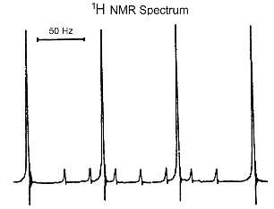

c) Explain why the 11B NMR spectrum of the BH4– ion is a 1:4:6:4:1 quintet with *J*B-H = 85 Hz.

d) The molecular structure of Al(BH4)3 is symmetrical, with all B atoms and the Al atom being in one plane and 120o angles between the three Al–B lines. Each BH4– ion is bonded to aluminum through Al–H–B bridge bonds, and the line through the bridging H atoms is perpendicular to the AlB3 plane. The reaction of Al(BH4)3 with additional BH4– ion produces [Al(BH4)4] –. The 11B NMR spectrum of the ionic compound [Ph3MeP][Al(BH4)4] in solution has a well-resolved 1:4:6:4:1 quintet (with *J* = 85 Hz). At 298 K, the 1H NMR spectrum has a multiplet at 7.5–8.0 ppm, a doublet at 2.8 ppm (J = 13 Hz), and a broad signal at 0.5 ppm. The broad signal remains broad on cooling to 203 K. Interpret this spectrum. (Note that the nuclear spin for 11B is 3/2 and for 31P is ½.)

**Problem 2. Structure of Aluminum Halides**

Aluminum is important in industrial economies as the metal and as a component of alloys. Its compounds are widely used as catalysts in the production of organic compounds and polymers. For example, aluminum chloride (AlCl3) is a catalyst in Friedel-Crafts alkylations. Organoaluminum compounds, such as Al2(CH3)6 and [(C2H5)2AlCl]2, are used in organic synthesis and as components of Ziegler-Natta polymerization catalysts.

A. Aluminum Halides.

a) In the solid state, aluminum chloride, AlCl3, has a layer lattice with six-coordinate aluminum (m.p. = 192 °C; sublimes at 180 °C), but aluminum chloride in the vapor state is a dimer, Al2Cl6. Draw the Lewis structure for the dimer and describe the bonding in this compound using Lewis and VSEPR (valence shell electron pair repulsion) theories.

b) Aluminum bromide, AlBr3, is a low melting solid (m.p. = 98 °C, sublimes at 255 °C), whereas aluminum fluoride, AlF3, has a very high melting point (m.p. = 1291 °C). Is the structure and bonding in aluminum fluoride and aluminum bromide likely to be similar to aluminum chloride?

B. An Organoaluminum Halide

If [(C2H5)2AlCl]2 is treated with NaF, the air-sensitive fluorine analog, [(C2H5)2AlF]x, is isolated. As noted in question A above, aluminum halides are at least dimeric under many conditions, as is (C2H5)2AlCl. Is [(C2H5)2AlF]x also dimeric or could it be monomeric, trimeric, tetrameric, and so on?

c) The molar mass of [(C2H5)2AlF]x was determined by measuring the freezing point depression of a solution in benzene. A 1.097 g sample of the compound dissolved in 65.26 g of benzene had a freezing point of 5.276 °C. (In this experiment, the freezing point of benzene was 5.500 °C, and the calibrated freezing point depression constant was

–5.57 °C /molal.) What is the value of *x* in [(C2H5)2AlF]x?

d) Sketch a possible Lewis structure for [(C2H5)2AlF]x.

**Problem 3. Polyoxoanions of Boron**

Like silicon, boron is found in nature in the form of oxo compounds, and never as the element. Like silicon, boron-oxygen compounds are characterized by great diversity and complexity. In these compounds boron can be bonded to three O atoms in a triangle (as in B(OH)3, BO33– or B3O63–) or to four atoms at the corners of a tetrahedron (as in [BO4]5–).

One of the most important boron-oxygen compounds is the ionic compound borax, whose formula is normally written as Na2B4O7∙10H2O. The compound is used widely in the manufacture of borosilicate glass, glass fiber, and insulation.

Hydrolysis of the borohydride ion (BH4–) produces hydrogen gas and a borate. Because of the possible use of borohydride salts as possible hydrogen storage devices, the aqueous chemistry of borates has again been studied thoroughly.

a) The species in a solution of 0.5 M boric acid, B(OH)3, were recently studied, and a plot of the fraction of total boron species in solution at equilibrium as a function of pH was published. The main species are boric acid as well as B(OH)4–, B4O5(OH)42– (the anion found in the mineral borax), and B3O3(OH)4–.

i. Indicate which curve in the plot below corresponds to a particular boron-oxygen species.

ii. Sketch the structure of each of the four boron-oxygen species above.

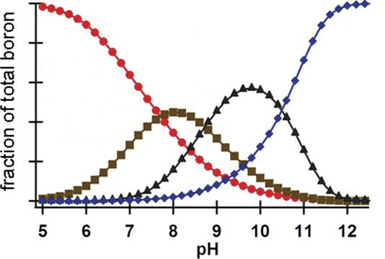

b) Borax is a good primary analytical standard for the titrimetric determination of acids. Others analytical standards of the same kind are anhydrous sodium carbonate and TRIS, (HOCH2)3CNH2. Borax and TRIS react with acids according to the following balanced equations:

Borate ion:

B4O72–(aq) + 2 H3O+(aq) + 3 H2O(l) 🡪 4 H3BO3(aq)

TRIS

(HOCH2)3CNH2(aq) + H3O+(aq) 🡪 H2O(l) + (HOCH2)3CNH3+(aq)

Which primary standard–Na2CO3, borax, or TRIS–will lead to the smallest relative error? Assume there is a weighing error of 0.1 mg in weighing the standard and that you will titrate 40.0 mL of 0.020 M HCl.

**Problem 4. Boron Nitride and Its Solid State Structure**

Boron-nitrogen chemistry has attracted significant attention in part because a B–N unit is isoelectronic with C–C. Furthermore, the radius of carbon and its electronegativity are roughly the average of those properties for B and N.

One of the simplest boron-nitrogen compounds is H3N–BH3, the ammonia-borane adduct. Pyrolysis of this compound leads to the generation of H2 gas and polyborazylene.

H3N–BH3(s) 🡪 2.5 H2(g) + (polyborazylene, BNH)

(If an efficient and low-cost method can be found to regenerate H3N–BH3 from BNH, the substance could be used to generate hydrogen in fuel-cell powered applications.) Further heating polyborazylene results in boron nitride, BN.

Boron nitride exists in several forms, the most common polymorph being one that is similar to graphite. Another, formed by heating the graphite-like form under pressure, has the same structure as zinc blende, ZnS. Boron nitride is thermally and chemically stable and is used in high temperature ceramics. Most recently, layers of the graphite-like form, hexagonal BN, have been combined with sheets of graphene to produce new materials.

a) A model of a portion of hexagonal boron nitride is illustrated below. How is it similar to, or different from, the structure of graphite?

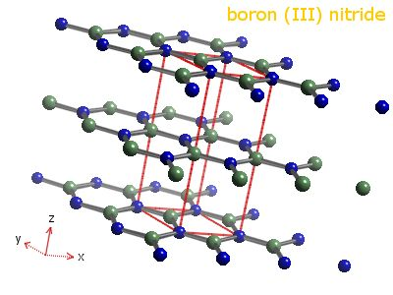

b) The ZnS-like structure of BN, illustrated below, is a face-centered cube of nitrogen atoms with boron atoms in one half of the tetrahedral holes of the lattice. If the density of this form of BN is 3.45 g/cm3, what is the B–N bond length?

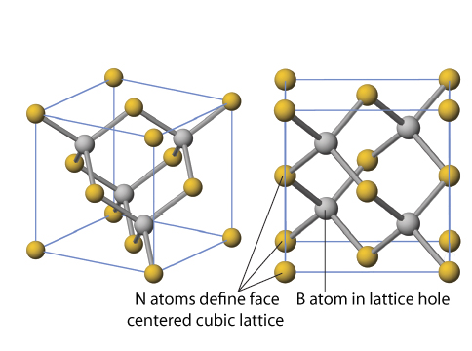

**Problem 5. The Tin Pest: Solid State Structure and Phase Equilibrium**

The ductility and malleability typical of metals has made metals essential structural elements in modern construction. The thermodynamically stable form of elemental tin at 298 K and ambient pressure is *white tin*, which has mechanical properties typical of metals and therefore can be used as a building material. At lower temperatures, however, a second allotrope of tin, *gray tin*, becomes thermodynamically stable. Because gray tin is much more brittle than white tin, structural elements made of tin that are kept at low temperatures for prolonged periods may crumble and fail. Because this failure resembles a disease, it has been termed the "tin pest".

a) Given the thermodynamic data below, calculate the temperature at which gray Sn is in equilibrium with white Sn (at 1 bar = 105 Pa pressure).

|  |  |  |
| --- | --- | --- |
| Substance | ∆fHº (kJ mol–1) | Sº (J mol–1 K–1) |
| Sn (s, gray) | –2.016 | 44.14 |
| Sn (s, white) | 0.000 | 51.18 |

b) Crystalline white tin has a somewhat complex unit cell. It is tetragonal, with *a* = *b* = 583.2 pm and *c* = 318.1 pm, with 4 atoms of Sn per unit cell. Calculate the density of white tin in g cm–3.

c) Gray tin adopts a face-centered cubic structure called the *diamond lattice*, illustrated below. When a crystalline sample of gray tin is examined by X-ray diffraction (using Cu K radiation,  = 154.18 pm), the lowest-angle reflection, due to diffraction from the (111) family of planes, is observed at 2 = 23.74º. Calculate the density of gray tin in g/cm3.



d) The pressure at the bottom of the Mariana Trench in the Pacific Ocean is 1090 bar. Will the temperature at which the two allotropes of tin are in equilibrium increase or decrease at that pressure, and by how much? In your quantitative calculations, you may assume that the energy (E), entropy (S), and molar volume of the two phases of tin are independent of temperature and pressure.

**Problem 6. Silanes: Thermochemistry and Bond Dissociation Enthalpy**

Bond dissociation enthalpies (or bond dissociation energies) are a measure of bond strength in chemical compounds. As such they can be useful in estimating whether a reaction is exo- or endothermic, that is, in estimating the enthalpy change occurring on reaction.

One use of dissociation enthalpies is to determine *element–element bond strength*, a parameter that can often not be measured directly. Here we wish to determine the Si–Si bond strength.

Silicon hydrides SinH2n+2 are called silanes. Most of them contain Si–Si bonds, but they become increasingly unstable as the number of silicon atoms increases.

a) Calculate the Si–Si bond dissociation enthalpy of Si2H6 from the following information:

Bond dissociation enthalpy for H–H = 436 kJ/mol

Bond dissociation enthalpy for Si–H = 304 kJ/mol

∆f*H* [Si(g)] = 450 kJ/mol

∆f*H* [Si2H6(g)] = 80.3 kJ/mol

b) Compare the calculated Si–Si bond energy with that for the carbon-carbon single bond (bond dissociation enthalpy = 347 kJ/mol). What implications does this have for the thermodynamic stability of silanes with *n* = 2 or greater as compared to analogous alkanes?

**Problem 7. Lewis Acid-Base Chemistry**

A unifying idea in chemistry is the theory of acid-base behavior put forward by G. N. Lewis (1875–1946) early in the 20th century. That is, acids are electron-pair acceptors, whereas bases are electron-pair donors. There are thousands of molecules that can be classified as Lewis acids or bases, and hundreds of studies of the quantitative aspects of Lewis acid-base chemistry were carried out in the 20th century. One person deeply involved in such work was H. C. Brown (1912–2004), who received the Nobel Prize (1979) for his work using Lewis base complexes of the Lewis acid borane (such as C4H8O–BH3) in synthetic organic chemistry.

Trisilylamine, N(SiH3)3, like all amines, is potentially a Lewis base. This question explores this function with this interesting compound.

a) The NSi3 framework of the compound is essentially planar. Account for this observation.

b) Consider the following reaction enthalpies, ∆r*Ho*, for acid-base reactions of trimethylborane [B(CH3)3] with given Lewis bases.

**Lewis Base** ∆**r*Ho* (dissociation) (kJ/mol)**

NH3 57.5

N(CH3)3 73.7

N(C2H5)3 about 42

C7H13N (quinuclidine) 83.4



i. Using N(CH3)3 as the reference base, explain why the other Lewis bases have smaller or larger values of the reaction enthalpy.

ii. Explain why trisilylamine does not form a stable complex with trimethylborane.

c) Gaseous (CH3)3NB(CH3)3 is introduced into an evacuated vessel at 100.0 °C to give the initial pressure of 0.050 bar. What is the equilibrium pressure of B(CH3)3 at this temperature? (For the dissociation of (CH3)3NB(CH3)3: ∆dissoc*Ho* = 73.7 kJ·mol–1 and ∆dissoc*So* = 191 J·K–1·mol–1.)

**Problem 8. Nitrogen Oxides: Chemistry, Reaction Equilibrium and Thermodynamics**

Nitrogen oxides play a critical role in atmospheric chemistry. They are produced in internal combustion engines from the high-temperature combination of O2 and N2 in air, and contribute to photochemical smog in many large cities. In the stratosphere, nitrogen oxides contribute to the photochemical degradation of ozone that maintains a steady state of this ultraviolet-absorbing gas. Some of the chemistry of nitrogen oxides is described below.

A. Interconversion of Nitrogen Oxides.

A colorless, gaseous, paramagnetic nitrogen oxide **A** is allowed to react with excess O2, and the mixture passed through a trap at –120 ºC, in which condenses a colorless solid **B**. A sample of **B** (2.00 g) is introduced into a 1.00 L evacuated container and its red-brown vapor equilibrated at various temperatures, giving rise to the pressures recorded below.

T, ºC *p*, atm

25.0 0.653

50.0 0.838

a) Identify compounds **A** and **B**.

b) What chemical reaction takes place when **B** is introduced into the evacuated container? Give ∆*H*º and ∆*S*º values for this reaction.

B. Reactivity of Nitrogen Oxides

Compound **B** (from Part A above) reacts with F2 to form a colorless gas **C**. Compound **C** reacts with gaseous boron trifluoride to form a colorless solid **D**. A 1.000 g sample of compound **D** is dissolved in water and titrated with 0.5000 M NaOH to a phenolphthalein endpoint, which requires 30.12 mL of the titrant.

c) Give structural formulas for compounds **C** and **D**, and explain the results of the titration of **D**.

d) Compound **D** reacts with excess nitrobenzene to give a major organic product **E**. Give the structural formula of **E**.

**Problem 9. Isomerism of Coordination Compounds of Metals**

Transition elements such as iron, copper, platinum, silver, and gold have played a central role in the development of human society. At the end of the 19th century Alfred Werner developed the field of coordination chemistry, and ideas from that field were important in the overall development of modern chemistry. These elements and their compounds are now used in countless ways, and their importance in biology is widely recognized.

1. Isomerism

Coordination compounds exhibit several forms of isomerism.

• *Stereoisomers* are isomers that possess identical constitution, but which differ in the arrangement of their atoms in space. Stereoisomers include optical isomers (enantiomers) and geometric isomers (diastereoisomers).

• *Structural* or *constitutional isomers* have the same empirical formula but differ in their atom-to-atom connections.

a) How many stereoisomers are expected for each of the following four-coordinate, square planar platinum(II) compounds? Draw the structure of each.

i. (PPh3)2PtCl2 (Ph = phenyl);

ii. [Pt(NH3)(pyridine)(NO2)(NH2OH)]+ (The Russian chemist Chernyaev first synthesized the diastereoisomers of this compound in 1926.) (Here both NO2– and NH2OH are N-bonded to the platinum(II) ion);

iii. Pt(en)Cl2 (where en = ethylenediamine, H2NCH2CH2NH2).

b) Draw each stereoisomer of the following octahedral, six-coordinate cobalt(III) and chromium(III) complexes.

i. Co(py)3Cl3 (where py = pyridine);

ii. [Cr(ox)2(H2O)2]– (where ox = oxalate ion, [O2C–CO2]2–);

iii. [Co(en)(NH3)2Cl2]+.

B. Chemotherapy Agents

There has been a concerted effort to find transition metal complexes that can act as drugs in the treatment of cancers. A particularly important recent example is a Ru(III) complex, the anion of which has the formula [Ru(DMSO)(imidazole)Cl4]–. Complexes of DMSO, dimethylsulfoxide [(CH3)2SO], are interesting in part because the DMSO ligand can bind to the metal ion either through the O atom or the S atom.

c) What is the total number of stereoisomers and structural isomers possible for [Ru(DMSO)(imidazole)Cl4]–?

C. OLEDs and an Aluminum Coordination Compound

In an organic light-emitting diode (OLED), a film of an organic compound emits light in response to a current. OLEDs are now used in computer monitors and in the screens on mobile phones and personal digital assistants (PDAs). One molecule used successfully in OLEDs is the aluminum(III) complex of 8-hydroxyquinoline. By incorporating different substituents, different wavelengths of light are emitted.

Macintosh HD:Users:johnkotz:Desktop:Aloxine.eps

8-hydroxyquinoline (C9H6NO) complex of Al3+

This water-insoluble compound is also used in the gravimetric analysis for aluminum in a sample.

d) Assuming octahedral coordination around the Al3+ ion, how many stereoisomers are possible for the complex (C9H6NO)3Al? Sketch the structure of at least one of the stereoisomers.

**Problem 10. Absorption Spectroscopy**

Although *pH* is almost always determined by glass electrode in modern laboratories, situations exist in which optical measurements employing indicators can be used advantageously. One instance is the determination of *pH* in seawater. Because of the high concentration of dissolved salts, electrode-based *pH* determinations in seawater suffer from systematic errors that are too large for some applications. An example is determination of PCO2-driven *pH* changes in the ocean. Anthropogenic CO2 releases cause an annual *pH* shift in North Pacific surface waters of only about –0.0017.

Thymol blue (molar mass 466.59 g·mol–1) is a dye that is a diprotic acid. The concentration of the non-ionized form, H2In0, is negligible near seawater pH and can be neglected. At 298K, the second ionization constant of thymol blue, corrected for the salinity of seawater, is *K*a2 = 10–8.090. Molar absorption coefficients (ελ) of HIn– and In2– at two wavelengths (λ) are as follows:

|  |  |  |
| --- | --- | --- |
| Species | ε436 nm (L·mol–1·cm–1) | ε596 nm (L·mol–1·cm–1) |
| HIn– | 13900 | 44.2 |
| In2– | 1930 | 33800 |

Measurements were made on a sample of seawater contained in a 10.00 cm optical cell:

|  |  |  |
| --- | --- | --- |
|  | Absorbance 436 nm | Absorbance 596 nm |
| Sample alone | 0.052 | 0.023 |
| Sample plus thymol blue indicator solution | 0.651 | 0.882 |

Calculate the *pH* and the molar concentration of thymol blue in the sample. Because the value of *K*a2 has been salinity corrected, activity coefficients should be neglected (i.e., considered to equal 1.000).

**Problem 11. Solution Equilibria**

Lead chromate has been widely used as a paint pigment, although this usage has been curtailed by environmental concerns in recent decades. Both components of this compound are hazardous to human health. Chromate is of particular concern because it is extremely mobile in groundwater. Therefore, humans can be exposed when they drink water from wells that are located at great distances from industrial sources of chromium.

a) Suppose that PbCrO4(s) in a landfill dissolves to equilibrium in a groundwater that has *pH* = 6.000. Using the following equilibrium constants, calculate the equilibrium concentrations of Pb2+, CrO42–, HCrO4– and Cr2O72–.

Quantities in parentheses () below are concentrations in mol·L–1. Assume that activity coefficients of all dissolved species equal 1.00 and therefore can be ignored.

$$K_{sp}=\left({Pb}^{2+}\right)\left({CrO}_{4}^{2-}\right)=2.82∙{10}^{-13}; K_{a2}= \frac{\left(H^{+}\right)\left({CrO}_{4}^{2-}\right)}{{(HCrO}_{4}^{-})}=3.34∙{10}^{-7}$$

$$K_{D}=\frac{\left({Cr}_{2}O_{7}^{2-}\right)}{{(H}^{+})^{2}{(CrO}_{4}^{2-})^{2}}=3.13∙{10}^{14}; K_{W}= {(H}^{+})\left({OH}^{-}\right)=1.00∙{10}^{-14}$$

b) A toxicologist wishes to know at what total dissolved chromium concentration (CrT) the equilibrium concentration of HCrO4– equals that of Cr2O72– in the human stomach. Supposing that stomach fluid can be represented as a dilute solution with *pH* = 3.00, calculate CrT.

**Problem 12. First Order Rate Processes and Radioactivity**

In nature, the long-lived radioactive elements, Th and U, give rise to sequences of shorter-lived radioactive isotopes. If nuclear decay occurs in closed systems, activities of daughter nuclides become equal to parent activities on a time scale related to the daughter’s half-life. Departures from this rule indicate that other processes in addition to radioactive decay are affecting the daughter’s abundance. Opportunities to identify and study the rates of these processes arise.

In water from a lake, the rate of radioactive decay of dissolved 222Rn (half-life, t½, 3.8 d) is found to be 4.2 atoms·min–1·(100 L)–1. All of this 222Rn is produced by decay of dissolved 226Ra (t½ 1600 y), which has an activity of 6.7 atoms min–1 (100 L)–1. These activities do not change measurably with time. Because every atom of 226Ra that decays produces an atom of 222Rn, the deficit in 222Rn activity implies that 222Rn is being lost from the lake by an unknown process in addition to radioactive decay.

a) Calculate the concentration of 222Rn in the lake in units of both atoms (100L)–1 and moles L–1.

b) Supposing that the unknown process obeys a first order rate law, calculate the rate constant for this process in units of min–1.

c) Based on periodic properties of elements, is the unknown process most likely a biological, chemical or physical process?

d) 222Rn decays exclusively by alpha emission. Identify its radioactive decay product (including the mass).

**Problem 13. Kinetics and Mechanisms of Isomerization of an Octahedral Metal Complex**

Coordination complexes of the transition metals can undergo a variety of reactions. Among these are electron transfer, substitution, rearrangement, and reaction at a coordinated ligand. Some of these reactions have been thoroughly studied and their mechanisms are generally well understood. This question examines the kinetics of the isomerization of a six-coordinate complex and uses the steady state approximation to develop rate laws for two possible pathways of reaction.

The *cis* isomer of the cation [Co(en)2Cl2]+ (where en = ethylenediamine) can be converted to the *trans* isomer in the presence of Cl– ion by two possible mechanisms: a) Associative and b) Dissociative.

**Macintosh HD:Users:johnkotz:Desktop:Isomer_mechanism.eps**

a) For each of the mechanisms above derive the rate law using the steady state approximation.

b) Show what happens to each of the rate laws when (i) the first step is rate-limiting and (ii) when the second step is rate-limiting.

c) Derive an equation for the observed rate constant, *k*obs, in each of the four cases.

d) Is it possible to tell which is the rate-determining step in the associative mechanism based on the observed rate law?

**Problem 14. Metal Phthalocyanines: Mechanism of Reduction**

Phthalocyanines and their metal complexes were discovered in 1920 by accident, when 1,2-dicyanobenzene (phthalonitrile) was heated in a copper jar. An amazingly thermally stable blue powder was collected. Besides thermal stability, metal phthalocyanines also have a property of being excellent catalysts of a number of oxidation reactions. This feature of phthalocyanines is due to the ability of the dianionic phthalocyanine (Pc) ligand to stabilize metals in various oxidation states; this is illustrated by the following problem.

1. Given the atom connectivity in a metal-free phthalocyanine molecule provided below, draw the structure of iron(III) phthalocyanine chloride, with a correct pattern of double bonds.



b) Dithionite anion occurs in aqueous solution at equilibrium with its monomer, SO2–, a free radical species. Draw the Lewis structure of dithionite anion and write a reaction of its dissociation into SO2–.

c) Another reduced sulfur species, sodium hydrosulfoxylate, NaHSO2, is also known. Show which common sulfur species can be used to synthesize sequentially both a metal dithionite anion and a hydrosulfoxylate anion using suitable reducing agents.

d) This question concerns the dithionite reduction of phthalocyanine complexes.

i. The following kinetic equation was obtained for the iron(III) phthalocyanine (PcFeIII) reduction to iron(II) phthalocyanine by dithionite:

S2O42– + PcFeIII 🡪 PcFeII + sulfur containing products; the reaction is relatively fast.

rate1 = k [PcFeIII][S2O42–]

ii. By contrast, for the iron(II) phthalocyanine reduction to iron(I) phthalocyanine the following kinetic equation was obtained:

S2O42– + PcFeII 🡪 PcFeI + sulfur containing products; the reaction is very slow.

rate2 = k [PcFeII][S2O42–]0.5.

iii. For cobalt(II) phthalocyanine reduction with dithionite to Co(I) phthalocyanine, yet another kinetic equation could be obtained:

S2O42– + PcCoII 🡪 PcCoI + sulfur containing products; the reaction is slow.

rate3 = k3 [S2O42–]

Propose mechanisms for the reactions above that would allow you to account for the difference in the observed kinetic orders.

**Problem 15. Isotope Effects in Azo Coupling Reactions**

Because chemical reactions depend principally on electrostatics, different isotopes of the same element generally have almost indistinguishable chemical properties. However, when the fractional difference in mass is large, the slight dependence of chemical properties on nuclear mass can result in perceptibly different reactivities. This is most commonly observed with isotopes of hydrogen, with compounds of protium (1H) often displaying quantitatively distinct reaction rates compared with those of deuterium (2H, abbreviated D) or tritium (3H, abbreviated T). In particular, the reduced masses of bonds to hydrogen, and thus the quantum mechanical zero-point energies of vibrations involving these bonds, *E*0 = *h*, where

■ = with *k* being the force constant of the bond to H and  = reduced mass = with *m*1 and *m*2 the masses of the two bonded atoms, depend significantly on the mass of the hydrogen isotope. Heavier isotopes have larger reduced masses and lower zero-point energies. If a bond to hydrogen is broken during an elementary reaction, the vibrational frequency of the bond in the transition state, and hence its zero-point energy, is very low. Since compounds of all hydrogen isotopes therefore have similar or identical energies in the transition state, but heavier isotopes have lower energies in the reactants, compounds of protium will have a smaller activation energy and, therefore, react faster than those of deuterium or tritium. The ratio (*k*H/*k*D), called a *primary kinetic isotope effect* when a bond to hydrogen is broken, is often in the range of 5–8 at ambient temperatures. *Secondary kinetic isotope effects*, where a bond remote to the site of isotopic substitution is broken, are typically much smaller, usually with *k*H/*k*D < 1.4.

Kinetic isotope effects have proven invaluable in the study of reaction mechanisms because of their ability to shed light on the details of processes that make or break bonds to hydrogen. A classic example is the study of the reaction between 2-naphthol-6,8-disulfonate and

4-chlorobenzenediazonium ion to form a highly colored azo dye:



a) Propose a synthesis of 4-chlorobenzenediazonium ion **2** from benzene.

b) Propose a structure for compound **3** (with H in **1**), and explain the selectivity of the reaction.

c) The kinetics of the reaction between compound **1H** (compound **1** with hydrogen substitution) and compound **2** was studied in buffered aqueous solution (*pH* = 6.6) in the presence of variable amounts of pyridine. The reaction was found to be first order in both **1H** and in **2** under all conditions. Describe in detail the experiments by which one could measure the second-order rate constants and determine the order of the reaction in each reagent.

d) In the absence of pyridine, the reaction between **1H** with **2** is faster than the reaction of **1D** with **2** (*k***1H**/*k***1D** = 6.55). In contrast, the analogous reaction between **4** and **5** shows no discernible isotope effect (*k***4H**/*k***4D** = 0.97). Explain these results.



e) The second-order rate constants of reaction of **1H** and **1D** with **2** are tabulated as a function of pyridine concentration in the table below. Account for the variation of rate and isotope effect with [py], both qualitatively and quantitatively. (The pyridine concentrations listed are those of the free-base form of pyridine, they have been corrected for the protonation of pyridine at *pH* 6.6).

|  |  |  |  |
| --- | --- | --- | --- |
| [py], mol L–1 | *k***1H**, L mol–1 s–1 | *k***1D**, L mol–1 s–1 | *k*H/*k*D |
| 0.0232 | 6.01 | 1.00 | 6.01 |
| 0.0467 | 11.0 |  |  |
| 0.0931 | 22.4 |  |  |
| 0.140 | 29.5 |  |  |
| 0.232 | 46.8 |  |  |
| 0.463 | 80.1 |  |  |
| 0.576 | 86.1 |  |  |
| 0.687 | 102. |  |  |
| 0.800 | 106. |  |  |
| 0.905 | 110. | 30.4 | 3.62 |

f) Predict the variation of the rate constant for the reaction of **4H** with **5** as pyridine concentration is increased.

g) Explain the observed variation of the isotope effect of reactions of **1** with the structure of the diazonium salt used (all reactions in the absence of pyridine):

Diazonium ion: 

*k***1H**/*k***1D**: 6.55 5.48 4.78

**Problem 16. Fluorescent Lamps: Heating Inert Gas Atoms by Electrons**

Fluorescent lamps provide around 80% of the world’s needs in artificial lighting. They consume several times less energy per light output than incandescent light bulbs, and hence are important in the fight to reduce world’s energy consumption. Fluorescent lamps are filled with low pressure noble gas, such as argon, and also mercury vapor at even lower pressure. Electrical discharge in fluorescent lamps causes partial ionization of Hg, resulting in emergence of electrons and equal number of ionized Hg atoms. Collisions of electrons with neutral Hg atoms lead to the electronic excitation of the latter atoms, which emit UV light when decaying back to the ground state. The UV light strikes the glass surface of the tube covered with a phosphor, which produces a glow of visible light that we can see.

The electric field between the tube cathode and the anode continuously transfers energy to the electrons. The electrons redistribute the energy among themselves, quickly reaching the temperature on the order of 11,000 K. Similarly, neutral Ar atoms also quickly equilibrate thermally among themselves. However, because of a very large mass mismatch between electronsand argon, collisions between electrons and Ar atoms are extremely inefficient in transferring the electrons’ energy to Ar atoms. Hence, the argon temperature in a tube is much lower than the electrons’ temperature.

Using the steady state approximation, find the steady state temperature of neutral Ar gas in middle column of the fluorescent lamp, given that electrons’ temperature, *T*e, is 11,000 K and the temperature of the outer tube wall, *T*wall, is 313 K.

In all calculations use the following specific parameters describing a typical fluorescent lamp having dimensions of 120 cm in length and 3.6 cm in diameter, and Ar pressure of 3 Torr

(1 Torr = 1 mm Hg; 1/760th of 1 atm pressure).

a) What is the total frequency, , of electron-Ar collisions in the tube having volume of 4.9·10–3 m3 and concentration of free electrons *n*e = 5.0·1017 m–3, if the mean collision time of an electron with Ar atoms is  = 7.9·10–10 s?

b) What is total rate of energy transfer from electrons to Ar in the tube, *J*e-Ar, in Joule·s–1?

Assume that only a small fraction of electron’s energy, *f*e->Ar = 2.5·10–5, is transferred to an Ar atom per single collision, and the average energy of electrons and Ar atoms is $\frac{3}{2}k_{B}T$, where *k*B is the Boltzmann constant and *T* is the corresponding temperature. Note that in a collision between an electron and Ar atom, the energy is transferred in both directions.

Assuming a linear drop of temperature from the tube center of the wall, the total thermal energy transfer rate from heated Ar gas in the middle to the tube wall is

, where Ar is the thermal conductivity of argon,

Ar = 1.772·10–4 J·s–1·m–1·K–1, *R*tube is the tube radius, *R*tube = 3.6 cm, and *S*t indicates the total area of the tube whose length is 120 cm.

c) At the steady state, derive an expression for the temperature of the neutral Ar gas in the fluorescent lamp tube, *T*Ar.

d) Compare the energy loss through the heat transfer by Ar atoms to the tube walls with the total energy input of a 40 W fluorescent lamp (1W = J·s–1 ).

e) Recalculate *T*Ar for the Ar pressures of 1 and 10 atmospheres, respectively. The only change in the parameters above will be in  , which is inversely proportional to the pressure,  ~ *P*–1. The thermal conductivity of Ar, Ar, is independent of pressure in this regime of pressures.

**Problem 17. Molecular Motors**

Molecular motors are ubiquitously used by cells for many purposes, including transporting various cargos from one part of the cell to another. One important motor protein is kinesin, which walks on filamentous tubes called microtubules made of another protein tubulin. In fact, kinesin is an enzyme, an ATPase, powered by hydrolysis of adenosinetriphosphate, ATP.

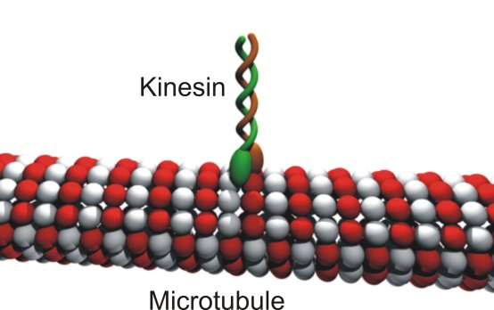

Consider placing a macroscopically long microtubule into a solution of free kinesin, *P*free, with the concentration [*P*free] and assume that there is equilibrium between tubule-bound kinesin (*Pbound*), free kinesin and binding sites (*Site*) available on the surface of the microtubule:

*P*bound  *P*free + *Site*

The occupancy of single binding sites by kinesin molecules is governed by the law of mass action:

$$K_{d}=\frac{\left[P_{free}\right][Site]}{[P_{bound}]}$$

where [*Site*] is the total concentration of binding sites on the microtubule, [*P*bound] is the concentration of the kinesin molecules bound to the microtubule, and *Kd* is the equilibrium constant.

When the kinesin molecule is bound to a microtubule, it moves unidirectionally along its surface with a speed, *v* = 640 nm/s.

Imagine a geometric plane, which is oriented perpendicular to the microtubule and intersects the microtubule at some specific position along the tube. This plane is called a cross section. Estimate the rate of passage of kinesin molecules through an arbitrary cross section of the microtubule in units of kinesin molecules per second. This rate of passage of kinesin molecules is related to the rate at which the microtubule–derived nanomotor moves in one or another direction. Use the following information:

* There are *n* = 16 kinesin binding sites per each *l* = 5 nm length of the microtubule.
* Kinesin molecules move independently of each other.
* Assume that kinesin molecules bound on the microtubule sites and free kinesin molecules in solution are in a dynamic equilibrium.
* Use the following parameters: *Kd* = 0.5∙10–6, [*P*Free] = 100 nM, and [*Site*] = 10 μM.

**Problem 18. Particles in a Box Problem and Conjugated Polyenes**

The energy levels of -electrons in molecules with conjugated bonds can be calculated with varying degrees of accuracy, depending on the complexity of the model. The most sophisticated and accurate approaches involve complex theoretical methods for solving the multi-particle Schrödinger equation. A simplified yet still powerful approach is to treat the -electrons as independent “particles in a box.” This model is useful for determining the energies of -electrons and the electronic spectra of such molecules as ethylene or molecules with conjugated double bonds. In this problem, use the “particle in a box” model to describe the -electron states of ethylene as well as linear and cyclic conjugated molecules.

The particle in a box model yields the energy levels for -electrons by treating them as moving freely along the length of the conjugated -bonds. An example of a hydrocarbon with a non-branched chain of conjugated -bonds is *trans*-1,3,5-hexatriene shown below.



The allowed quantum states occur for electronic wavefunctions that have wavelengths of  = *nL*/2, where *n* is an integer starting with *n* = 1 and *L* is the length of the molecule. The effective molecule lengths are *L* = 289 pm for ethylene and *L* = 867 pm for *trans*-1,3,5-hexatriene. The allowed energy states for the -electrons are given by Eq. 1.

 (Eq. 1)

In Eq. 1, *n* is the quantum number for the energy state and is an integer between 1 and ∞, *h* is the Planck’s constant in J∙s, *me* is the mass of the electron in kilograms and *L* is the length of the box in meters. Use two significant figures for your calculations.

a) Use the particle in a box model to determine the following:

i. the first two energy levels for the -electrons in ethylene;

ii. the first four energy levels for the -electrons in 1,3,5-hexadiene.

b) For each species, fill the energy levels with the -electrons, keeping in mind the Pauli principle for electron pairing. Identify the quantum number *n* of the highest occupied energy level of each species.

c) Use the highest occupied and lowest unoccupied energy levels to predict the wavelength of light that can be used to excite a -electron from the highest energy occupied state to the lowest energy unoccupied state for each species.

d) The molecule in carrots that makes them appear orange is -carotene. Use the particle in a box model to predict the energy gap between the highest occupied state and the lowest unoccupied state. Use this energy to determine the maximum wavelength for absorption of light by -carotene. Use a length for -carotene of *L* = 1850 pm.



*trans*--carotene

Some molecules have cyclic conjugated -systems. Benzene and coronene are examples of such molecules.



For molecules with “circular” -electron distributions, the quantized energy levels are given by Eq. 2.

 (Eq. 2)

In this case, the quantum number *n* has integer values between 0 and ±∞ and *R* is the radius of the ring in meters. Unlike the linear particle in a box problem, the circular problem allows for both positive and negative integer values for *n* for clockwise and counterclockwise motion. Also, for the circular problem, *n* = 0 is an eligible quantum state. For this problem, assume that the ring radii are 139 pm for benzene and 368 pm for coronene.

e) Describe the benzene’s -electron system using the particle-in-the-ring equation for energy levels. Draw a diagram depicting all occupied energy levels as well as the lowest-unoccupied energy level. When building the energy levels, keep in mind the Pauli principle for electron pairing and that there may be several states with the same energy referred to as degenerate states. Make sure that you use the right number of  electrons. Use two significant figures in your answers.

f) Now, draw a similar energy level diagram for coronene and calculate the quantized energy values for the occupied energy levels and the lowest unoccupied energy level. Use two significant figures in your answers.

g) Calculate the energy gaps between the highest occupied and lowest unoccupied energy levels for benzene and coronene.

h) Predict whether benzene or coronene is colored. The recommended way is to determine the longest wavelength of light absorption in nanometers (with two significant figures) for each molecule assuming that the electronic transition responsible for it is one between highest occupied and lowest unoccupied energy levels of each particular molecule.

**Problem 19. Toluene in a Superacid Solution**

Dissolving toluene in a mixture of HF–SbF5generates species **B** which has a temperature dependent 1H NMR spectrum (60 MHz) shown below. The upper figure shows the entire spectrum at –97 oC with the following parameters (chemical shifts are given in the ppm scale, : 9.38 (d, 2H), 8.40 (d, 2H), 5.05 (m, 2H), 3.30 (t, 3H). The lower figure shows the signals from the upper figure in the range of 5–10 ppm as the temperature is raised.



a) Provide a structure for **B** consistent with the –97 °C spectrum.

b) Assign each of the peaks in the –97 °C spectrum to the corresponding proton(s) in your structure for **B**.

c) Provide structures and/or chemical equations that explain why the spectrum changes with increasing temperature. Label your structures.

d) On the basis of the data provided and theoretical considerations, predict qualitatively the relative stabilities of your structures.

e) The peak at 3.30 ppm in the –97 °C spectrum corresponds to a methyl group. Why is it a triplet (*J* = 4.4Hz)?

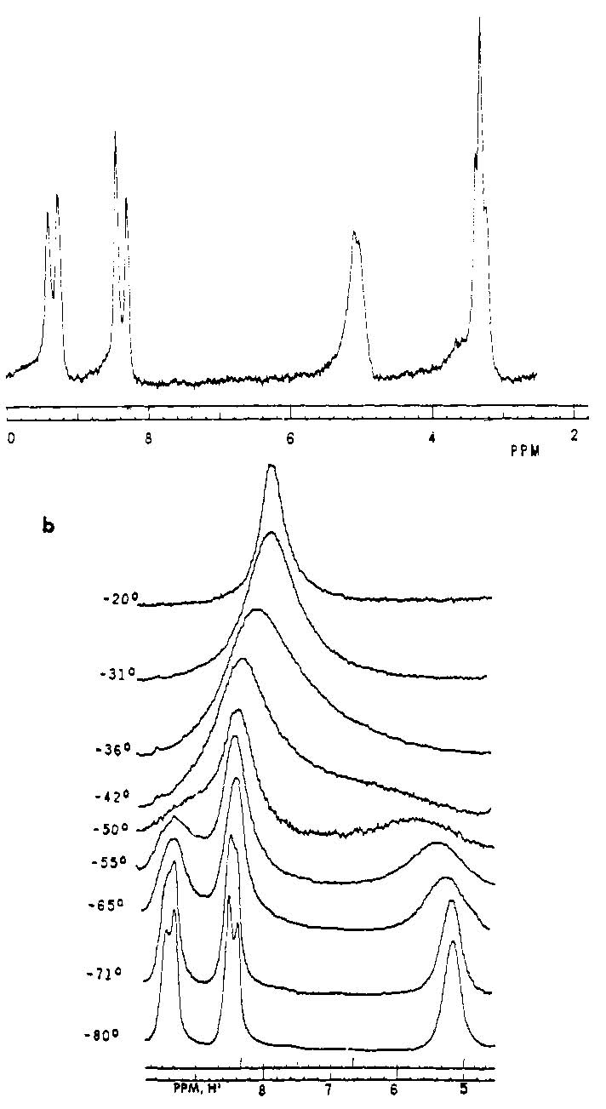

**Problem 20. Mechanism of Catalysis by Lactate Dehydrogenase**

*The structures of the 20 amino acids found in proteins are shown in the Figure at the end of this problem.*

The enzyme lactate dehydrogenase (LDH) catalyzes the reversible reduction of pyruvate anion to lactate anion, with NADH as the reducing agent. The reaction is formally the transfer of hydride ion (H ¯) from NADH to pyruvate:



The enzyme also catalyzes a reaction of sulfite (SO32‑) and NAD+:



The structure of the substrates pyruvate and NADH bound in the active site of LDH is shown schematically in Scheme 1. Several key amino acid residues in the active site are indicated. The dotted lines between fragments of LDH indicate weak intermolecular interactions among groups in the active site.

**Scheme 1**



The *pH* dependence of the rate of the reactions catalyzed by LDH was determined with pyruvate and NADH as the substrates for the forward reaction, and with lactate and NAD+ as the substrates for the reverse reaction. The data indicate the participation in catalysis of a group with *pK*a = 7, which corresponds to His-195 of LDH.

The *pH* vs. reaction rate [log(*k*cat/*K*m)] curves were different depending on whether the rate of the forward (pyruvate + NADH) or reverse (lactate + NAD+) reaction was measured, as shown in Figure below.



a) Which curve in the Figure above corresponds to the reaction with pyruvate and NADH? Which curve corresponds to the reaction with lactate and NAD+?

As shown in Scheme 1, the side chains of Arg-109 and His-195 are very close to the carbonyl group of pyruvate.

b) What type of weak intermolecular interactions exists between Arg-109 and the carbonyl group of pyruvate, and between His-195 and the carbonyl group of pyruvate? What is the electronic basis of this interaction?

The side chain of Ile-250 lies directly below the plane of the dihydronicotinamide ring of NADH (Scheme 1).

c) What type of intermolecular interaction would the side chain of Ile-250 make with NADH?

The function of Arg-109 in catalysis by LDH was investigated by site-directed mutagenesis. Arg-109 was changed to glutamine, and the catalytic activity of the mutant enzyme was studied. The results were:

* The rate of the (pyruvate + NADH) reaction catalyzed by the mutant enzyme was 1400-fold less than the reaction catalyzed by the wild-type enzyme.
* The ability of the mutant enzyme to bind pyruvate in the active site was also reduced, but by only about 15-fold compared to the wild-type enzyme.
* The rate of the reaction of sulfite with NAD+ was unaffected by the mutation.

d) Given the observations above, what is the function of Arg-109 in catalysis by LDH?

The side chain of Asp-168 is thought to interact non-covalently with the side chain of His-195 (see Scheme 1). Two hypotheses were proposed for the function of Asp-168 in catalysis by LDH:

1) The interaction between Asp-168 and His-195 might serve to hold the His-195 in the correct position to interact with pyruvate.

2) The interaction between Asp-168 and His-195 might serve to polarize His-195, which would make His-195 a stronger base.

To test these possibilities Asp-168 was changed to Ala (Mutant 2), and to Asn (Mutant 1), and the catalytic properties of the mutant enzymes were compared to those of the wild-type enzyme.

The results are summarized in the following table:

|  |  |  |  |  |  |
| --- | --- | --- | --- | --- | --- |
| **Constant** | **Wild-type**  (Asp-168) | **Mutant 1** (Asn-168 ) | **Ratio: Wild-type / Mutant 1** | **Mutant 2**  (Ala-168 ) | **Ratio: Wild-type / Mutant 2** |
| **Forward reaction:** | | | | | |
| *K*m (pyruvate), mM | 0.06 | 10 | 0.006 | 3.3 | 0.018 |
| *k*cat, s–1 | 250 | 20 | 12.5 | 5.5 | 45 |
| *k*cat/*K*m,  M–1∙s–1 | 4.2·106 | 2·103 | 2080 | 1.7·103 | 2500 |
|  |  |  |  |  |  |
| **Reverse reaction:** | | | | | |
| *K*m (lactate), mM | 40 | 120 | 0.33 | 80 | 0.5 |
| *k*cat, s–1 | 9 | 0.12 | 75 | 0.09 | 100 |
| *k*cat/*K*m,  M–1∙s–1 | 2.2·102 | 1 | 225 | 1.13 | 200 |

e) Given the facts above, which of the proposed functions, (1) or (2), of Asp-168 is better supported by the data?

The 20 amino acids found in proteins (side chains are shaded in gray).

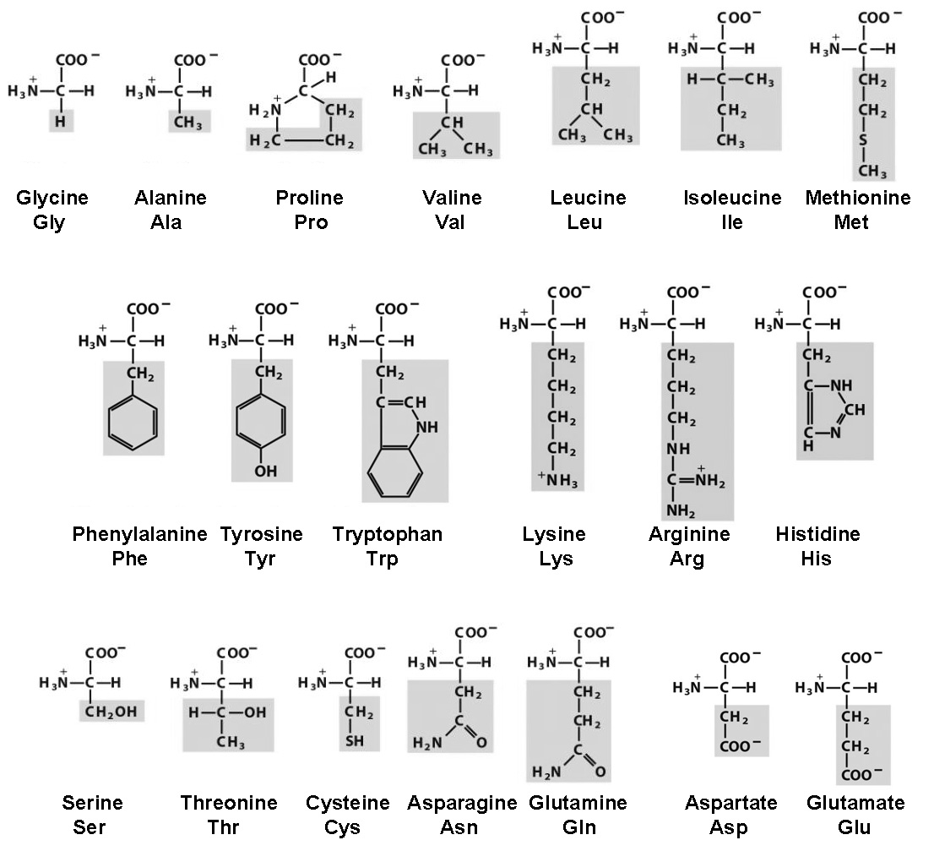

**Problem 21. Substrate Specificity of Subtilisin**

*See the Figure in Problem 20 for the structures and 3-letter abbreviations of amino acids.*

Subtilisin is a serine protease produced by the bacterium *Bacillus amyloliquefasciens* that catalyzes hydrolysis of peptide bonds in proteins:



More generally, serine proteases catalyze transfer of an acyl group from a donor molecule such as an amide or ester RCO‑L, to an acceptor nucleophile such as water, Nuc:



The Figure below shows a schematic of a peptide substrate bound in the active site of subtilisin (the gray surface represents the enzyme itself). Ser221 and His64 are two amino acid residues in the active site that are essential for catalysis of peptide bond hydrolysis.

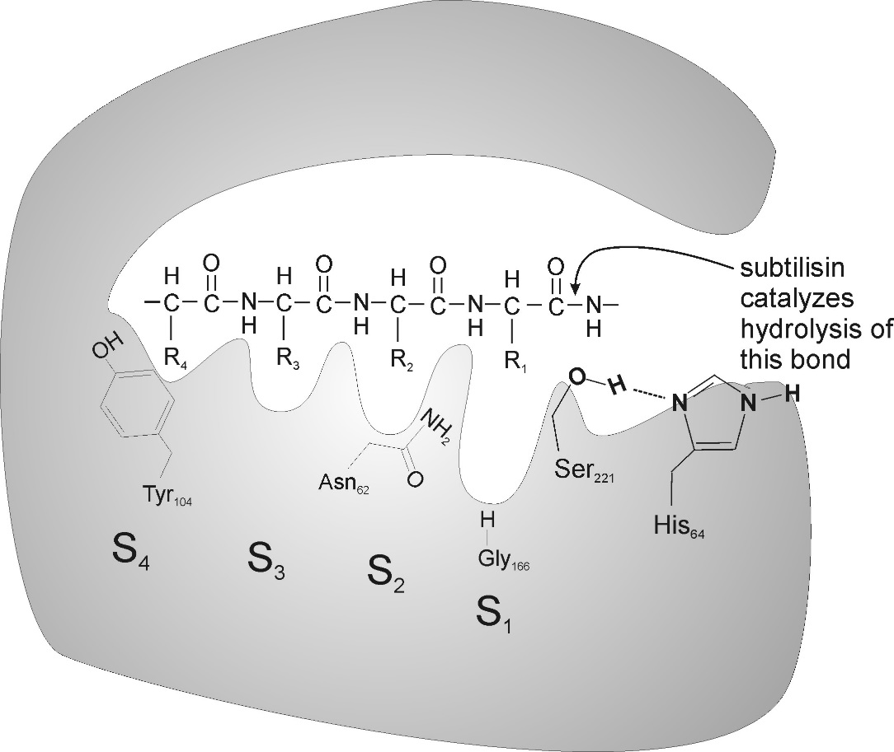

Subtilisin has an extensive substrate binding site in which are bound four amino acid residues on the N-terminal side of the peptide bond that is hydrolyzed. The side chains of these four residues are bound in four “subsites” in the enzyme, called S1–S4. Amino acid residues of subtilisin whose side chains project into the sub-sites are indicated in the Figure above: Gly166 in subsite S1, Asn62 in subsite S2, and Tyr104 in subsite S4. The chemical and structural properties of these residues from the enzyme determine which peptide substrates are bound and hydrolyzed by the subtilisin.

The peptide-*p*-nitroanilide substrate with the sequence: **Ala-Ala-Pro-Phe-*p*-nitroanilide** is hydrolyzed rapidly by subtilisin because the four amino acid residues in the substrate fit well into the binding sub-sites (the Ala-Ala-Pro-Phe residues are bound in subsites S4–S1, respectively).

Site-directed mutagenesis can be used to change residues in the binding subsites of subtilisin to alter the substrate specificity of the enzyme. In one experiment, Gly166 was changed to Ile (Gly166Ile mutant) and the catalytic activity of the mutant enzyme was tested with the following peptide substrates:

I Ala-Ala-Pro-Phe-*p*-nitroanilide

II Ala-Ala-Pro-Ala-*p*-nitroanilide

III Ala-Ala-Pro-Glu-*p*-nitroanilide

IV Ala-Ala-Pro-Tyr-*p*-nitroanilide

a) Which peptide would be hydrolyzed most rapidly (highest *k*cat/*K*m) by the Gly166Ile mutant enzyme?

In a second experiment, residues in subsites S1, S2, and S4, were changed to aspartate, either individually or in combinations. The mutants that were made are:

Mutant 1: Gly166 to Asp

Mutant 2: Gly166 to Asp and Asn62 to Asp

Mutant 3: Gly166 to Asp, Asn62 to Asp, and Tyr104 to Asp

The catalytic activity of the mutant enzymes was tested with the following peptide-*p*-nitroanilide substrates:

I Ala-Ala-Pro-Phe-*p*-nitroanilide

V Ala-Ala-Lys-Phe-*p*-nitroanilide

VI Arg-Ala-Lys-Arg-*p*-nitroanilide

VII Arg-Gly-Lys-Glu-*p*-nitroanilide

VIII Ala-Ala-Pro-Arg-*p*-nitroanilide

IX Ala-Gly-Glu-Arg-*p*-nitroanilide

X Phe-Gly-Lys-Arg-*p*-nitroanilide

XI Leu-Gly-Phe-Arg-*p*-nitroanilide

XII Ala-Ala-Lys-Arg-*p*-nitroanilide

XIII Arg-Gly-Ala-Arg-*p*-nitroanilide

XIV Arg-Gly-Lys-Phe-*p*-nitroanilide

b) Which substrate would be hydrolyzed most rapidly by each mutant enzyme?

**Problem 22. Electro-spray Ionization Mass-spectrometry of Peptides**

The pioneering work of John Fenn (2002 Nobel Prize) on the use of electrospray ionization (ESI) for mass spectrometry opened new possibilities for analyzing biologically important non-volatile molecules. ESI has since been used in numerous biological applications, resulting in emergence of proteomics that aims at large-scale characterization of proteins in organisms.

A bio-analytical chemist considered the use of ESI mass spectrometry to measure the relative abundance of myoglobin in two protein mixtures. Realizing the challenges of whole protein analysis, this chemist decided to reduce the problem to the peptide level. The relative concentrations of a peptide in two samples can be measured by isotope tagging. Consider the analysis scheme described below.

First, the proteins in two samples were digested using trypsin, and the digested samples were lyophilized (the solvent was evaporated, leaving behind the peptides). For isotope tagging of the peptides two methanolic solutions were prepared by dropwise addition of 160 µL of acetyl chloride to methanol cooled in an ice bath using 1 cm3 of CH3OH in one case and 1 cm3 CD3OH in the second case.

a) Write equation(s) for the chemical reaction(s) involved in the preparation of methanolic solutions of acetyl chloride.

The CH3OH solution was added to the digested lyophilized peptide sample 1. The CD3OH solution was combined with digested lyophilized peptide sample 2. After 2 hours both methanolic solutions were evaporated to dryness. 10 µL of 0.1% acetic acid in water was used to dissolve each of the residues and the resulting solutions were mixed. The mixture was then injected into a high-performance liquid chromatography-ESI mass spectrometer where the tagged peptides were separated and detected by a mass spectrometer.

The summary of the workflow is shown below:



b) What chemical modification of peptides occurs in isotopic tagging reactions, resulting in Tag 1 and Tag 2? What is the role of acetyl chloride?

Peptides undergo multiple protonation during ionization to form cations with the overall charge of +1, +2, +3 etc. As a result, a peptide with monoisotopic mass M (molecular mass based on most abundant isotopes of elements) can produce in its ESI mass spectrum signals of [M+H]+, [M+2H]2+, and [M+3H]3+ ions. The ion charge (“charge state”) corresponding to a given peak in a mass spectrum can be determined from the mass-to-charge (m/z) spacing between the isotopic peaks.

A series of peaks corresponding to a tagged peptide in the mass spectrum of the mixture of two samples (Mix 1 and Mix 2) was found at m/z values of 703.9 (100), 704.4 (81), 704.9 (36), 705.4 (61), 705.9 (44), and 706.4 (19). The numbers in parentheses show the relative areas under the peaks.

c) What is the charge state of the tagged peptide in this series of peaks?

d) Identify the monoisotopic peak corresponding to the light isotope tagged peptide and calculate the monoisotopic mass of the tagged peptide based on this peak.

e) Which m/z values have contributions from the heavy isotope tagged peptide?

f) Calculate the monoisotopic mass of the untagged peptide.

Analysis of the peptide mass and fragmentation patterns led the chemist to the conclusion that this series of peaks belongs to a tagged peptide originating from myoglobin.

g) Assuming that ionization efficiency is not affected by isotopes, calculate the relative abundance of myoglobin in the two protein samples using the relative areas of peaks in the series.

h) What would the relative peak intensities be if our chemist used 13CH3OH rather than CD3OH? The isotopic distribution patterns can be assumed to be the same for 12CH3OH and 13CH3OH tagged peptides within the experimental errors of mass spectrometric measurements.

i) Which of the reagents is a better choice for relative quantification of samples: 13CH3OH or CD3OH?

**Problem 23. Persistent Carbenes**

Compounds of the formally divalent carbon atom having two unshared electrons, either paired or unpaired, are known as carbenes. Free or metal–coordinated carbenes are often considered as unstable and short-lived intermediates in a number of organic reactions.

In the 1950s Ronald Breslow proposed that stable carbenes exist as intermediates in reactions involving vitamin B1, which occur in human body. The first persistent (stable) carbenes were isolated in 1990s, and some representatives are shown below. Some stable carbenes now find applications in chemistry, as organocatalysts and ligands, as well as in coordination chemistry of metals, and they are available commercially.



a) Draw Lewis structures for the simplest carbene, CH2, the one in which all the electrons are paired (singlet carbene), and the one where there are two electrons of the same spin (triplet carbene).

b) Draw resonance structures for **I**–**IV** that would help you to account for their persistence.

c) Which other factors may be responsible for the persistence of these species?

d) The triplet carbene CH2 is noticeably more stable than the singlet carbene. In contrast, all the compounds **I**–**IV** above are formally derived from the singlet carbene CH2; their triplet analogs are much less stable and have not been isolated. Why?

e) Fill in the structures of the missing compounds **A**–**D** in the scheme leading to a persistent carbene **D**:



f) A reaction very typical in carbene chemistry is carbene dimerization which may be reversible. Write a reaction scheme for dimerization of **I**.

**Problem 24. The Diels–Alder Reaction**

In 1928, Otto Diels and Kurt Alder first reported the reaction that would eventually carry their names. The reaction between a conjugated diene and a dienophile provides a cyclohexene, as shown in the simplest example below:

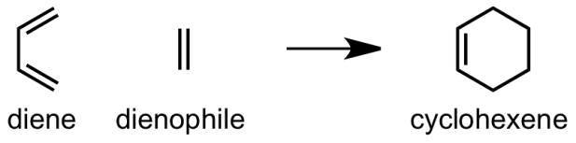

When the reaction partners are substituted, the possibilities increase as asymmetric centers are formed in the reaction. The Diels–Alder reaction is one of the most useful tools available to a synthetic organic chemist.

a) E. J. Corey, a professor at Harvard University and recipient of the 1990 Nobel Prize in Chemistry, employed the Diels–Alder reaction in his landmark synthesis of the prostaglandins. Draw the product of the following reaction and place a star (\*) next to the chiral centres.

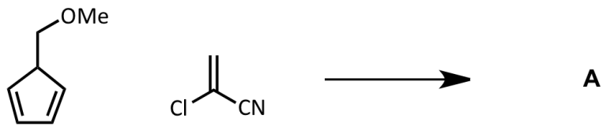

Due to its popularity, many chemists have sought to produce and employ even more useful variants of the reaction. Two of the most straightforward are hetero- and retro-Diels–Alder reactions. In a hetero reaction, one of the carbons in either the diene or dienophile is replaced with a heteroatom (N, O, S, etc.) such that the 6-membered ring of the product is a heterocycle. In the retro-Diels–Alder reaction, a cyclohexene transforms to a diene and olefin.

b) Both of these reactions appear in the following reaction sequence towards pseudotabersonine:

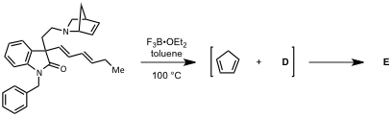

i. Draw the reactive intermediate **D**, as well as the final product of the reaction **E**.

ii. Suggest an “electron-pushing” mechanism for both parts of the transformation.

c) Triazenes are able to provide aromatic rings via a Diels–Alder process. Suggest an electron pushing mechanism for the following reaction. Draw the other two products of the reaction:

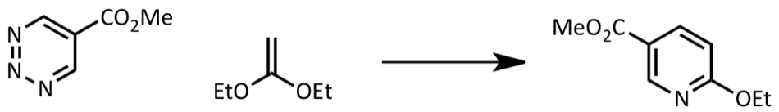

d) Danishefsky’s diene, named for Samuel Danishefsky of Columbia University, contains acid labile functional groups, which can be selectively removed after the Diels–Alder reaction. Draw the missing structures in the scheme of Danishefsky’s synthesis of disodium prephenate:

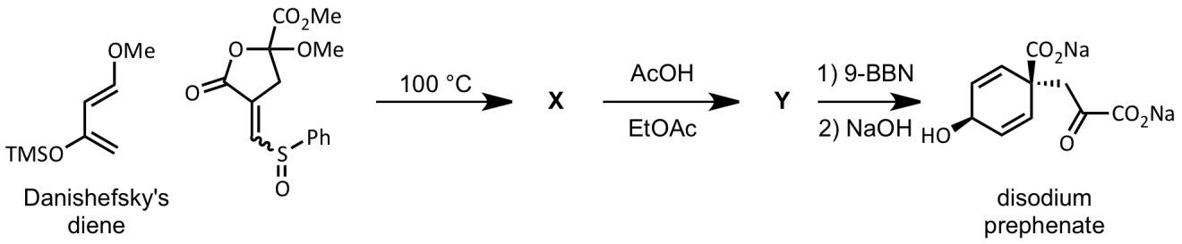

**Problem 25. Pericyclic Reactions and the Woodward–Hoffmann Rules**

A pericyclic reaction is a concerted reaction where formation of new bonds and cleavage of reacting covalent bonds occur simultaneously, without formation of intermediates, via a cyclic transition state. You have already encountered one of the important groups of pericyclic reactions in the previous problem: the Diels–Alder reaction. Inspired by aspects of his work on the synthesis of vitamin B12 in collaboration with Albert Eschenmoser, R. B. Woodward (Nobel Laureate in Chemistry, 1965) began studies with Roald Hoffmann to understand the principals which restrict and determine the outcomes of pericyclic reactions.

Based on deductions from frontier molecular orbital theory, Woodward and Hoffmann devised a set of rules, for which Hoffmann won the Nobel Prize in Chemistry in 1981, along with Kenichi Fukui who independently reached similar rules via an alternative methods. These chemists realized that for thermally–driven chemical reactions, the highest occupied molecular orbital (HOMO) was the relevant orbital; in photochemically–driven reactions, in contrast, an electron is excited from the HOMO by light to the lowest unoccupied molecular orbital (LUMO), making this the relevant orbital.

Two types of reactions governed by the rules are the Diels–Alder reaction (an example of cycloaddition) and electrocyclic reactions. For electrocyclic reactions, the Woodward–Hoffmann rules are:

|  |  |  |
| --- | --- | --- |
| Number of -Electrons Involved in the reaction | Thermal | Photochemical |
| 4*n* | Conrotatory | Disrotatory |
| 4*n*+2 | Disrotatory | Conrotatory |

These rules predict the stereochemical course of reactions as shown:

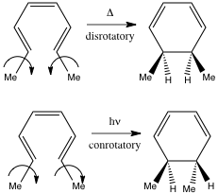

a) Based on these rules, predict the stereochemical outcome of the following electrocyclic reactions:

i.

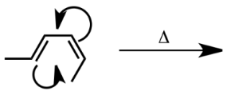

ii.

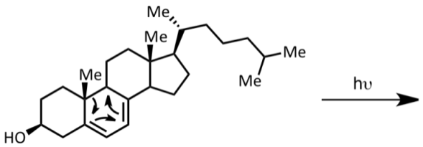

b) These reactions are employed by nature in the synthesis of a class of natural products called the endiandric acids. All of the reactions shown below are either electrocyclic or cycloadditions (Diels–Alder).

i. Draw the missing structures (**Y**, **Z**, endiandric acids **F** and **G**) in the scheme below.

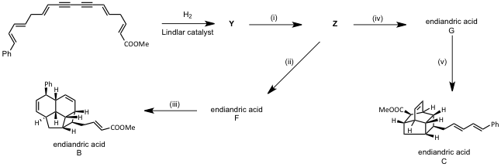

ii. Fill in the table for reactions (i)–(v):

|  |  |  |  |  |
| --- | --- | --- | --- | --- |
| Reaction | Diels–Alder? | electrocyclic? | Number of π electrons | *con*- or *dis*-rotatory |
| i |  |  |  |  |
| ii |  |  |  |  |
| iii |  |  |  |  |
| iv |  |  |  |  |
| v |  |  |  |  |

Another interesting result of pericyclic reactions can be found in the bullvalene family of compounds. The relevant type of rearrangement is the Cope rearrangement, the archetype of which is shown below:

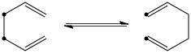

Although the compounds on both sides of the equilibrium are 1,5-hexadiene, the 13C atoms (shown as bold dots) show the movement of the electrons, and subsequently relocation of the bonds.

In this synthesis of polyketide natural products, one employs a Claisen rearrangement (similar to the Cope reaction but with one carbon in the starting material replaced with an oxygen) and electrocyclizations.

c) This synthesis of the polyketide natural product, SNF4435 C, features a Claisen rearrangement (similar to the Cope reaction but with one carbon in the starting material replaced with an oxygen) and electrocyclizations.

i. Draw the structures of the missing products in the scheme below:

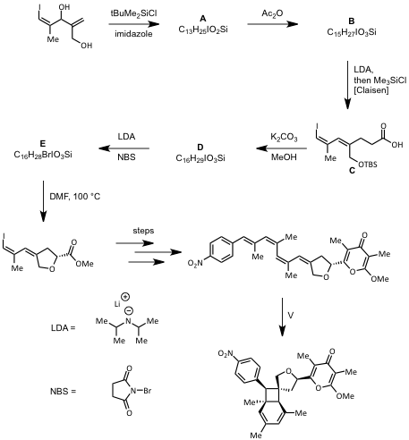

ii. How many electrocyclizations occur during the step labeled V, which is carried out under thermal conditions? Identify each cyclization by the number of -electrons involved and as con- or dis-rotatory.

**Problem 26. Synthesis of Tetracycline**



Tetracycline is a broad spectrum antibiotic that is active against penicillin-resistant Gram-positive bacterial organisms. The first synthesis of a tetracycline was reported by R. B. Woodward (Harvard University) and the Pfizer Pharmaceutical Company in 1962. Three of the four rings were synthesized by the following steps.

Complete the reactions and identify the structures of compounds **A**–**I**.

*Hints*: (1) the conversion of **E** to **F** involves only one methanol reactant; (2) compounds **A, B, C, D**, and **E** have proton NMR spectra with two hydrogen signals above 7.8 δ; these absorptions are not present in compounds **G, H**, and **I**.

*Note*: psi = pound per square inch; 1 psi equals 6,894.76 Pascals.



**Problem 27. Synthesis of Antiviral Drugs**

An important class of molecules comprised of both natural and designed products is the iminosugars. While not true carbohydrates, they are able to mimic sugars, acting as inhibitors of many enzymes. Due to this ability, they have been shown to have significant activity as antivirals, as well as in treatments of some genetic disorders such as Gaucher’s disease. Inspired by the significant activity, a number of synthetic organic chemists have pursued these targets. Consider two syntheses of the glucose mimic, DNJ.

a) Draw structures of the missing intermediates along their route, **A**–**D**:





b) i. Draw the missing intermediates in the synthesis, **J**–**P**.

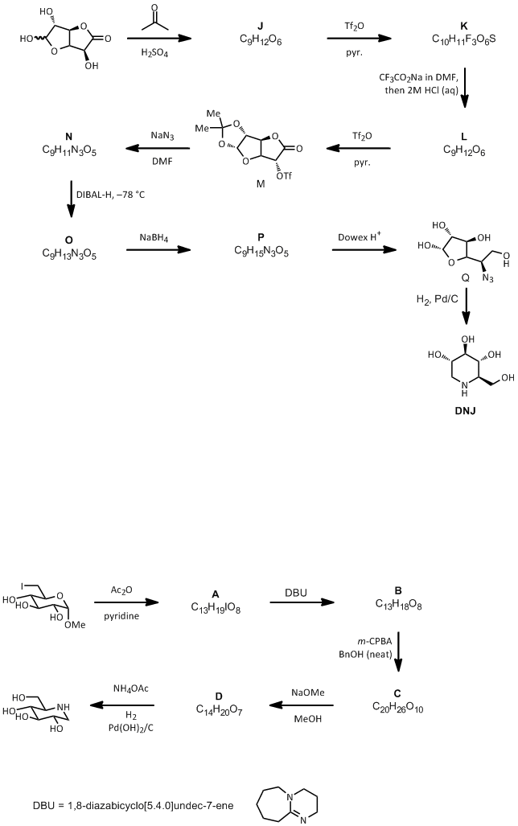

ii. The triflate group (Tf) transforms a hydroxyl group into a better leaving group. Rank the following groups in terms of leaving group ability from best (1) to worst (5).

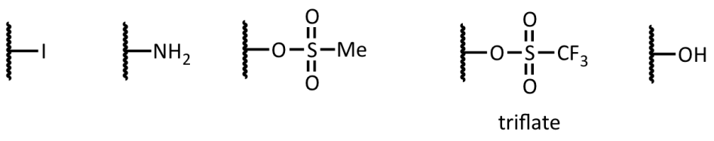

iii. Although it occurs in a single flask, the transformation of **Q** to DNJ can be considered to occur in 3 distinct steps. Suggest structures for the two intermediates **Q'** and **Q"** that arise as the reaction proceeds:

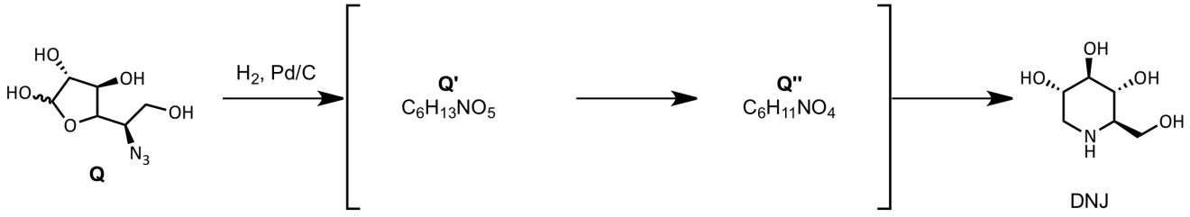

c) Rather than the organic solvents required for the two syntheses of DNJ, the synthesis of this furanose-mimicking iminosugar employs only water as the solvent–a fact which makes the synthesis cheaper and greener. Draw the missing structures for the intermediates, **X** and **Y**, that can be isolated as individual compounds and for the transitive intermediate, **Z.***Hint*: In this case, the tungsten catalyst selectively provides the (*S*, *S*) epoxide of the remaining olefin.

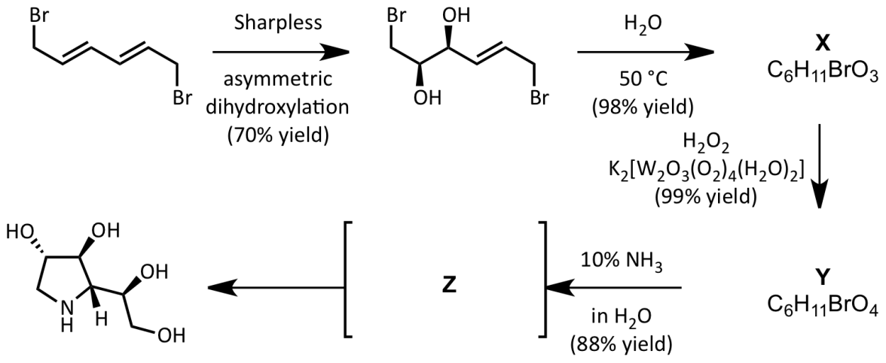

**Practical Problems**

**Safety**

The participants of the Olympiad must be prepared to work in a chemical laboratory and be aware of the necessary rules and safety procedures. The organizers will enforce the safety rules given in *Appendix A* of the IChO Regulations during the Olympiad. The Preparatory Problems are designed to be carried out only in a properly equipped chemistry laboratory under competent supervision. Since each country has own regulations for safety and disposables, detailed instructions are not included herein. Mentors must carefully adapt the problems accordingly.

The safety (S) and risk (R) phrases associated with the materials used are indicated in the problems. See the Appendix A and B of the Regulations for the meaning of the phrases. The Regulations are available on the website <http://www.icho2012.org/> . Safety cautions for the practical questions must be provided by the Mentors. Major cautions are:

• Use fume hoods if indicated.

• Safety goggles, a laboratory coat and rubber gloves should be worn **at all times in the laboratory**.

• Never pipette solutions using mouth suction.

• Dispose of reagents into the appropriate labeled waste containers in the laboratory.

**Problem 28. Analysis of Sodium Sesquicarbonate (Trona)**

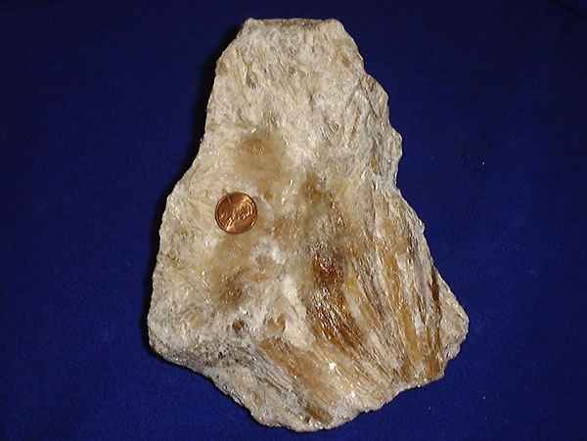

An image of trona

The common mineral trona, sodium sesquicarbonate, is used in detergents and in glass making. The mineral is composed of sodium carbonate, sodium bicarbonate, and water [*x*Na2CO3∙*y*NaHCO3∙zH2O]. The objective of this experiment is to determine the formula of the mineral.

To determine the formula, three experiments can be done. The first is the titration of a sample of the compound to determine the relative amounts of carbonate and bicarbonate ions.

*x* CO32–(aq) + *x* H+(aq) 🡪 *x* HCO3–(aq)

(*x + y*) HCO3–(aq) + (*x + y*) H+(aq) 🡪 (*x + y*) H2CO3(aq)

A second experiment can be done in which the sample is thermally decomposed to sodium carbonate, carbon dioxide, and water.

*x*Na2CO3∙*y*NaHCO3∙*z*H2O(s) 🡪 [*x* + (*y*/2)] Na2CO3(s) + (*y*/2) CO2(g) + [(*y*/2) + *z*] H2O(g)

Finally, a third experiment can be done in which the sample is reacted with aqueous HCl.

*x*Na2CO3∙*y*NaHCO3∙*z*H2O(s) + (2*x + y*) HCl(aq) 🡪

(2*x + y*) NaCl(aq) + (*x + y*) CO2(g) +6y (*x + y + z*) H2O(liq)

Combining the results of these three experiments will give the values of *x, y*, and *z*.

Note: This experiment was adapted from N. Koga, T. Kimura, and K. Shigedomi, *J. Chem. Educ.,* **2011**, *88*, 1309.

**Chemicals and Reagents**

• Sodium sesquicarbonate

• HCl (aq), hydrochloric acid

• Indicators for titration (phenolphthalein and methyl orange)

**Table of Chemicals:**

|  |  |  |  |
| --- | --- | --- | --- |
| ***Compound*** | ***State*** | ***S-Phrase*** | ***R-Phrase*** |
| Sodium sesquicarbonate | Solid, 5 g | 2 22 26 | 36 37 38 |
| HCl(aq) for titration | Solution in water, 50 mL; ~0.10 M (standardized) | 26 36 37 39 45 | 23 25 34 38 |
| HCl for decomposition reaction | Solution in water, ~1 M, 100 mL | 26 36 37 39 45 | 23 25 34 38 |

**Equipment and Glassware:**

* Analytical balance (± 0.0001 g)
* Volumetric flask, 100 mL
* Volumetric pipette, 10 mL
* Pipette bulb or pump
* Erlenmeyer flask, 100 mL (3)
* Burette, 50 mL
* Burette stand
* Hot plate
* Ice water bath
* Bunsen burner
* Crucible
* Crucible tongs
* Beaker, 100 mL (3)

***Directions:***

***A. Titration of Sodium Sesquicarbonate (SSC) with Hydrochloric Acid***

*All mass measurements should be done to the maximum allowed number of significant figures.*

In this portion of the experiment you will determine the relative amounts of carbonate ion and bicarbonate ion in a sample of SSC. You will titrate a sample with standardized HCl to a phenolphthalein endpoint, which indicates when the carbonate ion has been converted to bicarbonate ion.

*x* CO32–(aq) + *x* H+(aq) 🡪 *x* HCO3–(aq)

Then the resulting solution is further titrated with standardized HCl to a methyl orange endpoint where bicarbonate ion, from the SSC sample and from the first titration step, has been titrated.

(*x + y*) HCO3–(aq) + (*x + y*) H+(aq) 🡪 (*x + y*) H2CO3(aq)

1. Dissolve a weighed amount of SSC (about 2.5 g) in distilled water in a 100.0 mL volumetric flask. Mix thoroughly and fill with water up to the mark.
2. Transfer 10.0 mL of the SSC solution to a small Erlenmeyer flask using a 10 mL transfer pipet.
3. Add several drops of phenolphthalein solution to the titration sample.
4. Titrate the sample using standardized HCl (~0.1 M, known exactly) until the solution turns colorless. Record the volume of the standard solution of HCl required for the titration as V1 mL.
5. Add several drops of methyl orange indicator to the solution from step 4. (The solution will become light yellow.)
6. Titrate the sample solution with standardized HCl until the solution turns red or red-orange. (Note: Students often have problems seeing the methyl orange end point. You should consider doing a test sample before trying to carry out an exact titration.)
7. Add boiling chips to the sample solution and heat the solution to boiling for 1 or 2 min. Cool to room temperature (using a water bath). If the sample solution turned back to yellow, repeat the procedures (6) and (7). If the red coloration did not change, record the volume of the standard solution of HCl required for the second titration as V2 mL.
8. Repeat the procedures (2)–(7).

***B. Thermal Decomposition of Sodium Sesquicarbonate***

In this portion of the experiment you will determine the percent mass loss on heating a sample of sodium sesquicarbonate. You can combine the results of the thermal decomposition with the titration results in Part A to determine *x, y*, and *z*.

1. Record the mass of a crucible or small evaporating dish.
2. Add approximately 1 g to the crucible or evaporating dish and then weigh the sample and dish or crucible precisely.
3. Gently heat the crucible or evaporating dish with a burner flame for 3 min. Then heat with a hotter flame until decomposition is complete. (Be careful that solid pieces do not escape the dish.)
4. After cooling the crucible or dish to room temperature, determine the total mass precisely.
5. Repeat the steps (1)–(4).

***C. Reaction of Sodium Sesquicarbonate with Acid***

In the third portion of the experiment you will confirm a value for *z* in *x*Na2CO3∙*y*NaHCO3∙*z*H2O by decomposing the sample with acid and calculating the percent mass loss in that reaction.

1. Weigh about 0.5 g of SSC (s) and record the mass precisely.
2. Transfer about 20 mL of 1 M HCl into a beaker and record the total mass of beaker and HCl precisely.
3. Add SSC to the dilute HCl little by little, avoiding splashing of the solution.
4. After adding all the SSC, allow the solution to stand for 5 min or so.
5. Record the total mass of the beaker and the resultant solution precisely.
6. Repeat the procedures (1)–(5).

***Treatment of Data***

Use the results of the three experiments to calculate *x, y*, and *z* in *x*Na2CO3∙*y*NaHCO3∙*z*H2O.

**Problem 29. Analysis of Copper in a Nickel Coin**

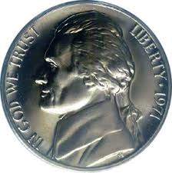 

United States nickels ($ 0.05 coins) consist of an alloy of nickel and copper (called “cupronickel”). Cupronickel alloys of similar composition are used for production of coins is some other countries. In this experiment you will determine the exact mass percentage of copper in a coin made of a copper-nickel alloy by dissolving the coin in nitric acid and determining the dissolved Cu(II) by iodometric titration.

**Materials**

• US nickel ($0.05 coin) or other material made of a cupronickel alloy.

• Nitric acid solution, HNO3 (aq), 8 mol∙L–1

• Sodium thiosulfate pentahydrate, Na2S2O3∙5H2O

• Potassium iodide solution, KI, 10% w/v

• Starch solution, 2% w/v

|  |  |  |  |
| --- | --- | --- | --- |
| ***Compound*** | ***State*** | ***S-Phrase*** | ***R-Phrase*** |
| HNO3(aq), 8 M | Aqueous solution | 1/2 23 26 36 45 | 8 35 |
| Na2S2O3·5H2O | Solid | 24 25 | 36 37 38 |
| KI | 10 % | 26 36 37 39 45 | 36 38 42 43 61 |

**Apparatus and Glassware**

• Analytical balance (± 0.0001 g)

• Hotplate

• Erlenmeyer flasks, 250 mL and 125 mL

• Volumetric flask, 100 mL

• Volumetric pipet, 1.00 mL

**Procedure**

1. Weigh the coin and then dissolve it by placing it in a 250 mL Erlenmeyer flask and then carefully adding 40 mL nitric acid solution. Heat the flask on a hotplate while the dissolution takes place, over ~20 min (the flask should be in a fume hood, as NO2 gas is evolved). After dissolution of the coin is complete, continue to boil the solution for 20 min, then allow the flask to cool to room temperature. Dilute the solution to 100.00 mL with distilled water.
2. While the nickel is dissolving, make up 50 mL of ~0.04 mol∙L–1 sodium thiosulfate solution. You will need to know the exact concentration of this solution; commercial crystalline Na2S2O5∙5H2O is sufficiently pure that the concentration can be determined accurately from its mass. The thiosulfate solution should be made up fresh on the day of the titration, as it degrades over time.
3. Into a 125 mL Erlenmeyer flask add 15 mL 10% (w/v) KI solution, then 1.00 mL of the diluted copper-containing solution.
4. Titrate the yellow-orange slurry with the sodium thiosulfate solution until the color has faded to pale yellow. Then add 1 mL of the starch solution and titrate to the starch endpoint. At the endpoint, the mixture should be milky and white or very pale pink. The titration can be repeated on a fresh aliquot of the copper-containing solution, and the results averaged, for improved precision.

**Questions and Data Analysis**

1. Give balanced chemical equations for the reactions that take place when:

i. The coin dissolves in nitric acid.

ii. The copper/nickel/nitric acid solution is added to the potassium iodide solution.

iii. The sodium thiosulfate solution is titrated into the mixture.

1. Calculate the mass percentage of copper in the coin.
2. If the coin is dissolved at room temperature, and the boiling step is omitted, then the amount of copper is overestimated, and the endpoint is not stable (the mixture turns white, but then spontaneously turns purple again within a few seconds). Explain why.
3. The Canadian nickel coin is mostly steel, with nickel plating and a small amount of copper. Could this procedure be used to analyze the copper content of a Canadian nickel coin? Explain why or why not.

**Problem 30. Synthesis and Analysis of Iron Oxalate Complex**

Iron is one of the most important transition metals used in industry. The ability of iron to readily change its oxidation state accounts for numerous applications of this metal in chemical and biochemical redox processes. The most common oxidation states of iron are +2 and +3; in both of these oxidation states, the metal can bind to several (usually up to six) donor atoms, such as the nitrogen atoms in various amines or organic heterocycles, the oxygen atoms in water or hydroxide ion, and carboxylates and other similar molecules or anions. In this experiment, an iron(III) oxalate complex will be prepared in two steps from an iron(II) precursor. Iron(III) oxalate complex is an interesting compound, in particular, because it is photosensitive. This compound is used in chemical actinometry for determining the number of photons that passes through the system. Upon exposure to visible or UV light, green crystals of iron(III) oxalate complex gradually decompose into a yellow-orange product.

Upon reacting an iron(II) salt with an oxalate, followed by oxidation in the presence of excess oxalate, one of three possible iron(III) oxalate complexes could be produced:



The number of oxalate ligands in the iron(III) oxalate complex synthesized in the present experiment will be determined by titration with potassium permanganate solution.

**Chemicals and Reagents**

* Ferrous ammonium sulfate hexahydrate, (NH4)2[Fe(H2O)2(SO4)2]∙6H2O
* 6 M H2SO4(aq)
* Oxalic acid (H2C2O4), 1M solution (or solid, H2C2O4∙2H2O)
* Potassium oxalate , K2C2O4, 2 M solution (or sodium oxalate, Na2C2O4, 2 M solution)
* Aqueous hydrogen peroxide, H2O2, 6% solution
* Ethanol, C2H5OH
* KMnO4 solution (~0.02 M)

|  |  |  |  |
| --- | --- | --- | --- |
| ***Compound*** | ***State*** | ***S-Phrase*** | ***R-Phrase*** |
| (NH4)2[Fe(H2O)2(SO4)2]·6H2O | Solid | 24/25 | 36/37/38 |
| H2SO4(aq) , 6 M | Solution in water | 26 30 45 | 35 |
| H2C2O4·2H2O | Solid | 24/25 | 21/22 |
| K2C2O4, 2 M | Solution in water | 24/25 | 21/22 |
| H2O2 | 6 % solution in water | 1/2 17 26 28 36/37/39 45 | 5 8 20 22 35 |
| C2H5OH | Liquid | 7 16 24 25 36 37 39 45 | 11 20 21 22 36 37 38 40 |
| KMnO4, 0.02 M | Solution in water | 60 61 | 8 22 50 53 |

**Equipment and Glassware**

* Erlenmeyer flasks, 125 mL (2), 50 mL (1), 25 mL (3)
* Pasteur pipettes and rubber pipette bulbs
* Hot plate
* Graduated cylinder, 25 mL
* Hot water bath
* Ice water bath
* Conical funnel, paper filters
* Fritted funnel for vacuum filtration
* Setup for vacuum filtration (stand, clamps to secure flasks, aspirator, filtering flask, conical rubber adaptor).
* Burette, 10 mL, with burette stand
* Small funnel to fill the burette

**A. Preparation of iron(III) oxalate complex.**

**Part A, Step 1**

a) In a 25 mL Erlenmeyer flask, dissolve 1.0 g of ferrous ammonium sulfate hexahydrate, (NH4)2Fe(SO4)2∙6H2O, in 3 mL of H2O to which has been added 3 drops of 6 M H2SO4.

2. While continuously swirling the flask, add 5.0 mL of 1 M oxalic acid (H2C2O4), and carefully heat the mixture to boiling (it is important to continuously swirl the flask while heating). Remove the flask from the hot plate and let the solid settle to the bottom of the flask.

3. Separate the solid product from the liquid by decantation: Do not disturb the solid product on the bottom of the flask. (Transfer the liquid to an Erlenmeyer flask and label as *Liquid Waste*). To wash the solid product, add ~3 mL of hot water to the flask (heat water in the Erlenmeyer flask up to about 80 oC on a hot plate), swirl the mixture, allow the mixture to settle and pipette off the liquid layer without disturbing the solid product (transfer liquid to the *Liquid Waste* container). Repeat the washing step one more time.

**Part A, Step 2**

1. To the wet solid, add 2 mL of 2 M potassium oxalate (K2C2O4).
2. With the flask in a 40 oC water bath, carefully add 2 mL of 6% H2O2 (continuously swirl the flask).
3. Transfer the flask to a hot plate, add 1.5 mL of 1 M oxalic acid (H2C2O4), and bring the mixture to a boil. Let the mixture boil for 1 min.
4. Remove the flask from the heat and cool to room temperature.
5. Separate the solid from the liquid using gravity filtration (collect the filtrate in a clean, 50-mL Erlenmeyer flask).
6. Cool the filtrate in an ice-water bath. To precipitate the product from the solution, add 8 mL of ethanol to the filtrate and swirl the flask.
7. Collect the solid product by vacuum filtration.
8. Air-dry the crystals (alternatively, dry the crystals between two sheets of filter paper).
9. Transfer the dry crystals to a clean, dry pre-weighed vial. Determine the mass of crystalline iron(III) oxalate complex produced.

**Part B. Analysis of Iron (III) Oxalate Complex**

**Part B, Step 1** *Standardize the ~0.02 M KMnO4 solution.*

1. Place ~0.02 M KMnO4 solution into a 10 mL burette. Into a 125-mL Erlenmeyer flask, add about 0.020 g of precisely weighed sodium oxalate. To this Erlenmeyer flask, add 20 mL of water and 5 mL of 6 M sulfuric acid (H2SO4). Warm up the content of the flask in a hot water bath (maintained at ~80 °C).
2. Titrate the sodium oxalate solution using the ~0.02 M KMnO4 solution; stop the titration when addition of the last drop of KMnO4 changes the color of the titrated solution to light-pink, and the color persists for ca. 1 minute. Record the volume of KMnO4 used for this titration, and determine the molarity of KMnO4 solution.

**Part B, Step 2**

1. Into a 125 mL Erlenmeyer flask, add ~0.020 g of the precisely weighed iron(III) oxalate product obtained in Part A. To this Erlenmeyer flask add 20 mL of water and 5 mL of 6 M sulfuric acid (H2SO4). Warm the content of the flask in a hot water bath (maintained at ~80 °C).
2. Titrate the hot solution in the flask with potassium permanganate of known concentration until a slight pink color that persists for ~30 sec. (use the solution standardized in Part B, Step 1). Record the volume of permanganate used for titration.

**Data Treatment**

1. Write down the equation of the chemical reaction that occurs in Part A, Step 1. Explain the role of sulfuric acid in this preparative procedure.
2. Calculate the percentage of oxalate in the iron(III) oxalate complex. Determine the composition of the synthesized iron(III) oxalate complex (select one of three possible structures provided in the Introduction).
3. Calculate the yield of iron(III) oxalate complex you obtained in Part A.
4. Write balanced equations of chemical reactions that were used in Part B, Step 2.

**Problem 31. Synthesis and Reduction of an Imine: Green Synthesis of a New Compound**



This reaction is an example of a green synthesis of an organic compound. The new functional group you will generate is important in many physiological processes as well as a crucial synthetic intermediate for a variety of drugs (e.g., Zetia® for lowering cholesterol, and Gleevec® and Taxol® for treating cancer). These three drugs alone grossed over $6 billion in 2006, the most recent year for which data were accessible.

The compounds you are making are traditionally synthesized in solvents such as dichloromethane or toluene over the course of many hours, often while boiling the reaction solution the entire time. In contrast, you are performing these same reactions using a benign solvent with reaction times of less than 15 min at room temperature. Our solvent, ethyl lactate (EL), is derived from renewable resources and is biodegradable. These reactions have been optimized previously by adjusting the polarity of the EL with water to attain the best combination of product quality and reaction speed. A few drops of lactic acid (LA), an acid found naturally in dairy products and in fatigued muscles, is used as a catalyst in some of the reactions.

**Chemicals and Reagents**

* Ethyl lactate
* Lactic acid
* Sodium chloride
* Substituted aniline (see below)
* Substituted aldehyde (see below)
* Ethanol
* Sodium tetrahydridoborate
* Methanol
* Hydrochloric acid (6 M)
* Dichloromethane
* TLC solvent: 50:50 ethyl acetate/hexanes

**Table of Chemicals:**

|  |  |  |  |
| --- | --- | --- | --- |
| ***Compound*** | ***State*** | ***S-Phrase*** | ***R-Phrase*** |
| Ethyl lactate | Liquid | 2 24 26 39 | 10 37 41 |
| Ethanol | Liquid | 7 16 24 25 36 37 39 45 | 11 20 21 22 36 37 38 40 |
| Methanol | Liquid | 1/2 7 16 36/37 45 | 11 23/24/25 39/23/24/25 |
| Sodium tetrahydridoborate | Solid | 22 26 36 37 39 43 45 | 25 34 43 |
| HCl | 6 M aqueous | 26 36 37 39 45 | 23 25 34 38 |
| Dichloromethane | Liquid | 23-24/25-36/37 | 40 |
| *p*-Anisidine | Solid | 45 53 | 45 23/24/25 68 |
| *p*-Bromoaniline | Solid | 26 36/37/39 | 20/21/22 36/37/38 |
| *p*-Chloroaniline | Solid | 53 45 60 61 | 23/24/25 43 45 50/53 |
| *p*-Ethoxyaniline | Liquid | 28 36/37 45 | 23/24/25 33 |
| *p*-Fluoroaniline | Liquid | 26 36/37/39 45 | 22 34 |
| *p*-Iodoaniline | Solid | 36/37 | 20/21/22 37/38 |
| *p*-Toluidine | Solid | 53 45 61 | 45 23/25 36 50 |
| *p*-Nitrobenzaldehyde | Solid | 26 28 | 36 37 38 41 |
| Salicylaldehyde | Liquid | 24/25 | 21/22 |
| *o*-Vanillin | Solid | 26 36 37 39 | 20 21 22 36 37 38 |
| *p*-(Dimethylamino)benzaldehyde | Solid | 22 24/25 26 36/37/39 | 22 36/37/38 |
| *p*-Fluorobenzaldehyde | Solid | 16 26 36 | 10 36/37/38 |
| Hexanes | Liquid | 53 45 | 45 22 |
| Ethyl acetate | Liquid | 16 26 33 | 11 36 66 67 |

**Table of Suggested Aniline/Aldehyde Combinations and Composition of Solvent (Ethyl L-Lactate : Water) Used for Reaction**

|  |  |  |
| --- | --- | --- |
| ***Aniline*** | ***Aldehyde*** | ***Amount of Solvent in mL, Fraction of Ethyl L-lactate by Volume / Comment*** |
| *p*-Anisidine  (*p*-methoxyaniline) | *p*-Nitrobenzaldehyde | 26 mL, 80% / use 23 mL to dissolve the  *p*-nitrobenzaldehyde |
| *p*-Bromoaniline | Salicylaldehyde | 5 mL, 80% |
| *p*-Bromoaniline | *o*-Vanillin | 5 mL, 80% |
| *p*-Chloroaniline | *p*-Nitrobenzaldehyde | 26 mL, 90% / use 23 mL to dissolve the  *p*-nitrobenzaldehyde |
| *p*-Ethoxyaniline  (p-phenetidine) | *p*-Nitrobenzaldehyde | 26 mL, 90% / use 23 mL to dissolve the  *p*-nitrobenzaldehyde |
| *p*-Fluoroaniline | Salicylaldehyde | 5 mL, 90% |
| *p*-Fluoroaniline | *p*-Nitrobenzaldehyde | 26 mL, 80% with 2 drops lactic acid / use 23 mL to dissolve the  *p*-nitrobenzaldehyde |
| *p*-Iodoaniline | *p*-Fluorobenzaldehyde | 5 mL, 80% |
| *p*-Iodoaniline | *o*-Vanillin | 5 mL, 80%  with 2 drops lactic acid |
| *p*-Toluidine | Salicylaldehyde | 5 mL, 80% |
| *p*-Toluidine | *p*-(Dimethylamino)benzaldehyde | 8 mL, 80%  with 2 drops lactic acid |
| *p*-Toluidine | *p*-Nitrobenzaldehyde | 26 mL, 80% / use 23 mL to dissolve the  *p*-nitrobenzaldehyde |

**Equipment and Glassware:**

• Graduated cylinders, 10 mL (2)

• Beral pipets (6)

• Beakers, 50 mL (2)

• Hot plate

• Spatulas

• Buchner filter funnel with filter flask and filter paper

• Small flasks for recrystallization (2)

• Melting point apparatus and capillaries

• Small vials with caps (2)

• Vials with caps (preferably without liner), 20 mL (2)

• UV lamps (optional)

• TLC spotters

• TLC plates (silica with fluorescent indicator A254)

• Chamber for TLC development

• Magnetic stirrer

• Ice water bath

***Experimental Directions for Imine Preparation:***

1. **The reactants**. Select a pair of reactants.

i. Calculate the mass corresponding to 0.010 mol for each of your compounds.

ii. Draw the structure of each compound and of the imine expected from this pair of reactants.

1. Begin chilling 50 mL of brine (saturated aqueous NaCl) and 50 mL of distilled water in an ice bath.
2. **Reaction solvent.** Find the proper solvent ratio for your reaction in the table of reactants above. Solvent ratios are expressed as % ethyl (L)-lactate in distilled water. The total volume of the solvent is 5.0 mL unless otherwise specified. Measure the volumes of ethyl lactate and water in a graduated cylinder. If you need lactic acid (LA), add the indicated number of drops. Mix thoroughly.
3. **Prepare your reactants.** Label two 50-mL beakers. Then, follow the set directions corresponding to the phases of your reactants. For the steps marked with an asterisk\* check volumes in the table of reactants above.

**If two solids:**

Weigh the mass corresponding to 0.010 mol of the aniline directly into a labeled beaker; do the same for the aldehyde using a second labeled beaker.

\*Add 2.0–2.5 mL of your solvent to both beakers. Be certain to leave about 0.5–1.0 mL solvent on reserve to use as a rinse.

Warm the beakers gently in the hood to dissolve both solids. This part should only take a few seconds. Mix thoroughly, and allow both solutions to cool to room temperature.

**If one solid, one liquid:**

Weigh the mass corresponding to 0.010 mmol of the aniline in a labeled beaker; do the same for the aldehyde using a second labeled beaker.

\*Add 3.5 mL of your solvent to the beaker containing the solid. Add 1.0 mL solvent to the beaker containing the liquid. Leave the remaining 0.5 mL solvent on reserve to use as a rinse. Mix thoroughly. Heat gently to dissolve the solid then allow the solution to cool to room temperature. Do not heat the liquid.

**If two liquids:**

Weigh the mass corresponding to 0.010 mol of the aniline directly into a labeled beaker; do the same for the aldehyde using a second labeled beaker.

Add 2.0–2.2 mL of your solvent to both beakers. Be certain to leave about 0.6–1.0 mL solvent on reserve to use as a rinse. Mix thoroughly. No heat is necessary.

5. **Reaction.** *Do this next step as quickly as possible!* Combine the solutions from two beakers and swirl a few times to mix. Some of the reactions are complete within seconds. Immediately use 0.5 mL solvent to rinse the beakers and add the rinse to the reaction beaker. Quickly, swirl the solution in the beaker a few times to make sure it is completely homogeneous. All of step 5 should be completed in less than 5 s. Record the “combine” time.

6. **Observe**. Let the reaction mixture sit undisturbed for up to 15 min. Watch carefully, and record all observations. Note the exact time you see first crystals, and label this time as “begin crystallization”.

Once crystal formation appears to be complete, note the time again and label it as “end crystallization”. Record the color of the solid at this point.

Let the reaction sit undisturbed another 5 min. Note whether or not there is a color change (some reactions may become a lighter color, and you should indicate this). Then, put the reaction beaker in an ice bath for 5 min. Note the times.

7. **Wash:** Add 10 mL of ice-cold brine to your solid. Use a clean spatula to transfer the solid gently in the brine until there are no solid chunks remaining. Some products are very compact, and you might need to scrape the surface of the solid gently to avoid chunks. You should end up with a suspension.

8. **Vacuum filter** this mixture.

9. Rinse and **vacuum filter again:** Rinse the beaker with 10 mL of ice-cold distilled water and then pour this liquid evenly over the crystals in your Buchner funnel. This step will ensure that the surface of the crystals is rinsed of any compounds adhering to the surface of the crystals. Scrape any residue with a spatula and transfer it to the crystals in the Buchner funnel. Reconnect the vacuum hose to draw the liquid through the filter. Discard the filtrate into the waste container.

10.**Recrystallize.** Dry your crystals as well as possible on the filter, then recrystallize your crude product from ethanol or methanol to obtain a pure sample.

11.**Weight and** **Determine the** **Melting Point:** Allow the recrystallized product to dry as well as possible on the Buchner funnel and then obtain the melting point. Weigh your dried product.

12.**Fluorescence (optional):** Many of the imines have a beautiful fluorescence. To observe this, follow the procedure below:

a) Transfer pea-sized portions of your crude product into two small vials (with caps). Label one vial as “W” and the other as “HCl”.

b) Add two drops of distilled water to the small vial labeled “W”. Add two drops 6 M HCl to the vial labeled “HCl”. Cap both vials tightly and allow the samples to sit undisturbed for at least 5 min. (The solids will not dissolve.) Note any color changes. Take the vials to a dark room. Turn your vials upside down and evaluate the fluorescence of both samples while the room is completely dark. The water-containing vial will serve as the control for the acid-containing vial. Record your observations.

Long wave UV: use the UV lamp set to 365 nm.

Short wave UV: use the UV lamp set to 254 nm. Do not look into the UV lamp when it is on-it can damage your eyes.

*Warning*: Do not look into the UV lamp when it is on-it can damage your eyes.

***Experimental Directions—Imine Reduction:***

*The toxicities of the imines and amines are unknown. In addition to goggles and a lab coat wear gloves throughout the experiment.*



1. **Yield and Stoichiometry:** Based on the amount of imine to be used, calculate the theoretical yield of reduced product.
2. **Prepare at least six TLC spotters.** Store the spotters in a clean, dry beaker until you are ready to use them.
3. **Prepare your imine TLC standard:** Place about 0.05 g of your imine in a small vial. Dissolve in about 2 mL of dichloromethane. Cap tightly to keep the solvent from evaporating.
4. **Reduction and Workup:**

a) Place approximately 0.8–1.0 g of your imine in a 20 mL vial. Record the exact amount that you use.

b) Leave a small amount of imine in the original vial so that you can do color and melting point comparisons later.

c) Into a small vial weigh 0.2–0.3 g NaBH4. Cap tightly.

d) Add 5 mL methanol to the 20 mL vial with your imine. Add a small magnetic stir bar to the vial, cap loosely and begin stirring. The sample will not dissolve but will form a suspension.

e) With a spatula, add about 1/5 of the NaBH4 to the methanol suspension of the imine. Cap the vial LOOSELY. The reaction is exothermic; it is accompanied by evolution of hydrogen gas. Capping tightly could result in your vial exploding. Not capping at all can result in evaporation of methanol.

f) While waiting for the bubbling to end, perform TLC analysis of your imine standard. Spot a tiny amount at your start point, let the solvent evaporate, and then use the UV lamp at 254 nm to verify you have enough sample. Develop the plate in 50:50 ethyl acetate/hexanes. Afterward, visualize with the UV lamp. Calculate the Rf value.

g) After the bubbling subsides, add another 1/5 of the NaBH4. Repeat this process until all of the NaBH4 has been used. The whole process should take 10–15 minutes.

h) At some point during the addition steps, your imine will briefly dissolve and then a pale or white precipitate will immediately form. Record all of your observations.

i) Once the bubbling has completely stopped, do another TLC. This time, you will spot two lanes. One lane will contain a fresh aliquot of the imine standard used for the first TLC. The other lane will contain the product mixture, which you will prepare for TLC analysis as follows:

Use a Pasteur pipet to transfer 1–2 drops of the final suspension to a small vial. Dissolve this mixture in 1–2 mL of dichloromethane. Use this solution to spot the plate. Again, use the UV lamp to verify you have enough sample spotted. Develop and visualize the plate as before. Once you have finished the TLC analysis, draw sketches of both plates in your report. Staple the plates on top of the corresponding pages that you hand in at the end of lab.

j) Add 10 mL 5% sodium bicarbonate to your reaction mixture. Mix thoroughly and filter the resulting solid.

k) Once all solid has been transferred to the filter paper, rinse the solid with 10 mL of cold distilled water. Allow the sample to air dry. You might want to recrystallize the product from methanol.

5. **Analysis of the Reduction Product:**

a) Obtain the melting point. Some of the melting points may be rather high.

b) If possible, obtain 1H and 13C NMR spectra.

***Treatment of Data***

a) Give the structures for the substituted aniline, the aldehyde, the imine, and the reduction product.

b) Report the melting points of the imine and the reduction product.

c) Optional: Report the 1H NMR and 13C spectrum of the imine and the reduction product. Report your observations of the fluorescence on the imine.

**Problem 32. Kinetics of Ferricyanide Oxidation of Ascorbic Acid**



L-Ascorbic acid, also known as vitamin C, is an essential human nutrient. It is believed to play a biochemical role as an antioxidant, protecting against damage from reactive oxidants by virtue of its ability to be easily oxidized itself. In this experiment, you will investigate the kinetics of oxidation of ascorbic acid by hexacyanoferrate(III) ion, Fe(CN)63–, also known as ferricyanide, running the reaction in the presence of more than 10-fold excess of the reducing agent. The bright yellow color of ferricyanide ion (max = 416 nm) is lost on its reduction to colorless ferrocyanide ion [hexacyanoferrate(II), Fe(CN)64–], allowing one to monitor the progress of the reduction of ferricyanide spectrophotometrically.

**Materials**

• L-Ascorbic acid (abbreviated HAsc)

• Potassium hexacyanoferrate(III) (potassium ferricyanide), K3[Fe(CN)6]

• Aqueous hydrochloric acid solution, 0.120 mol·L–1

• Deionized water

|  |  |  |  |
| --- | --- | --- | --- |
| ***Compound*** | ***State*** | ***S-Phrase*** | ***R-Phrase*** |
| K3[Fe(CN)6] | Solid | 50(B) 61 | 32, 52, 53 |
| HCl(aq), 0.12 M | Solution in water | 26 36 37 39 45 | 23 25 34 38 |

**Apparatus and Glassware**

• Analytical balance (± 0.0001 g)

• Volumetric flasks (2), 10 mL or 25 mL

• UV-visible spectrophotometer capable of measuring absorbance at 416 nm

• Spectrophotometric cuvette, 1 cm path length

• Plastic Beral pipettes, 1 mL (4), graduated in increments of 0.25 mL

**Procedure**

1. Prepare stock solutions of ascorbic acid (~0.060 mol∙L–1) and of potassium ferricyanide (~6.0 × 10–3 mol∙L–1) (10 or 25 mL each). The concentrations need not be exactly as stated, but you should record the exact concentrations of the stock solutions.

2. Using the Beral pipettes to dispense the solutions, mix 0.75 mL deionized H2O, 1.50 mL aqueous HCl, and 0.50 mL of the ascorbic acid stock solution and place the solution in a cuvette. If you have a single-beam spectrophotometer, blank the spectrophotometer using this solution. If you have a double-beam spectrophotometer, make up a second identical solution and use this as the reference sample.

3. Initiate the reaction by adding 0.25 mL of the ferricyanide stock solution to the above mixture and mixing thoroughly. If your cuvette has a lid that seals tightly, you can mix the solution in the cuvette itself. If the cuvette does not have a tight-fitting lid (or has a volume less than 3 mL), you will need to mix the solution in a small vial, then transfer a portion of the mixed solution into the cuvette. As quickly as possible, replace the cuvette in the spectrophotometer and begin measuring the absorbance at 416 nm as a function of time.

4. Record absorption at 416 nm, A416, as a function of time over the course of 10 minutes. In the early part of the reaction (when the absorbance is changing rapidly), you should record the absorbance frequently (every 10 seconds or so), but as the reaction slows, you can make less frequent readings if you wish (every 30 seconds or so).

5. Repeat steps 2–4 as needed to explore the effect on the rate of varying the ascorbic acid concentration in the range [HAsc] = 0.005–0.015 mol∙L–1 and of the acidity in the range [H+] = 0.01–0.10 mol∙L–1. If the reaction is slower than the initial experiment, you may need to extend the monitoring period to 15 or 20 minutes in order to allow the reaction to go nearly to completion (the absorbance, A416, should fall below 0.02).

**Questions and Data Analysis**

a) Give a balanced chemical equation for the oxidation of ascorbic acid by hexacyanoferrate(III) ion. Include a structural formula for the oxidation product of ascorbic acid.

b) Determine the reaction order in Fe(CN)63–, and justify your determination.

c) Determine the reaction order in HAsc, and justify your determination.

d) Ascorbic acid readily ionizes to form the ascorbate anion, Asc–, with a *pK*a = 4.10 (*K*a = 7.9·10–5). Indicate which proton in ascorbic acid is readily ionized and explain why it is so acidic.

e) The dependence of the reaction rate on [H+] is somewhat complex (it does not exhibit a simple, integer order). A plausible explanation for this is that both ascorbic acid (HAsc) and ascorbate anion (Asc–) can be oxidized by hexacyanoferrate(III) ion, but that they have different reactivities. Use this model to analyze your data quantitatively to determine the relative reactivity of ascorbate anion and ascorbic acid toward Fe(CN)63–.

**Problem 33. Synthesis of a Mannich Base: a Mannich Mystery**

The Mannich condensation is a widely used reaction to form highly substituted amines. In the key step in this reaction, an enolate or its equivalent adds to an iminium ion that is often formed *in situ* from an amine and an aldehyde. In this way, three molecules are condensed to form the final product. In particular, reactions of phenols and formaldehyde in the presence of primary or secondary amines gives rise to benzylic amines, with reaction taking place exclusively in the activated positions *ortho* or *para* to the phenol group:



In this experiment, you will explore the Mannich reaction between 2,2-dimethyl-1,3-diaminopropane with excess 2,4-di-*tert*-butylphenol and formaldehyde. Because the starting amine has two primary amino groups, one could envision many different possible Mannich products that could be formed in this reaction. In fact, one product is formed selectively and can be isolated in moderate yield. You will be asked to suggest a structural formula of this product based on its 1H NMR spectra provided below.

**Materials**

• 2,2-Dimethyl-1,3-diaminopropane, NH2CH2C(CH3)2CH2NH2

• 2,4-di-*tert*-butylphenol, C6H3(C[CH3]3)2OH

• Aqueous formaldehyde, 37% (w/v)

• Ethanol

• Methanol

• Hexane/ethyl acetate mixture for TLC (3:1 v/v)

|  |  |  |  |
| --- | --- | --- | --- |
| ***Compound*** | ***State*** | ***S-Phrase*** | ***R-Phrase*** |
| 2,2-Dimethyl-1,3-diaminopropane | Liquid | 26 36/37/39 45 | 10 22 24 35 |
| 2,4-di-*tert*-butylphenol | Solid | 22 36 | 22 36 37 38 |
| Formaldehyde(aq) | 37 % solution in water | 1/2 26 36/37/39 45 51 | 23/24/25 34 40 43 |
| C2H5OH | Liquid | 7 16 24 25 36 37 39 45 | 11 20 21 22 36 37 38 40 |
| CH3OH | Liquid | 1/2 7 16 36/37 45 | 11, 23/24/25 39/23/24/25 |
| Hexanes | Liquid | 53 45 | 45 22 |
| Ethyl acetate | Liquid | 16 26 33 | 11 36 66 67 |

**Apparatus and Glassware**

• Balance (± 0.01 g precision or better)

• Erlenmeyer flask, 125 mL

• Teflon-coated stirbar

• Hotplate/stirrer

• Graduated cylinder, 10 mL

• Büchner funnel

• Filter flask and source of vacuum (e.g., water aspirator)

• Silica gel-coated TLC plates and development chamber

• Melting point apparatus

• Ice water bath

• Spatulas

**Procedure**

1. To the 125 mL Erlenmeyer flask add 0.35 g 2,2-dimethyl-1,3-diaminopropane, 2.2 g 2,4-di-*tert*-butylphenol, 10 mL ethanol, and a stirbar. Stir the mixture until it becomes homogeneous, then add 1.0 mL 37% aqueous formaldehyde solution.

2. Heat the mixture to a gentle boil, with stirring, on the hotplate/stirrer. Maintain at a gentle boil for 1.5 hr. Alternatively, the heating can be carried out in a round-bottom flask under a reflux condenser, using a heating mantle or oil bath to heat the flask, with the solution maintained at reflux for 1.5 hr.

3. Take the flask off of the hotplate, remove the stirbar from the solution, and allow the reaction mixture to cool to room temperature. If no solid has formed, scratch the inner sides of the flask with a spatula to initiate crystallization. After the solution has reached room temperature, chill the flask in an ice bath for at least 10 minutes.

4. Suction-filter the precipitate on the Büchner funnel. Wash the solid thoroughly with 10 mL methanol to remove any unreacted 2,4-di-*tert*-butylphenol. After the wash, leave the precipitate on the Büchner funnel with the vacuum on (to suck air through the precipitate) for at least 15 min. This serves to dry the solid by evaporating any residual methanol.

5. Scrape the solid into a tared container and measure the yield of product.

6. Characterize the product by its melting point (it is between 200–250 °C) and by thin layer chromatography (silica gel, eluting with 3:1 hexane:ethyl acetate (v/v)).

**Questions and Data Analysis**

a) The 1H NMR spectra of the product, recorded in CDCl3 solution at 500 MHz at –40 °C and at 55 °C, are shown below. For each temperature, the full spectrum from 0–12 ppm is shown, then an expansion of the region from 1.5–4.5 ppm. Peak positions, where listed, are given in ppm. Some small impurities in the solvent are observable; they are marked with asterisks (\*) and should be ignored. Based on these spectra, suggest a structural formula for the observed product.

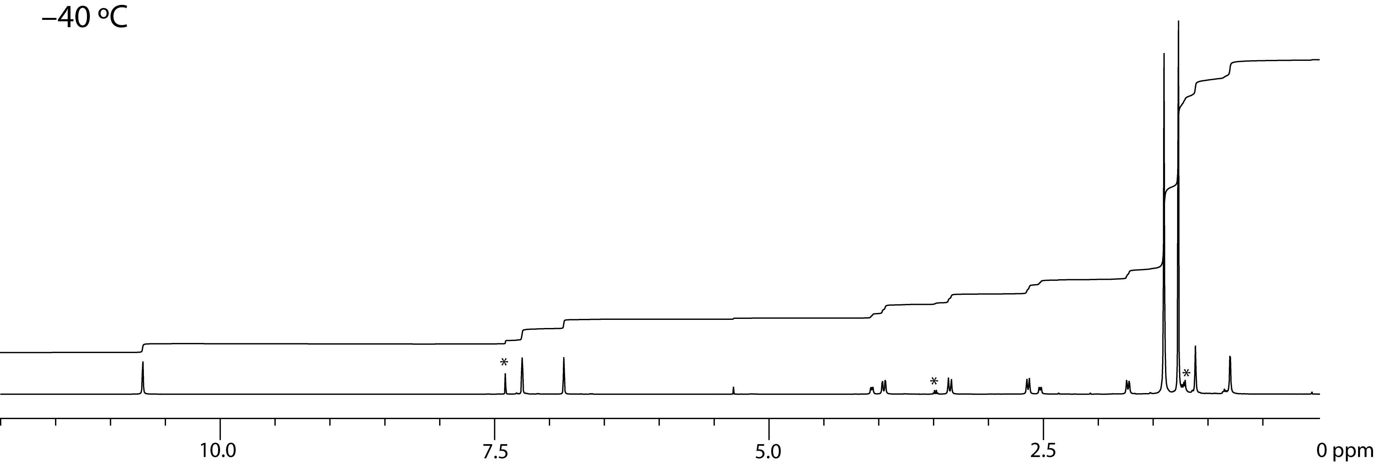

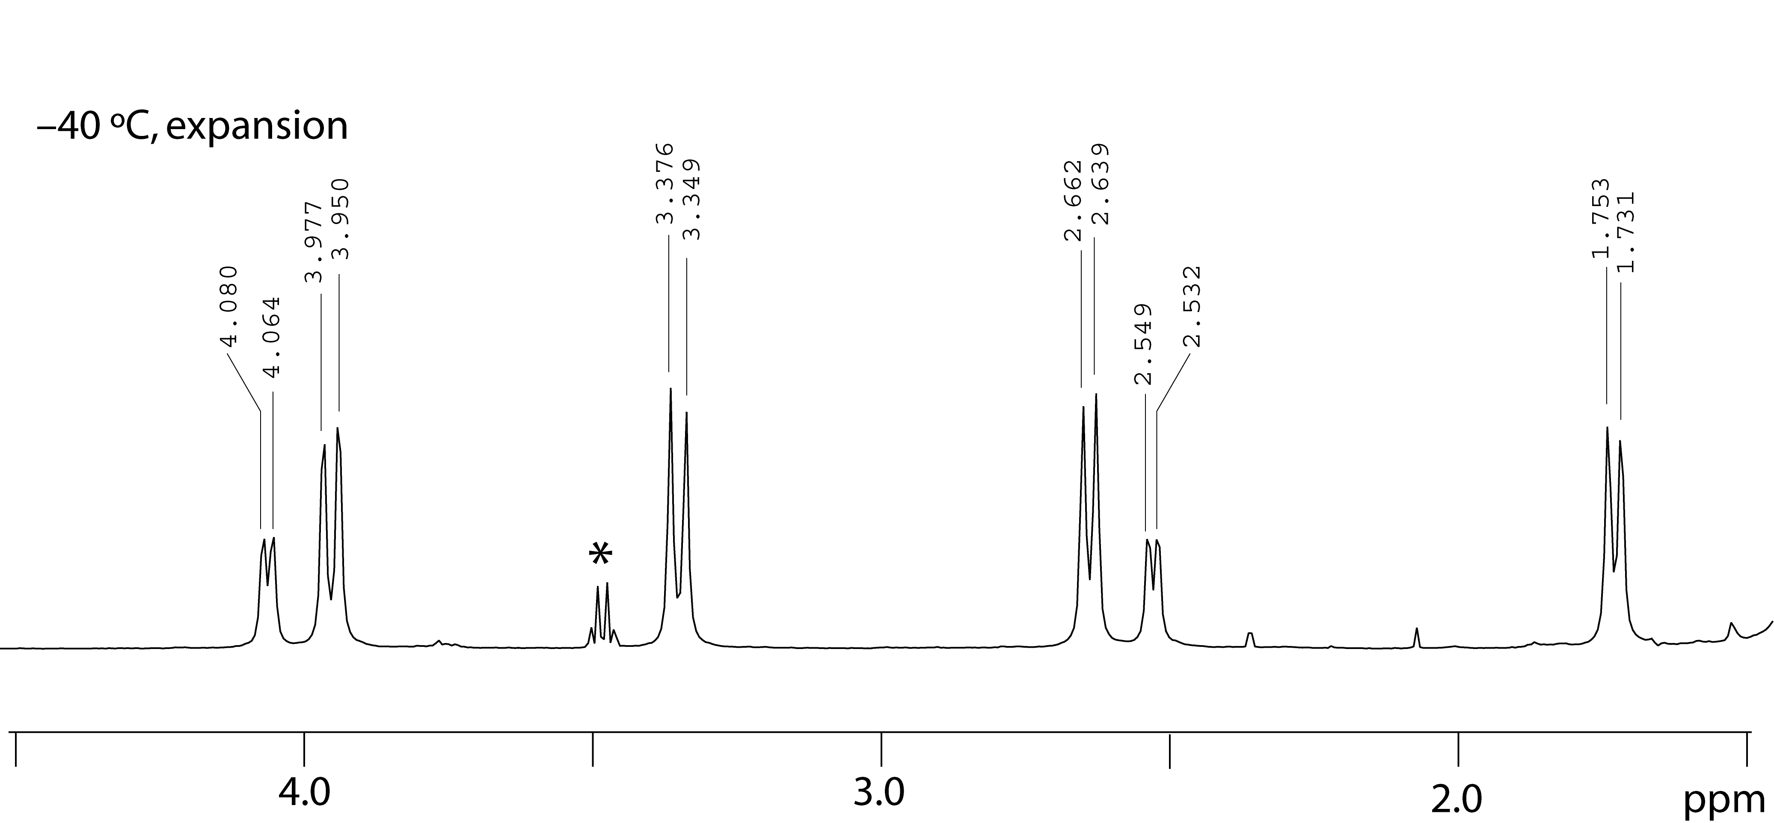

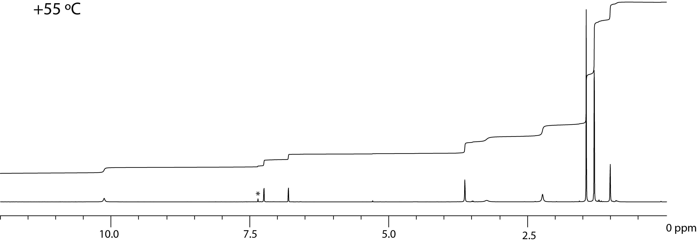

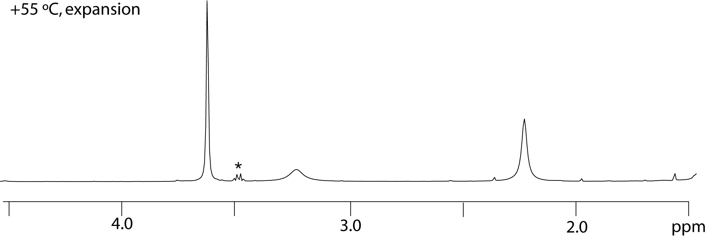

b) Suggest an explanation for the change in appearance of the 1H NMR spectra with temperature.

c) Calculate a percent yield of product.

d) Report the melting point and *R*f value of the compound.

**Periodic Table of the Elements**

|  |  |  |  |  |  |  |  |  |  |  |  |  |  |  |  |  |  |  |  |  |  |  |  |  |
| --- | --- | --- | --- | --- | --- | --- | --- | --- | --- | --- | --- | --- | --- | --- | --- | --- | --- | --- | --- | --- | --- | --- | --- | --- |
|  | MAIN-GROUP ELEMENTS | |  | | |  | |  |  |  |  | |  |  |  |  | | MAIN-GROUP ELEMENTS | | | | | | |
|  | 1A  (1) |  |  | | |  | |  |  |  |  | |  |  |  |  | |  |  |  |  |  | 8A  (18) | |
| 1 | **1**  **H**  1.008 | 2A  (2) |  | | | | | | | | | | | | | | | 3A  (13) | 4A  (14) | 5A  (15) | 6A  (16) | 7A  (17) | **2**  **He**  4.003 | |
| 2 | **3**  **Li**  6.941 | **4**  **Be**  9.012 |  | | | | | | | | | | | | | | | **5**  **B**  10.81 | **6**  **C**  12.01 | **7**  **N**  14.01 | **8**  **O**  16.00 | **9**  **F**  19.00 | **10**  **Ne**  20.18 | |
|  | TRANSITION ELEMENTS | | | | | | | | | | | | |  |
| 3 | **11**  **Na**  22.99 | **12**  **Mg**  24.31 | 3B  (3) | | | 4B  (4) | | 5B  (5) | 6B  (6) | 7B  (7) | (8) | | 8B  (9) | (10) | 1B  (11) | 2B  (12) | | **13**  **Al**  26.98 | **14**  **Si**  28.09 | **15**  **P**  30.98 | **16**  **S**  32.07 | **17**  **Cl**  35.45 | **18**  **Ar**  39.95 | |
| 4 | **19**  **K**  39.10 | **20**  **Ca**  40.08 | **21**  **Sc**  44.96 | | | **22**  **Ti**  47.87 | | **23**  **V**  50.94 | **24**  **Cr**  52.00 | **25**  **Mn**  54.94 | **26**  **Fe**  55.85 | | **27**  **Co**  58.93 | **28**  **Ni**  58.69 | **29**  **Cu**  63.55 | **30**  **Zn**  65.41 | | **31**  **Ga**  69.72 | **32**  **Ge**  72.61 | **33**  **As**  74.92 | **34**  **Se**  78.96 | **35**  **Br**  79.90 | **36**  **Kr**  83.80 | |
| 5 | **37**  **Rb**  85.47 | **38**  **Sr**  87.62 | **39**  **Y**  88.91 | | | **40**  **Zr**  91.22 | | **41**  **Nb**  92.91 | **42**  **Mo**  95.94 | **43**  **Tc**  (97.9) | **44**  **Ru**  101.1 | | **45**  **Rh**  102.9 | **46**  **Pd**  106.4 | **47**  **Ag**  107.9 | **48**  **Cd**  112.4 | | **49**  **In**  114.8 | **50**  **Sn**  118.7 | **51**  **Sb**  121.8 | **52**  **Te**  127.6 | **53**  **I**  126.9 | **54**  **Xe**  131.3 | |
| 6 | **55**  **Cs**  132.9 | **56**  **Ba**  137.3 | **57**  **La**  138.9 | |  | | **72**  **Hf**  178.5 | **73**  **Ta**  180.9 | **74**  **W**  183.8 | **75**  **Re**  186.2 | | **76**  **Os**  190.2 | **77**  **Ir**  192.2 | **78**  **Pt**  195.1 | **79**  **Au**  197.0 | **80**  **Hg**  200.6 | | **81**  **Tl**  204.4 | **82**  **Pb**  207.2 | **83**  **Bi**  209.0 | **84**  **Po**  (209.0) | **85**  **At**  (210.0) | **86**  **Rn**  (222.0) |
| 7 | **87**  **Fr**  (223.0) | **88** Ra (226.0) | **89**  **Ac**  (227.0) | |  | | **104**  **Rf**  (261.1) | **105**  **Db**  (262.1) | **106**  **Sg**  (263.1) | **107**  **Bh**  (262.1) | | **108**  **Hs**  (265) | **109**  **Mt**  (266) | **110**  **Ds**  (271) | **111**  **Rg**  (272) | **112**  **Cn**  (285) | | **113**  **Uut**  (284) | **114**  **Uuq**  (289) | **115**  **Uup**  (288) | **116**  **Uuh**  (292) | **117**  **Uus**  (294) | **118**  **Uuo**  (294) |

|  |
| --- |
| INNER TRANSITION ELEMENTS |

|  |  |  |  |  |  |  |  |  |  |  |  |  |  |  |  |
| --- | --- | --- | --- | --- | --- | --- | --- | --- | --- | --- | --- | --- | --- | --- | --- |
| 6 | Lanthanides | **58**  **Ce**  140.1 | **59**  **Pr**  140.9 | **60**  **Nd**  144.2 | **61**  **Pm**  (144.9) | **62**  **Sm**  150.4 | **63**  **Eu**  152.0 | **64**  **Gd**  157.3 | **65**  **Tb**  158.9 | **66**  **Dy**  162.5 | **67**  **Ho**  164.9 | **68**  **Er**  167.3 | **69**  **Tm**  168.9 | **70**  **Yb**  173.0 | **71**  **Lu**  174.0 |
| 7 | Actinides | **90**  **Th**  232.0 | **91**  **Pa**  231.0 | **92**  **U**  238.0 | **93**  **Np**  (237.1) | **94**  **Pu**  (244.1) | **95**  **Am**  (243.1) | **96**  **Cm**  (247.1) | **97**  **Bk**  (247.1) | **98**  **Cf**  (251.1) | **99**  **Es**  (252.1) | **100**  **Fm**  (257.1) | **101**  **Md**  (258.1) | **102**  **No**  (259.1) | **103**  **Lr**  (260.1) |