46th International Chemistry Olympiad
July 23, 2014
Hanoi, Vietnam

PRACTICAL EXAMINATION



Country:
Name as in passport:
Student Code:
Language:

GENERAL INTRODUCTION
Safety
- Safety is the most important issue in the laboratory. You are expected to follow the safety rules given in the IChO regulations. Safety glasses and lab coats must be worn in laboratory ALL TIMES.
- If you behave in an unsafe manner, you will receive one warning before you are asked to leave the laboratory. If required to leave due to a second warning, you will receive a score of zero for the rest practical examination.
- Eating, drinking, or smoking in the laboratory or tasting a chemical is strictly forbidden.
- Pipetting by mouth is strictly forbidden.
- Use the labeled waste containers near you for disposal of liquids and solids. A waste container (plastic can) is also available on each bench for organic and inorganic waste. Discard used glass capillaries into a solid trash.
- In case of emergency, follow the instructions given by the lab assistants.
Examination Procedures
- This practical examination has XX pages for 3 practical problems. Periodic Table of Elements is at the end of this booklet. Do not attempt to separate the sheets.
- You have 5 hours to complete practical problems 1, 2, and 3. You have 30 min to read through the problems before the START command is given.
- DO NOT begin working on the tasks until the START command is given.
- When the STOP command is given, you must stop your work on the tasks immediately. A delay in doing so may lead to your disqualification from the examination.
- After the STOP command has been given, wait in your lab space. A supervisor will check your lab space. The following items should be left behind:
  - The practical examination booklet (this booklet),
  - Your chosen TLC plates in Petri dish with your student code (Problem 2).
- Do not leave the laboratory until you are instructed to do so by the lab assistants.
- You may need to reuse some glassware during the examination. If this is the case, clean it carefully in the sink closest to you.
- Replacement of chemicals and laboratory ware will be provided if necessary. Other than the first, for which you will be pardoned, each such incident will result in the loss of 1 point from your 40 practical points. Refilling of wash-bottle water is permitted with no loss of points.
Notes
- Use only the pen provided for filling in the answer boxes. You may also use the calculator and the ruler provided. Do not use the mechanical pencil for filling in the answer boxes.
- All results must be written in the appropriate areas with the working shown. Results written elsewhere will not be graded. If you need to do rough calculations, etc., use the draft papers or the back of the sheets. All answers on the draft papers or the back of the sheets will NOT be graded.
- You should take care to report answers to an appropriate number of significant figures and give the appropriate unit.
- Contact a supervisor near you if you need a refreshment/toilet break.
- Read the whole description of the problems before you begin
- An official English version of this examination is available upon request if you require clarification.

Attention: Pipetting by mouth is strictly forbidden. Student was provided a pipette bulb. Make sure that you properly use the pipette bulb shown in Figure below.  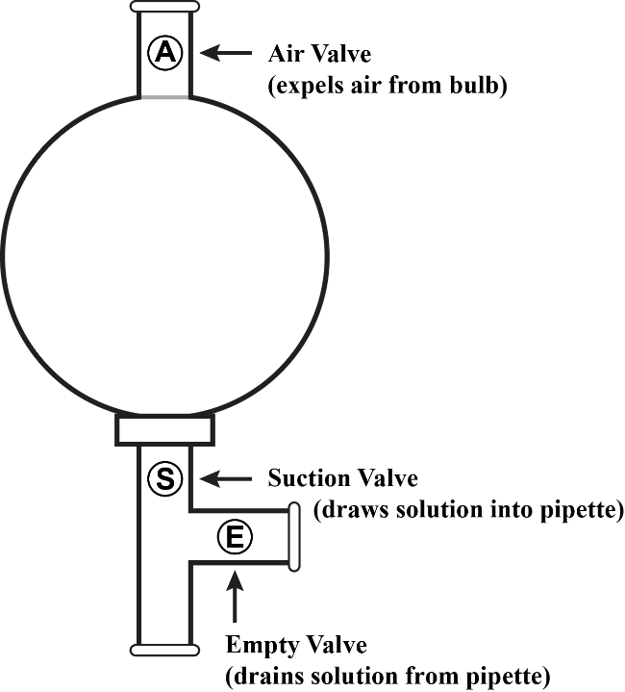  Description of three-way pipette bulb.  An adapter is provided for larger pipettes. | Instructions for using the thermometer  1. Press the [ON/OFF] button to display the temperature reading in Celsius.  2. Insert the stainless steel probe (at least 5 cm) in the solution to be measured.  3. Wait for display to stabilize (display value is unchanged and stable for 3 seconds) and read the temperature on the display.  4. Press the [ON/OFF] button again to turn the thermometer off, then rinse the stainless steel probe with distilled water.

List of chemicals
The concentration indicated on the label is approximate. The exact values are indicated in the table.
Chemical/Reagent | Quantity | Placed in | Labeled | Safety
Practical Problem 1
0.100 M KI solution | 120 mL | Glass bottle | 0.1 M KI | H320
Solution #A1 contains KI, Na₂S₂O₃, and starch indicator in distilled water | 40 mL | Glass bottle | Solution #A1 | H314, H302, H315, H319
Solution #B1 contains Fe(NO₃)₃, HNO₃ in distilled water | 40 mL | Glass bottle | Solution #B1 | H314, H315, H319, H335
Solution #A2-1 contains 5.883 ×10^{–4} M Na₂S₂O₃, KNO₃, and starch indicator in distilled water | 360 mL | Glass bottle | Solution #A2-1 | H314 H272
Solution #B2 contains 0.1020 M Fe(NO₃)₃ and HNO₃ in distilled water. | 100 mL | Glass bottle | Solution #B2 | H314, H272, H315, H319
Distilled water | 1 L | Glass bottle | H₂O (Practical Problem 1)
Practical Problem 2
Artemisinin | 1.000 g | Small bottle | Artemisinin
Sodium borohydride, NaBH₄ | 0.53 g | Small bottle | NaBH₄ | H301-H311
CH₃OH | 20 mL | Glass bottle | Methanol | H225, H301
n-Hexane | 30 mL | Bottle | n-Hexane | H225
cerium staining reagent for TLC | 3-5 mL | Bottle | Ceri reagent
CH₃COOH | 1 mL | 1.5 mL vial | Acetic Acid | H226, H314
Ethyl acetate | 5 mL | Glass bottle | Ethyl acetate
Bag of NaCl for salt bath | 0.5 kg | Ice bath | NaCl bag
CaCl₂ in drying tube | 5-10 g | Tube | CaCl₂ | H319
Practical Problem 3
~ 30 wt% H₂SO₄, solution in water | 40 mL | Bottle | ~30 wt% H₂SO₄ | H314
1.00×10^{–2}M KMnO_{4,} aqueous solution | 50 mL | Bottle | ~0.01 M KMnO_{4,} | H272, H302,
2.00×10⁻³M EDTA, aqueous solution | 40 mL | Bottle | 2.00×10⁻³ M EDTA | H319
pH = 9-10 Buffer aqueous Solution, NH₄Cl + NH₃ | 40 mL | Bottle | pH = 9-10 Buffer Solution | H302 , H319
~20 wt% NaOH, aqueous solution | 20 mL | Plastic bottle | ~20 wt% NaOH, | H314
~3 M H₃PO₄, solution in water | 15 mL | Bottle | ~3 M H₃PO₄ | H314
Indicator: ETOO, solid in KCl | ca. 0.5 g | Plastic bottle | ETOO | H301

List of Glassware and Equipments
Problem | Item on every working place | Quantity
Practical Problems 1-3 | Hotplate stirrer | 1
Practical Problems 1-3 | Magnetic stirring bar (seek in Kit #1) | 1
Practical Problems 1-3 | Plastic wash bottle filled with distilled water (refill if necessary from the 1 L glass bottle of distilled water provided) | 1
Practical Problems 1-3 | 1-L glass beaker for inorganic waste liquid | 1
Practical Problems 1-3 | 250-mL conical flask for organic waste liquid | 1
Practical Problems 1-3 | Pipette rack with:  1-mL graduated pipette  5-mL graduated pipette (One for Problem 1; another labeled ‘MeOH’ for Problem 2)  10-mL graduated pipette  10-mL volumetric pipette  25-mL graduated pipette  Pasteur pipette and bulb  Glass spatula spoon  Cleaning brush  Large glass stirring rod  Glass funnel | 1  1  2  1  1  1  2  2  1  1  1
Practical Problems 1-3 | Bag of paper towels | 1
Practical Problems 1-3 | Goggles | 1
Practical Problems 1-3 | Digital thermometer | 1
Practical Problems 1-3 | Three-way pipette bulb with a little rubber adapter for bigger pipettes | 1
Practical Problems 1-3 | Ceramic Büchner funnel with fitted rubber bung | 1
Practical Problems 1-3 | Büchner flask | 1
Practical Problems 1-3 | Pair of rubber gloves | 1
Practical Problems 1-3 | One cotton glove | 1
KIT  # 1 | Practical Problem 1 (KIT # 1)
KIT  # 1 | Digital stop watch | 1
KIT  # 1 | Insulating plate for the hotplate stirrer labeled I.P. | 1
KIT  # 1 | 100-mL glass beaker | 6
KIT # 2 | Practical Problem 2 (KIT # 2)
KIT # 2 | 5-mL graduated measuring cylinder | 1
KIT # 2 | 50-mL graduated measuring cylinder | 2
KIT # 2 | 100-mL two-neck round bottom flask with plastic stopper (in ice bath) | 1
KIT # 2 | 100-mL conical (Erlenmeyer) flask | 1
KIT # 2 | Hair dryer | 1
KIT # 2 | Petri dish with cover containing 1 TLC plate, 2 capillaries in paper holder | 1
KIT # 2 | Plastic pot for ice bath | 1
KIT # 2 | Stand & clamp | 1
KIT # 2 | TLC developing chamber with glass lid | 1
KIT # 2 | Tweezers | 2
KIT # 2 | Metal spatula | 1
KIT # 2 | Very small test tubes for TLC in container | 2
KIT # 2 | Zipper store bag (containing cotton wool, round filter paper, watch glass for Problem 2 labeled with WHITE student code) | 1
KIT # 2 | Empty Petri dish with cover | 1
KIT # 3 | Practical Problem 3 (KIT # 3)
KIT # 3 | 50-mL glass beaker (for transferring EDTA and KMnO₄ solutions to burettes) | 2
KIT # 3 | 25-mL burette with BLUE graduation marks | 1
KIT # 3 | 25-mL burette with BROWN graduation marks | 1
KIT # 3 | 250 mL glass beaker | 2
KIT # 3 | 250 mL conical flask (Erlenmeyer flask) | 2
KIT # 3 | 100 mL volumetric flask with stopper | 2
KIT # 3 | 10 mL glass graduated measuring cylinder | 1
KIT # 3 | 100 mL glass graduated measuring cylinder | 1
KIT # 3 | Burette stand & clamp | 1
KIT # 3 | Reel of pH paper | 1
KIT # 3 | Zipper store bag (containing a large round filter paper for the glass funnel) | 1
 | Items on the tables for the common use:
 | Electronic balance with 0.1-mg resolution (6-8 students/each)

Replacement or extra chemicals | Lab assistant’s signature | Student’s signature | Penalty
_________________  _________________  _________________ | ______________  ______________  ______________ | ______________  ______________  ______________ | _______  _______  _______

Attention: You MUST do the experiments in the order
Problem 1, 2 and then 3
(this is in order to control
the temperature of the magnetic stirrer properly).
PRACTICAL EXAMINATION
Practical Problem 1  14 % of the total | Code: |  | Question | 1 | 2 | 3 | 4 | 5 | 6 | Total
Practical Problem 1  14 % of the total | Examiner |  | Mark | 2 | 4 | 50 | 2 | 2 | 10 | 70
Practical Problem 1  14 % of the total |  |  | Grade

Practical Problem 1. The oxidation of iodide by iron(III) ions – a kinetic study based on the thiosulfate clock reaction
Clock reactions are commonly used as demonstrations by chemical educators owing to their visual appeal. Oxidation of iodide by iron(III) ions in a weakly acidic medium is a reaction that can be transformed into a clock reaction. In the presence of thiosulfate and starch, chemical changes in this clock reaction can be presented by the following equations:

Reaction (1) is a fast reversible equilibrium which occurs in the reaction mixture giving a reservoir of iron(III) and thiosulfate ions. After being produced in reaction (2), iodine in the form of triiodide ion (I₃–), is immediately consumed by thiosulfate in reaction (3). Therefore, no iodine accumulates in the presence of thiosulfate. When thiosulfate is totally depleted, the triiodide ion accumulates and it may be detected by use of starch indicator according to reaction (4).
The kinetics of reaction (2) is easily investigated using the initial rates method. One has to measure the time elapsed between mixing the two solutions and the sudden color change.
For the oxidation of iodide by iron(III) ions (reaction 2), the reaction rate can be defined as:
(5)
The initial reaction rate can then be approximated by:
(6)
with Δ[Fe³⁺] being the change in the concentration of iron(III) ions in the initial period of the reaction. If Δt is the time measured, then Δ[Fe³⁺] is the change in iron(III) ion concentration from the moment of mixing to the moment of complete thiosulfate consumption (assume that the reaction rate does not depend on thiosulfate concentration). Therefore, from the reactions' stoichiometry it follows:

(7)
and consequently:
(8)

The initial thiosulfate concentration is constant and significantly lower than that of iron(III) and iodide ions. The above expression enables us to determine the initial reaction rate by measuring the time required for the sudden color change to take place, Δt.
The rate of reaction is first order with respect to [Fe³⁺], and you will determine the order with respect to [I–]. This means the initial reaction rate of reaction can be expressed as:

$v_{0}=k[{\text{Fe}}^{3+}]_{0}[I^{−}]_{0}^{y}$ (9)

where k is the rate constant and y is the order with respect to [I–].

We assume that the reaction rate does not depend on the thiosulfate concentration, and that the reaction between Fe³⁺ and S₂O₃²⁻ is negligible. You have to observe carefully the color changes during the clock reaction and to determine the reaction order with respect to [I–], and the rate constant of clock reaction.

Experimental Set-up

Instructions for using the digital timer (stopwatch)
- Press the [MODE] button until the 00:00:00 icon is displayed.
- To begin timing, press the [START/STOP] button.
- To stop timing, press the [START/STOP] button again.
- To clear the display, press the [SPLIT/RESET] button.

PRECAUTIONS
- To minimize fluctuations in temperature only use the distilled water on your bench (in the wash bottle and in the glass 1 L bottle).
- The heating function of the heating magnetic stirrer must be TURNED OFF (as shown in Figure 1 below) and be sure that the stirrer plate is not hot before starting your experiment. Put the insulating plate (labeled I.P.) on top of the stirrer plate for added insulation.
- Start the stopwatch as soon as the solutions #A and #B are mixed. Stop the stopwatch as soon as the solution suddenly turns dark blue.
- Magnetic stirrer bar (take it with the provided tweezers) and beakers should be washed and rinsed with distilled water and wiped dry with paper towel to reuse.

General Procedure
Solution # A (containing Na₂S₂O₃, KI, KNO₃ and starch) is first placed in the beaker and is stirred using the magnetic bar. The rate of stirring is set at level 8 as indicated in Figure 1. Solution #B (containing Fe(NO₃)₃ and HNO₃) is quickly added into solution #A and the stopwatch is simultaneously started. The time is recorded at the moment the solution suddenly turns dark blue. The temperature of the solution is recorded using the digital thermometer.
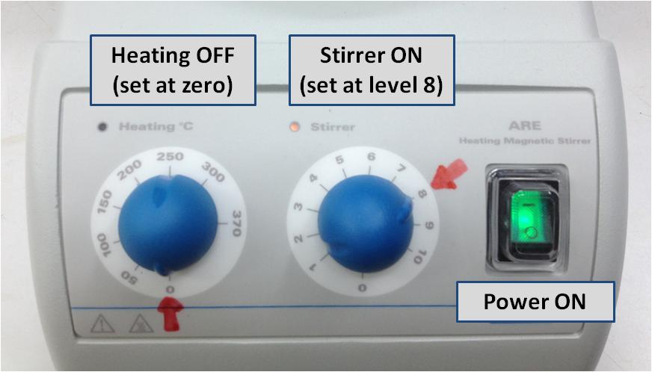
Figure 1. The apparatus employed for kinetic study of the clock reaction.
1. Practice run to observe the color changes
- There is no need to accurately measure the volumes used in this part – just use the marks on the beaker as a guide.
- Pour ca. 20 mL of solution # A1 (containing KI, Na₂S₂O₃, and starch in water) to a 100-mL graduated beaker containing a magnetic stirrer bar. Place the beaker on top of the insulating plate on the magnetic stirrer.
- Pour ca. 20 mL of solution # B1 (containing Fe(NO₃)₃ and HNO₃ in water) in another 100 mL graduated beaker.
- Quickly pour the solution # B1 into solution # A1 and start stopwatch simultaneously. Stop stopwatch when the color of the mixture changes. There is no need to record this time. Answer the following questions.

Task 1.1: Write down the molecular formula of the limiting reactant for the given clock reaction.

Task 1.2: What are the ions or compounds responsible for the colors observed in this experiment? Tick the appropriate box.

Color | Compound
Purple | □ Fe³⁺  □ [Fe(S₂O₃)]⁺  □ Fe²⁺  □ starch-I₅⁻  □ I₃⁻
Dark blue | □ Fe³⁺  □ [Fe(S₂O₃)]⁺  □ Fe²⁺  □ starch-I₅⁻  □ I₃⁻

2. Determination of the order with respect to [I–] (y), and the rate constant (k)
In this section, Δt is determined for different initial concentrations of KI according to the table below. The experiment is repeated as necessary for each concentration of KI.
Hint: Use 25 mL graduated pipette for solution #A2-1, 10 mL graduated pipette for KI, 5 mL graduated pipette for solution #B2, and one of the burettes for water (you will need to refill the burette from the wash bottle for each measurement).
- Prepare 55 mL of solution # A2 in a 100 mL beaker containing a magnetic stirrer bar and place it on top of the insulating plate on the stirrer. Solution #A2 contains solution #A2-1, KI, and distilled water (see the table below for the volume of each component).
- Add 5 mL of solution # B2 in another 100 mL beaker.
Quickly pour prepared solution #B2 into solution #A2. Determine the time (Δt) necessary for the color change by a stopwatch. The temperature of the solution is recorded.

Task 1.3: Record the time (Δt) for each run in the table below. (You DO NOT need to fill all three columns for the runs.) For each concentration of KI, record your accepted reaction time (Δt_{accepted}) and temperature. You will be only graded on your values of Δt_{accepted} and T_{accepted}.

No | 55 mL of solution #A2 |  |  |  |  |  |  |  |  | Δt_{accepted}  (s) | T_{accepted}  (ºC)
No | #A2-1 (mL) | H₂O  (mL) | 0.100M  KI (mL) | Run 1 |  | Run 2 |  | Run 3 |  | Δt_{accepted}  (s) | T_{accepted}  (ºC)
 |  |  |  | Δt  (s) | T  (ºC) | Δt  (s) | T  (ºC) | Δt  (s) | T  (ºC) | Δt_{accepted}  (s) | T_{accepted}  (ºC)
1 | 20.4 | 31.6 | 3.0
2 | 20.4 | 30.1 | 4.5
3 | 20.4 | 28.6 | 6.0
4 | 20.4 | 27.4 | 7.2
5 | 20.4 | 25.6 | 9.0
When you are satisfied you have all the necessary data for Problem 1, before continuing further with the analysis, it is strongly recommended that you start the practical procedure for Problem 2 since there is a reaction time of one hour in that Problem.

Task 1.4: Fill in the table below and plot the results in the graph.

Hint: Make sure your data is graphed as large as possible in the provided space.

No. | 1 | 2 | 3 | 4 | 5
ln([I⁻]₀ / M) | - 5.30 | - 4.89 | - 4.61 | - 4.42 | - 4.20
Δt_{accepted} (s)
ln(Δt_{accepted /} s)
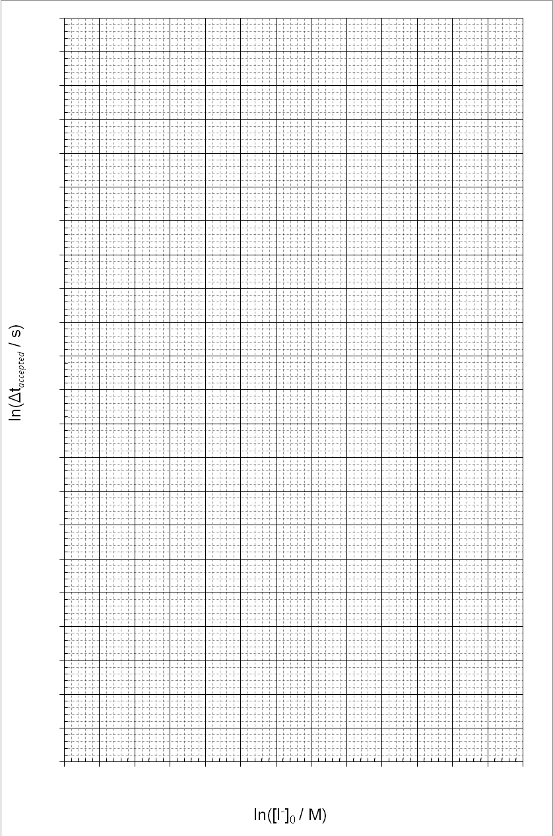
Task 1.5: Draw the best fit line on your graph and use this to determine the order with respect to [I–] (y).

y = ………………………………

Task 1.6: Complete the table below and calculate k for each of the concentrations of iodide. Report your accepted value for the rate constant, giving the appropriate unit. Remember that the order with respect to [Fe³⁺] is equal to one.
No | Δt_{accepted}  (s) | [Fe³⁺]₀  (×10⁻³ M) | [I⁻]₀  (×10⁻³ M) | [S₂O₃²⁻]₀  (×10⁻³ M) | k
1 |  |  | 5.0
2 |  |  | 7.5
3 |  |  | 10.0
4 |  |  | 12.0
5 |  |  | 15.0
k_{accepted} = ………………….

Practical Problem 2  13 % of the total | Code: |  | Task | 1 | 2 | 3 | 4 | 5 | Total
Practical Problem 2  13 % of the total | Examiner |  | Mark | 35 | 15 | 20 | 4 | 2 | 76
Practical Problem 2  13 % of the total |  |  | Grade

Practical Problem 2. Synthesis of a derivative of Artemisinin
Artemisinin (also known as Quinghaosu) is an antimalarial drug isolated from the yellow flower herb Artemisia annua L., in Vietnam. This drug is highly efficacious against the chloroquine-resistant Plasmodium falciparum. However, artemisinin has a poor solubility in both oil and water so that one needs to prepare its new derivatives to improve the applicability of this drug. The reduction of artemisinin is an attractive method to synthesize new derivatives of artemisinin as shown in Scheme 1.

Scheme 1

In this practical exam you are going to reduce artemisinin to product P and check its purity using Thin-Layer Chromatography (TLC).

Experimental Set-up
- The experimental set-up is shown in Figure 2.1.
- By moving the finger clamp, you can adjust the position of the two-neck round-bottom flask.

1: Digital thermometer; 2: Plastic Stopper; 3: CaCl₂ drying tube; 4: Ice Bath
Figure 2.1. Reaction system for Problem 2
Procedure
Step 1. Synthesis of a Derivative of Artemisinin
- Prepare an ice bath with a temperature between –20 and –15 ºC by mixing ice and sodium chloride in the plastic pot (approximate ratio of NaCl : crushed ice = 1 scoop : 3 scoops). Use the digital thermometer to monitor the temperature. Place the bath on the magnetic stirrer. Put a layer of three tissues between the bath and the stirrer.
- Connect the CaCl₂ drying tube to the small neck of the round-bottom flask and close the other neck with the plastic stopper.
- Place a magnetic stirring bar into the dry round-bottom flask and set up the reaction system onto the clamp-stand so that the system is immersed in the ice bath. Monitor the temperature using the digital thermometer.
- Setting aside a tiny amount (ca. 2 mg) of artemisinin for TLC analysis, open the stopper and add the 1 gram of artemisinin through the bigger neck.
- Use the glass funnel to add 15 mL of methanol (measured using the 50-mL graduated cylinder). Close the stopper and turn on the magnetic stirrer. (Set the magnetic stirrer to level 4). Start the stopwatch to keep track of the time.
- After ca. 5 min stirring, open the stopper and add carefully 0.53 g of NaBH₄ in small portions over 15 min using a spatula. Close the stopper in between addition. (Caution: Adding NaBH₄ rapidly causes side-reactions and overflowing). Keep stirring for 50 min. Maintain the temperature of the ice bath below –5 ºC; remove some of the liquid and add more NaCl-crushed ice mixture if necessary. Cool the vial containing the 1 mL of acetic acid in the ice bath.

During this waiting time, you are advised to finish calculations from Problem 1, answer the questions below, and prepare further experimental steps.

- Prepare 50 mL of ice-cold distilled water (cooled in the ice bath) in the 100 mL- conical flask. Measure ca. 20-22 mL n-hexane in the 50 mL measuring cylinder and cool it in the ice bath. After the reaction is complete, keep the reaction flask in the ice bath below 0 ºC. Remove the CaCl₂ tube, open the stopper, and add gradually ca. 0.5 mL of the cold acetic acid from the vial into the reaction flask until the pH is between 6 and 7. (Use the glass rod to spot the reaction mixture on to the pH paper.) With stirring, slowly add the 50 mL ice cold water over 2 min. A white solid precipitates in the reaction flask.
- Assemble the vacuum filtration apparatus. Put a filter paper onto the Büchner funnel, wet the filter paper with distilled water and open the vacuum valve. Transfer the reaction mixture on to the filter, and remove the stirring bar from the reaction flask using the spatula. Wash the product three times with portions of 10 mL ice-cold water (cooled in the ice bath). Wash the product two times with portions of 10 mL ice-cold n-hexane (cooled in the ice bath). Continue to use the pump to dry the solid on the filter. After ca. 5 min, carefully transfer the dried powder on to the watch glass labeled with your code and put into the labeled Petri dish. Turn off the vacuum valve when you do not use it! Note: Your sample will be collected, dried and weighed later by the lab assistant.
Task 2.1: The recording of your yield will be performed after the exam by the lab-assistents.

Step 2. TLC Analysis of the product
- Check your TLC plate before use. Unused damaged plates will be replaced upon request without penalty. Use the pencil to draw the start front line, and the line where the solvent front will be run to exactly as shown in Figure 2.2. Write your student code on the top of the TLC plate in pencil.

Figure 2.2. Instruction of TLC plate preparation
- Dissolve ca. 1 mg of artemisinin (a spatula tip) in ca. 0.5 mL of methanol in the labeled very small test tube (use the labeled 5 mL graduated pipette). Dissolve ca. 1 mg of the product in ca. 1 mL of methanol in the labeled test tube.
- Spot the artemisinin solution and the product solution on the TLC plate using two different glass capillary spotters so the finished plate is as shown in Figure 2.2.
- Prepare the TLC developing chamber. Use the 5 mL graduated cylinder to make 5 mL of a mixture of n-hexane/ethyl acetate (7/3, v/v) as the solvent system. Pour the mixture of n-hexane/ethyl acetate into the chamber (Note: The solvent level should not reach the spots on the plate if prepared as shown). Cover and swirl the chamber and allow it to stand for 2 min.
Figure 2.3. A TLC plate placed in the TLC developing chamber and instruction for R_{f} calculation of compound A
5. Insert the TLC plate upright into the TLC developing chamber. Wait until the solvent system reaches the pre-drawn solvent front line. (Note: You are advised to work on some question below while you wait for the TLC to run.)
6. When the solvent front reaches the line, remove the TLC plate using the tweezers and then dry the solvent using the hair dryer set at level 1.
7. Dip the piece of cotton wool into the cerium staining reagent, taking care not to let the tweezers come into contact with the solution since the metal stains the plate. Carefully apply the stain to the whole TLC plate.
8. Heat the TLC plate using the hair dryer set at level 2 (Attention: Do NOT set the hair dryer to COLD) until the blue spots of artemisinin and the product appear on the TLC plate.
9. Ask the lab assistant to take a photo of your final TLC plate together with your student code.
10. Circle all the visualized spots and calculate the R_{f} values of both artemisinin and the product (See instruction in Fig. 2.3). Store your TLC plate in the Petri dish.

Task 2.2: Fill the values of R_{f} in Table below.
R_{f, Artemisinin} | R_{f, Product} | R_{f Artemisinin}/R_{f Product}
---------------------- | -------------------------- | --------------------------

Task 2.3: Check the total number of developed spots on the TLC plate:

1 2 3 4 5

Step 3. Identifying the reaction product P

The reduction of artemisinin leads to the formation of two stereoisomers (P). Comparing the ¹H-NMR spectrum (in CDCl₃) of one of these isomers with the spectrum of artemisinin shows an extra signal at δ_{H} = 5.29 ppm as a doublet, and also an extra signal as a broad singlet at δ_{H} = 2.82 ppm.

Task 2.4: Suggest structure for P. (You do not need to draw the stereochemistry of the compounds).
P

Task 2.5: P is mixture of two stereoisomers. What is their stereochemical relationship? Check the appropriate box below.
Z/E Isomers Enantiomers Diastereomers Constitutional Isomers

Practical Problem 3  13 % of the total | Code: |  | Task | 1 | 2 | 3 | 4 | 5 | 6 | 7 | 8 | 9 | 10 | Total
Practical Problem 3  13 % of the total | Examiner |  | Mark | 0 | 25 | 2 | 25 | 3 | 4 | 3 | 2 | 5 | 2 | 71
Practical Problem 3  13 % of the total |  |  | Grade

Practical Problem 3. Analysis of a hydrated zinc iron(II) oxalate double salt
Zinc iron(II) oxalate double salt is a common precursor in the synthesis of zinc ferrite which is widely used in many types of electronic devices due to its interesting magnetic properties. However, such double salts may exist with different compositions and different amount of water depending on how the sample was synthesized.
You will analyze a pure sample of hydrated zinc iron(II) oxalate double salt (Z) in order to determine its empirical formula.
Procedure
The concentration of the standard KMnO₄ is posted on the lab walls.
Bring a clean 250 mL beaker to the lab assistant who will be waiting by the balance. You will receive a pure sample of Z for analysis. Accurately weigh between 0.7-0.8 g of the pure sample Z onto the weighing paper (m, grams). This should then be immediately quantitatively transferred into your 250 mL beaker for analysis, and its mass recorded in table below.

Task 3.1: Record the mass of the sample of pure Z taken.

Mass of sample, m (gram) | Lab assistant’s signature
------------------ | ---------------------

Analysis of Z
- Using the 100 mL graduated measuring cylinder, measure ca. 30 mL of 30 wt% H₂SO₄ solution and add it into the 250-mL beaker containing your accurately weighed pure sample of Z. To speed up the dissolving of your sample you may use the hotplate stirrer to warm up the mixture, but be careful not to boil it. You should not use the digital thermometer as the acid may damage it. After the solid has dissolved, remove the beaker from the hotplate stirrer and cool it to close to room temperature. After the solution has cooled, quantitatively transfer it into the 100 mL volumetric flask. Add distilled water up to the 100 mL–mark. We will now call this solution C.
- Use an appropriately labeled beaker to transfer the standardized KMnO₄ solution into the burette graduated with brown marks.
- Use another appropriately labeled beaker to transfer the standardize EDTA solution into the burette graduated with blue marks.

Titration with KMnO₄
a) Using the 5 mL graduated pipette add 5.00 mL of the solution C into a 250 mL conical flask.
b) To this conical flask add about 2 mL of 30 wt% H₂SO₄ solution, about 3 mL of 3.0 M H₃PO₄ solution, and about 10 mL of distilled water. Heat the mixture on the hot plate stirrer until hot, but be careful not to boil it.
c) Titrate the hot solution with the standardized KMnO₄ solution, recording your burette readings in the table below. At the end point of the titration, the pink color of the solution appears. Repeat the titration as desired and report your accepted volume of KMnO₄ solution consumed (V₁ mL) in the table.
Task 3.2: Record volumes of standardized KMnO₄ solution consumed
(You DO NOT need to fill in the entire table)
 | Titration No
 | 1 | 2 | 3 | 4
Initial reading of the burette of KMnO₄, mL
Final reading of the burette of KMnO₄, mL
Consumed volume of KMnO₄, mL
Accepted volume, V₁ ₌ ________ mL

Task 3.3: Can aqueous HCl or HNO₃ be used instead of H₂SO₄ for the dissolving of sample Z and the subsequent analyses?
HCl YES NO

HNO₃ YES NO

Titration with EDTA
- Clean both the 250 mL beakers ready for the next part of the experiment. Pipette 10.00 mL of solution C into a 250 mL beaker. Heat and stir the solution on the hotplate stirrer, but be careful not to boil it. Add ca. 15 mL of 20 wt% NaOH solution to the beaker and keep it on the hotplate for ca. 3-5 min in order to complete the precipitation of iron hydroxide, and to convert all Zn²⁺ ions into the ionic complex [Zn(OH)₄]²⁻.
- Using a glass funnel and the large quantitative filter paper, filter the hot suspension directly into the 250 mL conical flask. From this point take care with the volumes as you will be preparing a standard solution of exactly 100 mL from the filtrate. As it is filtering, prepare some warm distilled water in a 250 mL beaker (ca. 50 mL). Wash the precipitate on the filter paper (at least 5 times) with small portions (ca. 5 mL) of the warm distilled water. Cool the filtrate down and then quantitatively transfer it into the 100 mL volumetric flask via a glass funnel. Add distilled water to make up to the 100 mL mark. This will now be referred to as solution D.
- Pipette 10.00 mL of solution D into a 250 mL conical flask. Add ca.10 mL ammonia buffer solution (pH = 9 – 10) and a small quantity of the ETOO indicator using the glass spatula spoon. Mix well to obtain a purple solution. Titrate the solution with the standardized 2.00 × 10^{–3} M EDTA solution, recording your burette readings in table below. At the end point, the color of the solution turns blue. Repeat the titration as desired and report your accepted volume of EDTA solution consumed (V₂ mL) in the table.

Task 3.4: Record the volumes of EDTA solution consumed
(You DO NOT need to fill in the entire table)
 | Titration No
 | 1 | 2 | 3 | 4
Initial reading of the burette of EDTA, mL
Final reading of the burette of EDTA, mL
Consumed volume of EDTA, mL
Accepted volume,V₂ ₌ ________ mL
Determination of the empirical formula of Z

Task 3.5: Calculate the number of moles of Zn²⁺,$n_{{\text{Zn}}^{2+}}$, present in 100 mL of solution C.
$n_{{\text{Zn}}^{2+}}$ (mol): ……………

Task 3.6: Give the ionic equations for the reduction-oxidation reactions taking place in the titration with KMnO₄.

Task 3.7: Calculate the number of moles of Fe²⁺, $n_{{\text{Fe}}^{2+}}$, present in 100 mL of solution C. [YOU WILL NEED THE PRECISE CONCENTRATION OF KMnO₄ POSTED ON THE WALLS IN YOUR LAB]
V₁, mL = …………………………………….

$n_{{\text{Fe}}^{2+}}$ (mol): …………………………

Task 3.8: Calculate the number of moles of C2O42- anion, $n_{C_{2}O_{4}^{2−}}$_{, in 100 mL of solution C.}
$n_{C_{2}O_{4}^{2−}}$ = ………………………………………….

Task 3.9: Calculate the number of moles of water, $n_{H_{2}O}$, in the original sample of Z taken for analysis.

Task 3.10: Give the empirical formula of Z:

Periodic Table of the Elements
6 | Lanthanides | 58  Ce  140.1 | 59  Pr  140.9 | 60  Nd  144.2 | 61  Pm  (144.9) | 62  Sm  150.4 | 63  Eu  152.0 | 64  Gd  157.3 | 65  Tb  158.9 | 66  Dy  162.5 | 67  Ho  164.9 | 68  Er  167.3 | 69  Tm  168.9 | 70  Yb  173.0 | 71  Lu  174.0
7 | Actinides | 90  Th  232.0 | 91  Pa  231.0 | 92  U  238.0 | 93  Np  (237.1) | 94  Pu  (244.1) | 95  Am  (243.1) | 96  Cm  (247.1) | 97  Bk  (247.1) | 98  Cf  (251.1) | 99  Es  (252.1) | 100  Fm  (257.1) | 101  Md  (258.1) | 102  No  (259.1) | 103  Lr  (260.1)

 | 1 |  |  |  |  |  |  |  |  |  |  |  |  |  |  |  |  |  |  |  |  |  | 18
1 | 1  H  1.008 | 2  (2) |  |  |  |  |  |  |  |  |  |  |  |  |  |  |  | 13  (13) | 14  (14) | 15  (15) | 16  (16) | 17  (17) | 2  He  4.003
2 | 3  Li  6.941 | 4  Be  9.012 |  |  |  |  |  |  |  |  |  |  |  |  |  |  |  | 5  B  10.81 | 6  C  12.01 | 7  N  14.01 | 8  O  16.00 | 9  F  19.00 | 10  Ne  20.18
2 | 3  Li  6.941 | 4  Be  9.012 |  | Transition Elements
3 | 11  Na  22.99 | 12  Mg  24.31 | 3 |  |  | 4 |  | 5 | 6 | 7 | 8 |  | 9 | 10 | 11 | 12 |  | 13  Al  26.98 | 14  Si  28.09 | 15  P  30.98 | 16  S  32.07 | 17  Cl  35.45 | 18  Ar  39.95
4 | 19  K  39.10 | 20  Ca  40.08 | 21  Sc  44.96 |  |  | 22  Ti  47.87 |  | 23  V  50.94 | 24  Cr  52.00 | 25  Mn  54.94 | 26  Fe  55.85 |  | 27  Co  58.93 | 28  Ni  58.69 | 29  Cu  63.55 | 30  Zn  65.41 |  | 31  Ga  69.72 | 32  Ge  72.61 | 33  As  74.92 | 34  Se  78.96 | 35  Br  79.90 | 36  Kr  83.80
5 | 37  Rb  85.47 | 38  Sr  87.62 | 39  Y  88.91 |  |  | 40  Zr  91.22 |  | 41  Nb  92.91 | 42  Mo  95.94 | 43  Tc  (97.9) | 44  Ru  101.1 |  | 45  Rh  102.9 | 46  Pd  106.4 | 47  Ag  107.9 | 48  Cd  112.4 |  | 49  In  114.8 | 50  Sn  118.7 | 51  Sb  121.8 | 52  Te  127.6 | 53  I  126.9 | 54  Xe  131.3
6 | 55  Cs  132.9 | 56  Ba  137.3 | 57  La  138.9 |  |  |  | 72  Hf  178.5 | 73  Ta  180.9 | 74  W  183.8 | 75  Re  186.2 |  | 76  Os  190.2 | 77  Ir  192.2 | 78  Pt  195.1 | 79  Au  197.0 | 80  Hg  200.6 |  | 81  Tl  204.4 | 82  Pb  207.2 | 83  Bi  209.0 | 84  Po  (209.0) | 85  At  (210.0) | 86  Rn  (222.0)
7 | 87  Fr  (223.0) | 88  Ra  (226.0) | 89  Ac  (227.0) |  |  |  | 104  Rf  (261.1) | 105  Db  (262.1) | 106  Sg  (263.1) | 107  Bh  (262.1) |  | 108  Hs  (265) | 109  Mt  (266) | 110  Ds  (271) | 111  Rg  (272) | 112  Cn  (285) |  | 113  Uut  (284) | 114  Fl  (289) | 115  Uup  (288) | 116  Lv  (292) | 117  Uus  (294) | 118  Uuo  (294)

